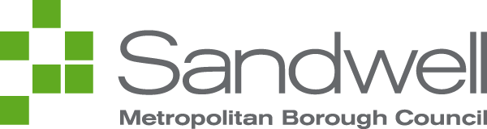

Quality Policy Statement –
Urban Design and Building Services

The Quality Policy Statement and Manual have been developed to show the management commitment to maintaining an effective quality management system and how Urban Design and Building Services (UDBS) meet the clauses of ISO9001:2015 international standard for quality management systems.

The scope as fully described in our quality manual includes; design, development, co-ordination and delivery of construction related projects and repairs and maintenance of public buildings and schools.

The UDBS Key Objectives sets out our business/quality objectives which support the corporate ambitions of Sandwell MBC. These are monitored and reviewed at quarterly quality review meetings.

UDBS gives equal importance to its commitment to our business/quality objectives and corporate ambitions. The leadership team and employees are committed to continually improving the quality management system to help achieve these objectives and corporate ambitions by providing quality services and products that consistently meet the contractual and relevant legislative requirements of the council and its customers.

We recognise the importance of maintaining effective communication with our employees and it is only by securing their commitment, understanding and contribution to the implementation of this policy and the compliance with the requirements of the Quality Manual, that the high standards we want to achieve can be met.

Quality management should be recognised as a normal aspect of all our work and we expect the co-operation of all our employees to bring this about.

The Quality Policy Statement and Manual are reviewed and updated as necessary and regular management reviews ensure UDBS performance is monitored and all aspects of the quality management system remain suitable and effective.



Signature: Date: 2nd May 2024
Lee Constable
Strategic Lead (Assets)


Signature: Date: 2nd May 2024
Helen Coldicott
Strategic Lead (Design)

