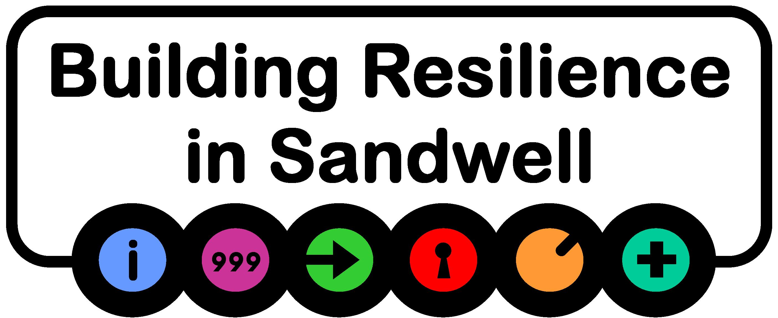

**Sandwell MBC**

**Rest Centre Plan**

**In the event of activation turn to** **Page 28**

**BLANK PAGE**

# Foreword

In the event of a major emergency or incident the council may be called upon to support the emergency services in the evacuation of local residents and visitors to the borough.  This would be to a place of safety on a temporary basis for their protection. This duty amongst others is placed on the council and detailed in the Civil Contingencies Act 2004.

Sandwell Council intends that Emergency Planning arrangements will be in place in order to provide support as quickly as possible and that the staff & organisations responding do so in a safe, knowledgeable and caring manner. This plan is therefore ‘owned’ by all of the participants enabling them to fulfil their role effectively and discharge their responsibilities during an evacuation.

During major emergencies, it has been proven that preparation and effective joint working is key to an effective response, this document provides clarity in terms of roles and responsibilities and is a key element of the council’s emergency management framework.

Emergency Planning is a continuous process. Responders are encouraged to review these procedures periodically and confirm current arrangements are adequate or propose any amendments to the Resilience Team.

**Alan Lunt**

Executive Director – Place, Sandwell Council

Item Record Table

|  |  |  |  |  |
| --- | --- | --- | --- | --- |
| **Title** | Sandwell Rest Centre Plan | | | |
| **Freedom of Information and Data Protection** | No Restrictions.  FOI Lead Agency - Sandwell Council | | | |
| **Author** | Nabeel Yafai, Sandwell Metropolitan Borough Council. | | | |
| **Document Owner** | Resilience Team (RT) | | | |
| **Document Maintenance** | A full review of this plan will be conducted every 3 years in close consultation with key stakeholders. In addition, contact details will be confirmed on an annual basis. | | | |
| **Consulted** | SLT, PfP / British Red Cross / Housing Management / Public Protection & Community Safety / Rest Centre Liaison Officers | | | |
| **Approved by** |  | | **Date:** …./…../…… | |
| **Validation Date** | Live Incident ☐ TT Exercise ☐ Live Exercise ☐ Other ☐  Validated by ………………. on ……………….. | | | |
| **Publication Date** | …../…./…. | **Review Date**: | | …./…../…… |
| **Superseded Documents** | Sandwell Rest Centre Plan 2015-2017 | | | |

Authorisation

The Resilience Team (RT) is responsible for publishing plans within a hierarchy of similar publications. Readers wishing to quote these plans as reference material in other work should confirm with the RU whether the individual publication and amendment state remains authoritative.

Distribution

Distribution of plans is managed by the RT. Requests for issue of this publication, or amendments to its distribution should be referred to the RT. All other Sandwell Council emergency plans can also be obtained from the RT.

|  |  |
| --- | --- |
| **Distribution Method (inc. URL)** | **Date Uploaded** |
| *Resilience Direct / Council Website* |  |
|  |  |

|  |  |  |
| --- | --- | --- |
| **Date of Change** | **Description of Change** | **Version** |
| *09/2014* | *Initial Plan Created* | *1* |
| *06/2018* | *Review / update* | *2* |
| *15/01/2019* | *Various amendments* | *2.1* |
| *June 2019* | *Final Amendments* | *2.2* |
| *June 2023* | *Review / update* | *3* |
| *12/03/2024* | *Pet Management addition (Pages 66 & 84)* ***(New)*** | 3.1 |
| *08/08/2024* | *Addition of Rapid Relief Team assistance* ***(New)*** | 3.1 |
| *17/09/2024* | *Addition of Appendices* ***H****,* ***I, J*** *and* ***K****, including document restructuring layout.* ***(New)*** | 3.2 |
| *13/01/2025* | *Removal of Langley and Smethwick Leisure Centres (swimming baths) and update Rest Centre map* | **3.3** |
|  |  |  |

Amendments

Comments on factual accuracy or proposals for amendment are welcomed by the RT at [emergency_planning@sandwell.gov.uk](mailto:emergency_planning@sandwell.gov.uk).

To ensure the integrity of this document, holders are requested to inform the Resilience Team, in writing, of any amendments to the information relating to their organisation or authority. All amendments should be addressed to the Resilience Team at the above address.

Table of Contents

Foreword iii

Item Record Table iv

Authorisation v

Distribution v

Amendments v

Table of Contents vi

**Section 1 Introduction 7**

1.1 Aim and Objectives 7

1.2 Strategic Overview 7

1.2.1 Level of Service 7

1.2.2 Mutual Aid 8

**Section 2 Types of Rest Centres and Operations 8**

2.1 Rest Centre Management 10

2.1.1 Distinction between Roles and Tasks in Rest Centre Operations 10

2.1.2 Rest Centre Roles and Responsibilities 10

2.1.3 Tasks within Rest Centres 10

2.1 Evacuation Scenarios and Rest Centre Requirements 13

2.2 Rest Centre Locations 14

2.3 Rest Centre Profiles 17

2.4 Additional Considerations 18

2.4.1 Emergency Prescriptions Access 20

2.5 Rest Centre Stand Down 25

**Section 3 Activation Procedures 28**

**Appendix A** Rest Centre Box Equipment List 32

**Appendix B** Multi Agency Roles & Responsibilities 33

**Appendix C** Risk Assessment 34

**Appendix D** Evacuee Information Leaflet 36

**Appendix E** Staff Debrief Form 38

**Appendix F** Rest Centre Feedback Questionnaire 40

**Appendix G** Pet Management Guidelines for Rest Centres 42

**Appendix H** Rest Centre Role Instructions & Checklist 45

**Appendix I** Rest Centre Facilities checklist 46

**Appendix J** Rest Centre Role Instructions & Checklist 47

**Appendix K** Rest Centre Roles and Responsibilities49

# Introduction

During or following an emergency, it may be necessary for the local authority to provide care to members of the public who have been evacuated from their homes and require temporary accommodation, or to uninjured survivors of an incident.

The statutory responsibility for housing the homeless rests with the council and Sandwell Council maintains plans to deal with such eventualities. Sandwell Council has a “duty of care” commitment and will support the caring for the homeless in a major emergency.

**Purpose of the Plan**

This document provides a comprehensive framework for the establishment, staffing, and management of local authority Rest Centres within the Borough of Sandwell. It is designed to offer clear guidelines to support all agencies that may play a role in the operation of a Rest Centre, ensuring effective coordination and service delivery during emergencies.

## Aim and Objectives

**Aim**

To enable the provision of suitable premises for temporary shelter and safety during an emergency.

**Objectives**

* to activate a prearranged call out system in response to the council’s Resilience Team or Emergency Services requesting the opening of a designated Rest Centre.
* to identify and maintain the resources required for the establishment and running of a Rest Centre.
* to provide a welcoming, safe and comfortable environment where evacuees will feel supported and cared for, taking into account the differences in our communities, including those of age, race, gender, disability and faith.
* to provide appropriate staffing levels bearing in mind the needs and numbers of the evacuees.
* to establish and maintain adequate communications with all relevant agencies,
* to activate the necessary procedures to ensure the safe departure of all evacuees prior to the closure of the Rest Centre.
* to close the Rest Centre, following discussion and direction from the appropriate authority.

## Strategic Overview

### Level of Service

When preparing this plan, Sandwell Council has acknowledged it will:

* provide temporary accommodation for those evacuated within the Borough of Sandwell.
* provide for short term Rest Centre accommodation, keeping this arrangement under constant review, providing longer term accommodation where necessary.
* acknowledge that the emergency services may use any building as a survivor reception centre initially.
* arrange to transport the evacuees from the initial survivor reception centres to the designated Rest Centre if this building is not suitable for their needs in the medium to long term.
* endeavour to set up the designated Rest Centre, ready to receive evacuees within 2 hours of being notified that it is needed.
* provide 2 levels of response at the Rest Centre. For all evacuations, a basic core service will be provided. For those with further needs this will be enhanced by the delivery of additional services such as overnight accommodation.

### Mutual Aid

There are informal mutual aid agreements between neighbouring Local Authorities. For example, if there is a major incident which exceeds the resources of a single local authority, neighbouring local authorities agree to assist.

# Types of Rest Centres and Operations

There are many designated Rest Centres within Sandwell, selected because they have basic facilities for a short-term stay. Some of these have capacity for a large number of people, with many rooms, good catering, and communication systems. Others are of a smaller community centre size with a central hall and minimal catering facilities.

All centres have been assessed by the Resilience Team for their suitability.

**Rest Centre**

A Rest Centre is a building designated for the temporary accommodation of evacuees displaced by an incident. It serves as a place of safety for those who have been evacuated and are uninjured. For many, rest centre accommodation will be their last resort, as many evacuees will prefer to stay with family and friends, which should be encouraged wherever possible. Pre-existing support networks generally provide more social, emotional, and practical support than can be offered in a Rest Centre.

The Rest Centre will be managed and staffed by the British Red Cross (BRC) and assisted by council staff as appropriate. Under certain circumstances, the police may also provide assistance. While the building is in use as a rest centre, normal health, safety and security procedures must be followed, such as fire and evacuation plans.

Other centres that may be opened during an emergency include:

* Survivor’s Reception Centre
* Family and Friend’s Reception Centre
* Humanitarian Assistance Centres
* Mass Vaccination Centre
* Designated (Treatment) Centres

Most designated Rest Centres would also be suitable for use as the above; the main differences being the users and the support services provided.

**Survivor Reception Centre (SRC) / Rest Centre transition**

A survivor reception centre may be set up by the Police as soon as an incident occurs. Once the Police have completed their investigations i.e. taking witness statements etc, the council may decide to use the SRC as a Rest Centre if evacuees require temporary shelter. This approach can streamline the process by avoiding the need to transport evacuees to another location, reducing unnecessary delays and distress.

**Spontaneous Rest Centres**

There may be occasions where spontaneous rest centres may be opened by the public. During an incident where residents require evacuating from their homes, nearby places of worship/community centres may decide to offer their support to shelter the evacuees in their building. Depending on the circumstances, the council may not get involved with managing the spontaneous rest centre, particularly during short-term shelter. However, if overnight accommodation is needed, the Resilience Team may activate Rest Centre Liaison Officers and the British Red Cross to manage the centre and provide necessary supplies, such as bedding.

## Rest Centre Management

### Distinction between Roles and Tasks in Rest Centre Operations

In the context of a rest centre, the distinction between Roles and Tasks is crucial for ensuring a well-coordinated response. While tasks refer to specific actions or duties that need to be completed, roles define the broader responsibilities of individuals or teams in managing various aspects of the rest centre. For example, a reception staff’s role is to oversee the entry and exit process, while their tasks include recording arrivals and directing evacuees. Understanding this distinction helps ensure that staff are not only aware of their immediate tasks but also of the overall responsibility their role entails, enabling a more coordinated and effective response.

### Rest Centre Roles and Responsibilities

The broader Roles and Responsibilities of parties involved in the management of a rest centre are detailed in Appendix K.  Some responsibilities may overlap multiple roles or change during the course of response, depending on circumstances and availability. A brief overview of Multi-Agency Roles and Responsibilities can be found in Appendix B.

### Tasks within Rest Centres

There are many different tasks that may need to be undertaken within a rest centre, the Rest Centre Manager should assign staff as required and ensure each task is completed effectively and efficiently.

**Reception**

|  |  |
| --- | --- |
| **Roles and Responsibilities** | * Maintain sufficient staff in reception to ensure that all arrivals are introduced into the centre with minimum delay and that all departures are recorded. * Direct evacuees to the rest area and other facilities as required. * Provide information regarding refreshments, procedures and assist with general queries. |

**Registration**

|  |  |
| --- | --- |
| **Roles and Responsibilities** | The purpose of the registration procedure is to identify who is in the Rest Centre. This is of particular importance for the Police if the incident has involved casualties or there are people unaccounted for.   * Issuing badges or tickets may aid in registration, evacuees should be invited in number order to minimise delays in reception and inconvenience for evacuees. * All completed Registration Forms should be retained by the reception staff unless forms are requested by the Police and then the self-carbonating copy will be kept and used as a reference. Ensure the forms are legible. |

**Registration and Procedures for Children (not accompanied by parents or guardians)**

|  |  |
| --- | --- |
| **Roles and Responsibilities** | If a child or young person (defined as a person aged up to 18-year-old) is taken to the Rest Centre from an educational establishment or similar group, the following principles apply:   * He/she should be accompanied and supervised by a member of staff or responsible adult from the establishment or group, taking into consideration recommended child to adult ratios. * The accompanying adults/staff should notify parents/guardians in accordance with the existing policy for emergency closures. * Some form of register should be provided to Rest Centre staff. * Each child should be identified against the register by accompanying staff and then complete the normal registration process. * Consideration should be given to the welfare of children in a potentially stressful public environment – use of a separate room where possible. * Parents/guardians should bring some form of identification with them when they arrive to collect their child from the Rest Centre. * The accompanying adults should notify rest centre staff if they are aware of the possibility of the child being released to an inappropriate adult. |

**Vulnerable Adults and Children**

|  |  |
| --- | --- |
| **Roles and Responsibilities** | * If unidentified or unaccompanied children or vulnerable adults arrive at a rest centre then assistance should be sought from the Police, likely in partnership with the Emergency Duty Team. Effort should be made to identify the child or adult and contact their parent or guardian. Consideration should also be made regarding making a referral to the Sandwell Children’s Trust for unaccompanied children, as well as notifying the Emergency Duty Team. |

**Cleaning**

|  |  |
| --- | --- |
| **Roles and Responsibilities** | * Complete ongoing cleaning and tidying of facilities during rest centre operation. * arrange for the disposal of waste from the Centre. * all rest centre facilities should be returned to their original layout before the premises are vacated.   It is at the Facilities Staff discretion if further assistance is required to clean and tidy the Rest Centre areas. |

**Feeding**

|  |  |
| --- | --- |
| **Roles and Responsibilities** | * To be provided through the Salvation Army or procured through Duty Emergency Planning Officer. * Inform the DEPO of any shortfall in your resource requirements or problems with feeding arrangements. * provide light refreshments and/or meals for those accommodated and rest centre staff, as required. * British Red Cross may provide light refreshments (tea/coffee) but will not provide meals. * ensure good hygiene standards are maintained in feeding and food preparation areas. |

**Security**

|  |  |
| --- | --- |
| **Roles and Responsibilities** | Consideration must be given to ensuring appropriate security measures are introduced at the Rest Centre. It is recommended that the reception desk be set up near the main entrance to the Rest Centre to control access once the Rest Centre is established.   * Allocate which entrances and exits are to be used, this will help maintain the security of the Rest Centre. * the Police may be prepared to assist by maintaining a presence. * alternatively, the DEPO may be able to arrange a security contractor to attend, if required. * In the short-term EPO’s may be available to assist. * issuing registration ID cards to evacuees during the initial registration process will assist in controlling subsequent access to the Rest Centre. * Public Order issues are a matter for the Police. * where possible, a secure, lockable area for the valuables of both the Evacuees and the Rest Centre staff should be provided. Items should be labelled before storage. |

**Information Provision to Evacuees**

|  |  |
| --- | --- |
| **Roles and Responsibilities** | * Assist with access to: * Telephones (dependant on facility), * Notice board – displaying Rest Centre name, address and up to date information, * Local Map/A-Z. * provide evacuees with information leaflet Appendix D * confirm the facilities that are available for evacuee use. * ensure staff are available to respond to information requests. * ensure that evacuees are regularly informed of the current situation. |

**First Aid**

|  |  |
| --- | --- |
| **Roles and Responsibilities** | The provision of First Aid assistance/advice will be provided by St John Ambulance. It is preferred that where possible, First Aid should be delegated to Facilities Staff to ensure provision. |

# 2.1 Evacuation Scenarios and Rest Centre Requirements

When establishing a Rest Centre, it will be helpful to consider the types of incidents and scale which may determine the structure of the service to be provided.

**a) Short-term evacuation**

This applies to precautionary situations, such as a chemical spill, an unsafe building structure, or an unexploded bomb. In these cases, a safe location is provided for evacuees to assemble, but significant welfare provision is not usually required. The aim is to offer temporary refuge while responding agencies work to close the incident.

**b) Medium-term evacuation**

This is in response to a major incident that may involve fatalities, further risk to life, injuries, or property damage, such as a rail crash or large fire. The centre may need to adopt a more extended approach to provide support for survivors, as well as their friends and relatives. The duration of the incident may be uncertain, and additional services such as meals, psychological support, or medical care may be required, but without the need for overnight accommodation.

**c) Long-term evacuation**

In cases such as flooding or an explosion, evacuees may be unable to return home for days, weeks, or even months. In such circumstances, arrangements would be made for overnight and ongoing accommodation at a more suitable location as part of the council’s response. A long-term service would be provided for evacuees and the wider community, with the Rest Centre initially serving the immediate needs and later transitioning into a Humanitarian Assistance Centre if necessary.

## Rest Centre Locations

**Sandwell**

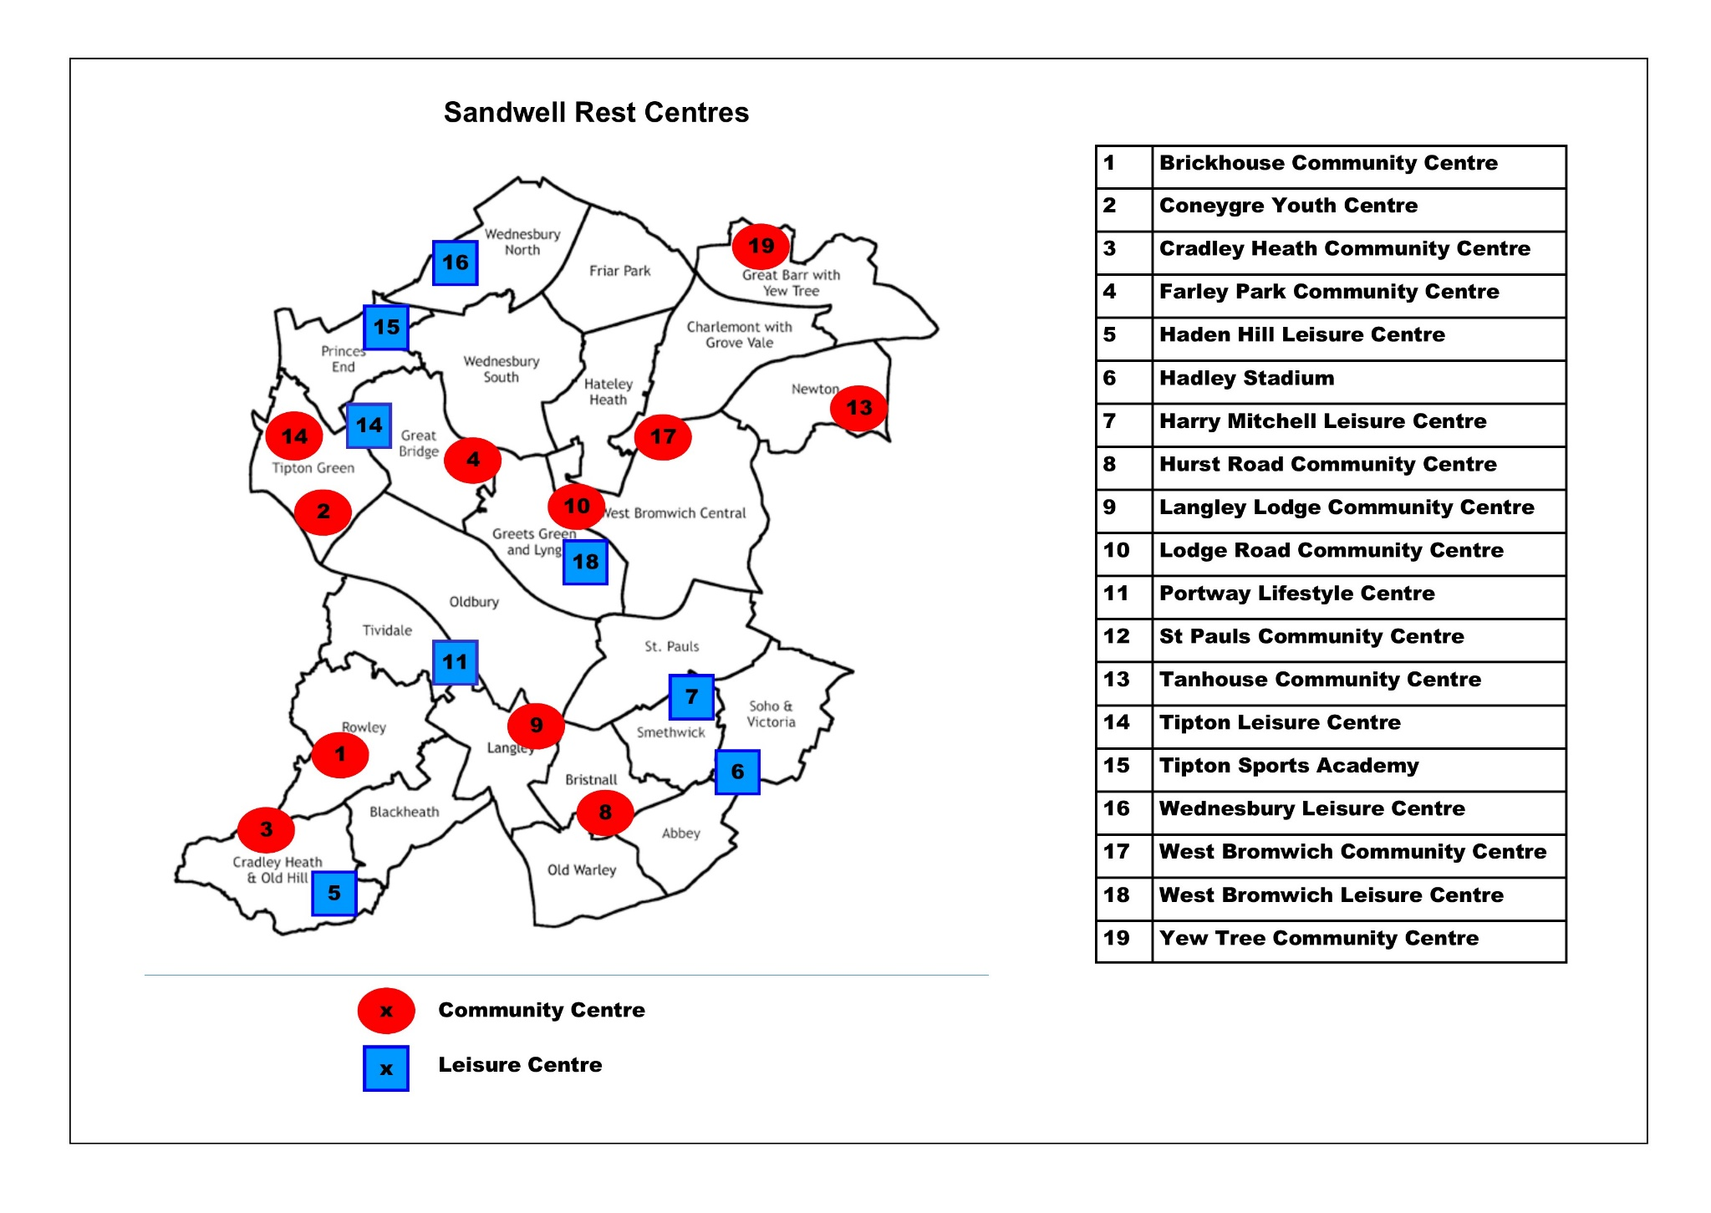

**Rest Centre Page**

1. Brickhouse Community Centre - Rowley Regis 17
2. Coneygre Youth Centre - Tipton Green 19
3. Cradley Heath Community Centre - Rowley Regis 21
4. Farley Park Community Centre - Great Bridge **\*** 23
5. Haden Hill Leisure Centre – Cradley Heath (Closed until 2027) 25
6. Hadley Stadium - Soho and Victoria **\*** 27
7. Harry Mitchell Leisure Centre - Smethwick 29
8. Hurst Road Community Centre – Bristnall **\*** 31
9. Langley Lodge Community Centre - Langley **\*** 33
10. Lodge Road Community Centre - Greets Green and Lyng 35
11. Portway Lifestyle Centre - Tividale 37
12. St Pauls Community Centre - Tipton Green 39
13. Tanhouse Community Centre - Newton 41
14. Tipton Leisure Centre - Tipton Green **\*** 43
15. Tipton Sports Academy - Princes End 45
16. Wednesbury Leisure Centre 47
17. West Bromwich Community Centre - Charlemont with Grove Vale 49
18. West Bromwich Leisure Centre – Greets Green & Lyng 51
19. Yew Tree Community Centre - Great Barr with Yew Tree **\*** 53

**\*** Not suitable for overnight accommodation.

## Rest Centre Profiles

The following pages (17-54) have been redacted

**+**

## Additional Considerations

Consideration should be given to the following areas:

**Housing**

If overnight accommodation is required, the DEPO will contact Housing Solutions to attend the Rest Centre.

**Crisis Care/Support**

Immediate support for the public will be available via the Red Cross who will be on site and Sandwell Council’s Social Care teams who are available 24 hours.

**Disability**

All rest centres have accessible toilets and wheel ramp access to ensure that the meets of people with disabilities are met if possible. The Rest Centre staff should make all practicable efforts to support people with disabilities and any issues should be fed back to the DEPO.

**Protected Characteristics**

The Equality Act 2010 provides protection from discrimination for protected characteristics. Rest Centre staff should consider reasonable arrangements where necessary to meet the needs of individuals. It is expected that all staff be sensitive and respectful to the dignity of members of the public and concerns are fed back to the DEPO.

**Pets**

If a pet area is required, the council’s Dog Warden may be contacted for advice/assistance. Requirements may include:

* sawdust,
* animal waste bags,
* old newspaper/cardboard boxes,
* water/feeding bowls,
* pet food.

The council’s Dog Wardens can be contacted via Serco’s emergency contact number, held by the Duty Emergency Planning Officer. For further assistance contact could be made with the RSPCA or a local vet. To report a stray dog**call Noah's Ark on**0333 577 5070.between 9am and 5pm Monday to Friday. Outside these hours, and on weekends or bank holidays, please call 01733 740426

**Management of pets in the centre**

Assign one staff member during each shift for the focal point for pet management and queries.

The **supervision of pets** is the responsibility of the pet owner. Whilst house-trained pets are generally suitable for rest centres, consider that they may experience stress due to the unfamiliar environment. In such circumstances, unpredictable behaviour may be expected.

If an animal is **injured or becomes ill** while at the Rest Centre.

• Ask the owner to contact their vet and ask advice. Owners can leave the rest centre to take their animal to the vet.

• Ring one of the 24 hour animal hospitals listed below. If necessary, arrange a taxi to take the owner and pet to the hospital. The owner is responsible for the costs of transport and

treatment.

• If the pet is not registered to a vet, contact the council’s Dog Warden Service who may be able to assist with their emergency vet cover. The owner will be responsible for the costs.

• In an emergency contact the RSPCA on 0300 123 8585

It is essential that the arrangements for pets and animals are clearly agreed with the building owner. Some have secure areas outside that can be used for pets. Check with the building’s facilities management on arrival. Pet management guidelines for rest centres can be found in APPENDIX G.

**Media**

A major incident will attract regional, national and possibly international media attention. During a major incident, West Midlands Police will implement the media element of their Major Incident Plan to manage such interest and will take the lead on dealing with the Media. It is recommended that the Local Authority Press Officer is advised of the incident at an early stage and will act as the co-ordinator of information about the Rest Centre.

If the Police’s Major Incident Plan is not implemented, all media enquiries will be dealt with by the council’s Communications Team or Duty Press Officer (out of hours), in consultation with the DEPO. Consider the following:

* Locating the council’s Duty Press Officer at the Rest Centre to handle inquiries, if media are on site.
* allocating a room or area for Press/Media; under no circumstances should they be allowed access to the Rest Centre facilities or the Evacuees.
* liaising between the Media and the Evacuees.
* providing support during any interviews.

Further information can be found in Sandwell’s Media Crisis Plan.

**Infection Control**

There may be occasions where rest centre managers may need to manage infection control in a rest centre building. This may include encouraging/promoting of hand washing, the use of hand gels and wiping down surfaces. In addition to this, the Public Health department may provide a Risk Assessment which will be based on the specific infection/disease. Furthermore, during a pandemic or a national infectious disease, rest centre managers/officers should adhere to any guidance set by the government.

**The Resilience Team holds a small stock of infection control PPE in the bunker.**

### Emergency Prescriptions Access

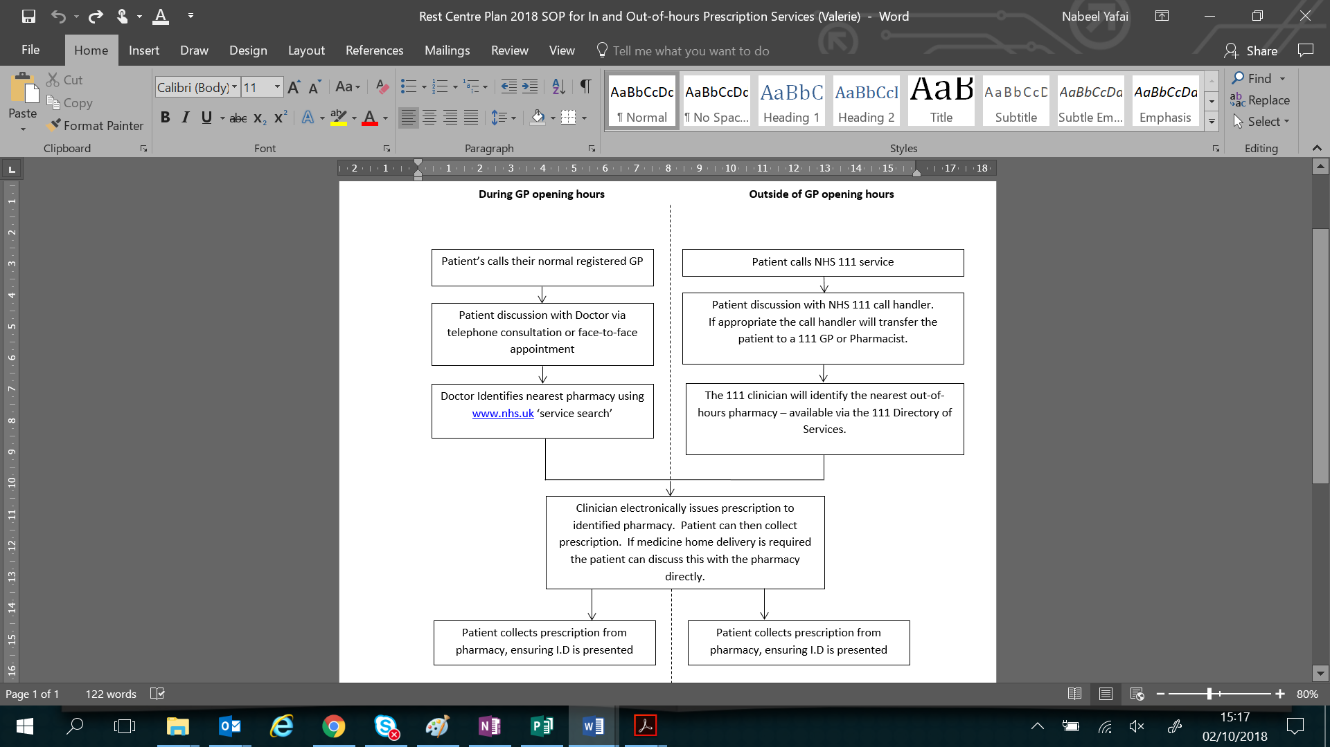

**Note:** Individuals who are not registered with a GP, i.e. overseas travellers, should contact NHS 111.

**Faith Requirements**

The Needs of Faith Communities in Major Emergencies (Cabinet Office, 2005) provides the following information. This is not an exhaustive list of faiths or needs; however, it does reflect the religions on the census conducted within the borough.

|  |  |
| --- | --- |
| **Buddhism** | |
| Dietary | Buddhists are usually vegetarian but may eat meat as an individual choice. On ‘special days’ food will be taken before noon but not afterwards. In addition, some days are set aside for fasting. |
| Worship | Ideally a quiet space should be set apart for Buddhists to meet together for meditation and prayer. |
| **Christianity** | |
| Medical | Medical treatments such as blood transfusions, surgery, or the administration of drugs are permissible; where possible, consent should always be sought. Some Christians require medical examinations to be completed by a person of the same sex, unless this is not possible due to the circumstances or need for rapid treatment. |
| Worship | A quiet area would be appropriate. Sunday remains a special day, set apart from the rest of the week for prayer, reflection and church. |
| Other | Some may observe strict rules about their behaviour which may require them to eat separately from everyone else. Christians who are injured or distressed may wish to receive Holy Communion and/or the Sacrament of the Sick. |
| **Church Of Jesus Christ Of Latter-Day Saints (Mormons)** | |
| Medical | Necessary emergency medical treatment should be carried out without delay. Blood transfusions and surgery, as well as all other medical treatment deemed necessary are appropriate. Organ donation and organ transplants are an individual decision. May wear a special undergarment next to their skin, this should be treated with respect, but may be removed for medical treatment. |
| Worship | A quiet, private place is appropriate for a blessing. |
| Other | Prohibits: alcohol, tea, coffee, tobacco and non-prescription drugs. |
| **Hinduism** | |
| Medical | To save life Hindus are permitted to receive blood and organ transplants and medicines of all types. |
| Dietary | The majority are vegetarians, who do not eat eggs or fish. They require cheese which is vegetarian, and many avoid meals cooked with onions, garlic or vegetables that grow under the ground. Non-vegetarians will still not eat beef as the cow is seen as a sacred animal in India. |
| Worship | Most Hindus would like to have a mala (rosary) to pray with. A Hindu will welcome conversation, preferably with someone of the same sex. |
| **Islam** | |
| Medical | Life-saving considerations take precedence over all Islamic religious duties. Medical treatment, such as blood transfusions, surgery or administering drugs are allowed, if death has not occurred. For transplants consent is required. |
| Dietary | Fasting during Ramadan; exceptions include the very old or young, people with disabilities or illness and woman during pregnancy/breast feeding.  Practising Muslims adhere to strict dietary requirements - Pork or related products and alcohol are strictly forbidden. Halal (permissible food and drink) - all kinds of fish, vegetables and fruits. Lamb, beef and chicken is only Halal if animals have been correctly slaughtered under Islamic Law. Haram means forbidden; Halal and Haram foods should never be mixed during preparation or handling. |
| Worship | Pray five times a day facing Makkah (south-east) in an empty/clean space. |
| Other | Comforting by way of touching or hugging by the opposite sex is not allowed, except for blood relatives. If shock is severe, group Muslims together apart from non-Muslims.  Individual survivors (if strangers) must be grouped by sexes. Muslims under normal circumstances do not intermingle with the opposite sex. |
| **Jehovah’s Witnesses** | |
| Medical | Jehovah’s Witnesses object to elective termination of pregnancy and allogeneic blood transfusion; they will sign hospital forms to confirm this. Baptised Jehovah’s Witnesses usually carry an Advance Medical Directive/Release document directing that no blood transfusions be given under any circumstances. A more detailed Health Care Advance Directive form outlining personal treatment choices may also be carried.  Hospital Liaison Committees are trained to facilitate communication between medical staff and patients and are available night or day, to assist with difficulties either at the request of the treating team or the patient. |
| **Judaism** | |
| Medical | All obligations of the Sabbath may be put aside if life is threatened. Blood transfusions and essential treatments should be completed without delay. |
| Dietary | Fish must have both fins and scales. Shellfish is not permitted. Meat must come from correctly slaughtered ruminant animals - cows, sheep, goats and deer. Chicken and other birds must also be correctly slaughtered.  Food and drink containing both meat and dairy may not be cooked or eaten together. Dairy may not be eaten after a meat meal; most observant Jews will wait 3-6 hours before dairy is consumed. On certain occasions Jews may undertake fasting. |
| Other | The Sabbath (Shabbat) begins at sunset Friday and ends an hour after sunset Saturday. During this time, religious Jews do not travel, use the phone, write, use electrical equipment, and cook.  Very orthodox followers avoid physical contact with the opposite sex. Comforting by means of touching will not be welcomed. |
| **Rastafarianism** | |
| Dietary | Rastafarians do not eat pork or fish with scales.  Most Rastafarians are vegetarian and eat mainly organic food. |
| Worship | Worship includes prayer, singing, drumming, and reasonings (discussions). |
| **Sikhism** | |
| Medical | There are no religious objections to blood transfusions, blood products or transplants. Decisions regarding organ donation rests with the individual. In the absence of any close relatives, a Medical Officer in charge may take whatever action necessary in order to save life. |
| Dietary | There may be some non-vegetarian Sikhs, but in an emergency situation it is best to serve vegetarian food (excluding fish and egg) as this will cater for the needs of all Sikhs. Dairy produce is acceptable, if it is free from animal fat, for instance any cheese served should be one made with non-animal rennet.  Sikh gurdwaras (places of worship) may be able to assist with catering, as they are accustomed to providing large amounts of vegetarian food through the practice of langar (hospitality for all). |
| Worship | Set prayers are said daily in the morning, evening and at night before going to sleep. |
| Other | Sikh males and females, particularly those who have taken Amrit, always wear the following articles of faith popularly known as the Five Ks: Kesh (unshorn hair), Kangha (comb), Kara (iron wristlet), Kirpan (sword), Kacherra (a pair of shorts tailored in a special manner).  The use of tobacco or alcohol in any form is strictly forbidden to the Sikhs. It is therefore extremely important that they are accommodated in places where smoking or consumption of alcohol is not permitted.  According to Sikh etiquette, comforting a member of the opposite sex by physical contact, for example touching or hugging, should be avoided unless the persons are closely related. |

## Rest Centre Stand Down

The standing down of a Rest Centre will be coordinated by the Rest Centre Manager following consultation with the Duty Emergency Planning Officer (DEPO) and the Police (as appropriate).

The following points will be considered prior to standing down the Rest Centre:

* Has the incident been brought under control?
* Is it safe for evacuees to return their own homes and the area affected?
* by the incident?
* Will the incident continue for such a period that overnight accommodation should be arranged?

Closure will be easier and safer during daylight hours than in hours of darkness. If homes have been damaged or destroyed; in the short term, the DEPO or Housing Options Team will arrange for overnight accommodation at a hotel, longer term the relevant housing association or appropriate council services would assist in temporary accommodation or relocation.

**Stand Down Arrangements**

Each organisation represented at the Rest Centre will be responsible for standing down their personnel.

The Evacuees at the Rest Centre will be informed of the incident stand down and rest centre closure by rest centre staff and Police Officers (depending on their presence).

The wider public will be informed of stand down of the incident via the local media; the council’s Duty Press Officer will liaise with the Police regarding press releases.

**Closure Tasks**

The following tasks should be completed prior to, during or shortly after the closure of a Rest Centre; by the appropriate persons.

The Duty Emergency Planning Officer (DEPO) will:

* inform the council’s Duty Press Officer of the closure, and request they notify the local media,
* arrange for return transportation for the Evacuees,
* thank all internal and external staff involved for their help,
* check the contents of the Rest Centre box against the kit list and arrange to replenish items as necessary,
* arrange an initial debrief (debrief forms) or a formal debrief of the Rest Centre staff, as required.

The Rest Centre Liaison Officer, Rest Centre Manager and Staff (British Red Cross) will:

* notify the Evacuees of the closure and assist with any queries – signpost if required,
* hand out feedback forms to members of the public,
* ensure the Rest Centre is clean and every effort has been made to restore it to its original state at the end of the occupancy,
* return equipment and furniture to their original place
* all reports and records have been collated
* inform the DEPO when closure of the Rest Centre is complete
* submit all invoices as soon as possible directly to the Resilience Team.

Facility Staff will:

* compile a list of any breakages or damage to enable repair or replacement,
* submit all invoices as soon as possible directly to the Resilience Team.

**Debrief Arrangements**

Every incident generates operational issues, and as a result, there may be areas to be addressed, both internally for each organisation and as part of the overall planning process.

Following a large scale or long-term evacuation the council’s Resilience Manager will coordinate a multi-agency debrief with a view to validating the arrangements contained within this plan. Responders will hold their own operational debrief after an incident, and as required internal working procedures will be updated to reflect any issues encountered.

Where circumstances allow, the Rest Centre Team should be debriefed before they leave the Centre. Where this isn’t possible, a debrief form (Appendix E) will be given to all staff involved at the earliest opportunity, to enable them to make any comments.

Arrangements will also be made to enable the general public to provide feedback and comment (Appendix F); this process may include Elected Members from the relevant areas.

Rest Centre Operation

# Activation Procedures

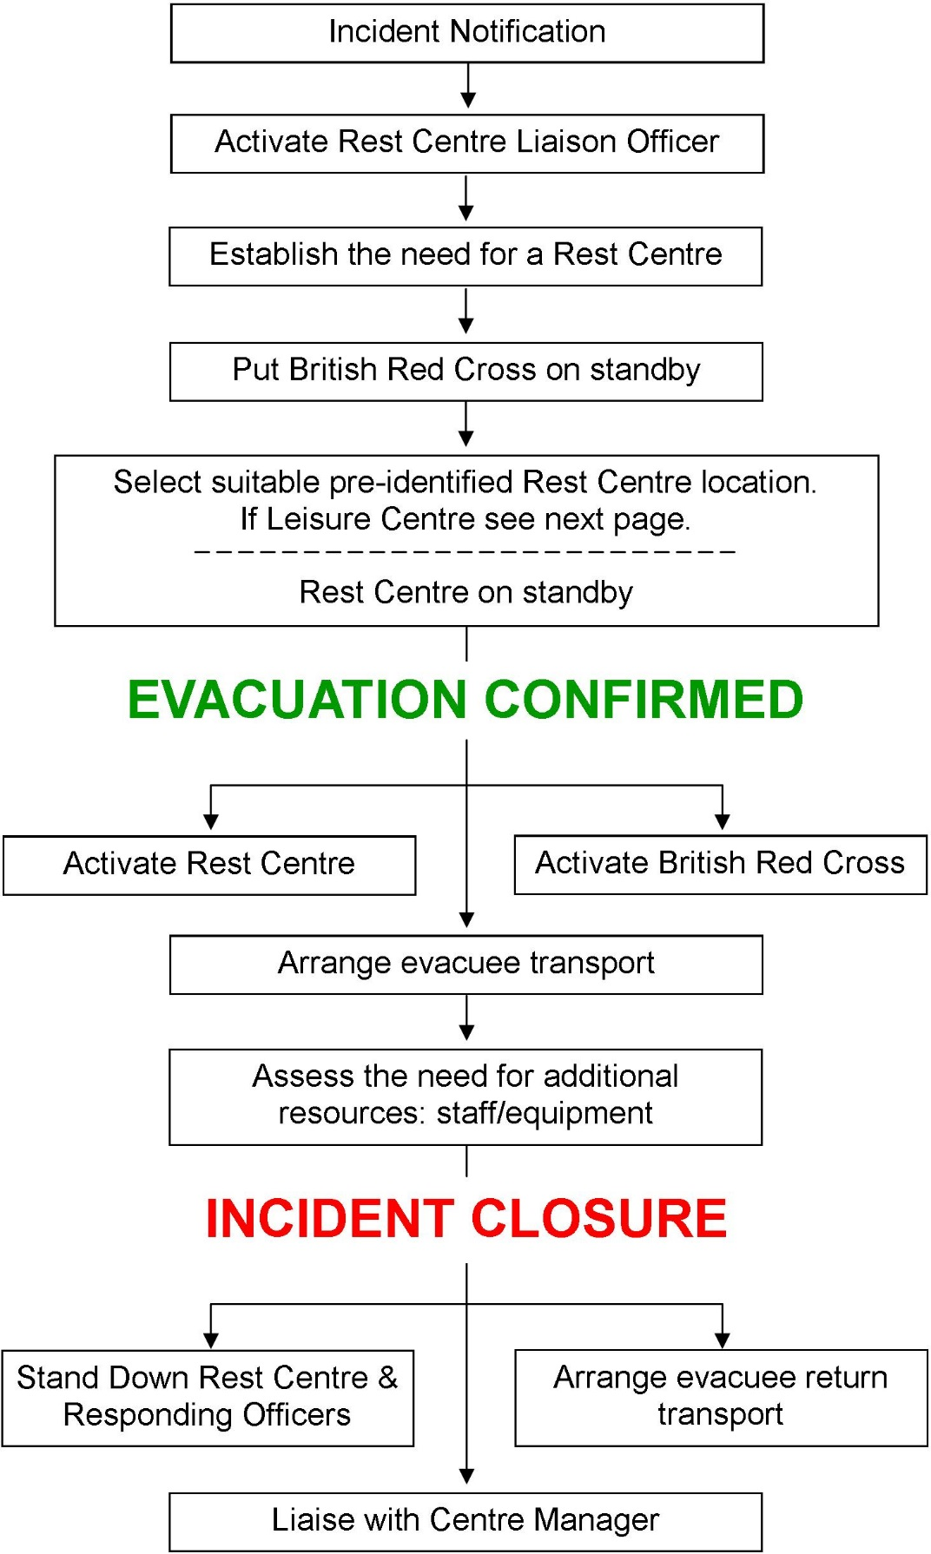

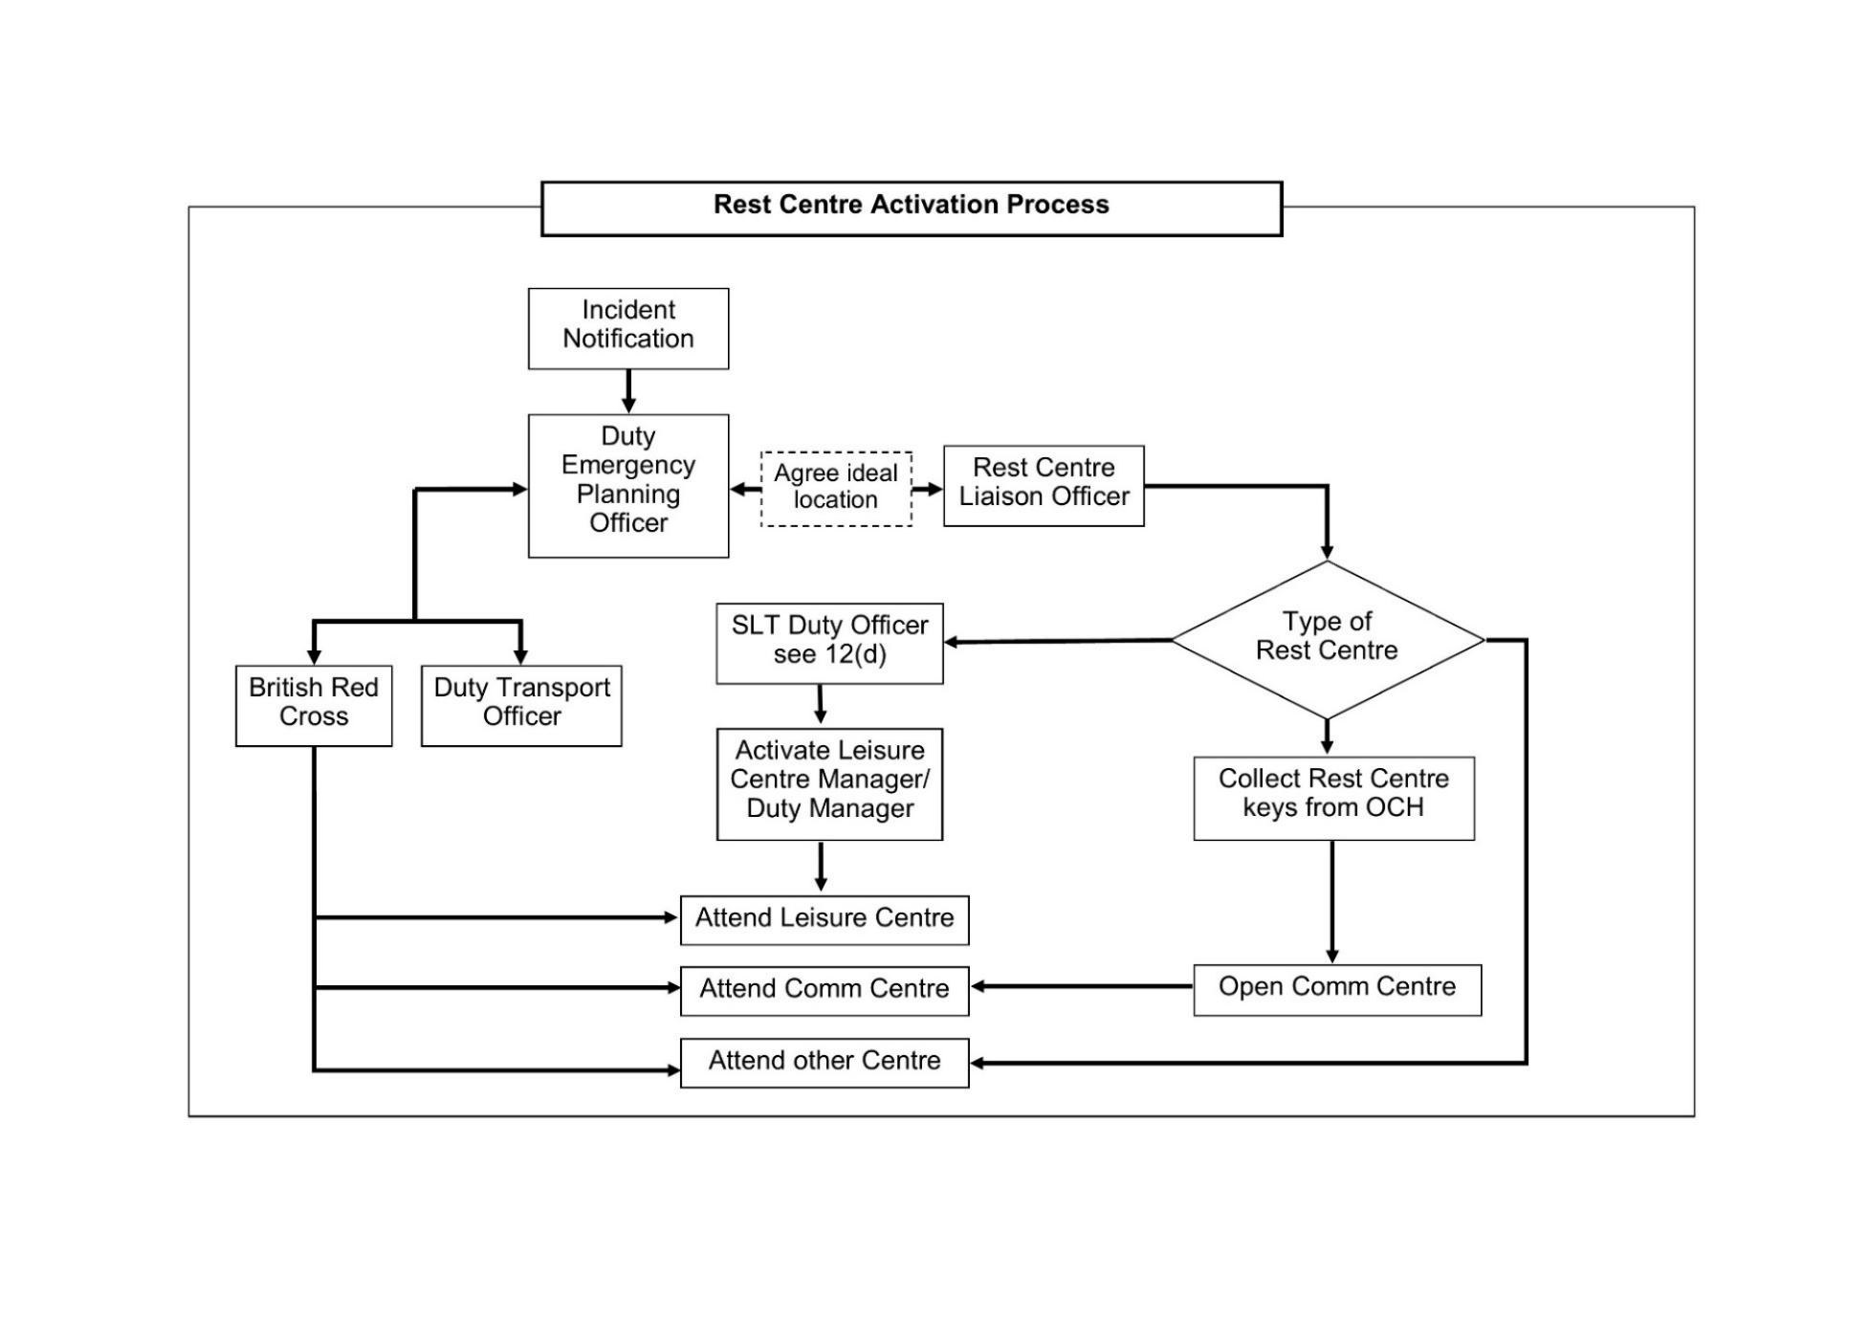

**Evacuation**

In most circumstances, the Police and/or Fire Service have the responsibility for deciding to evacuate people. The Police should contact the council’s Duty Emergency Planning Officer (DEPO) direct, or via Community Alarms. The Duty Emergency Planning Officer will then contact all agencies likely to be involved through the normal channels.

The Police will usually select an evacuation assembly point, inform the public of the situation and advise the Duty Emergency Planning Officer, or the local authority Forward Liaison Officer if already on site.

**Initial Actions**

The Duty Emergency Planning Officer will assess the incident and seek information from responding partners on:

* name and details of emergency service contact, together with the control room incident reference number.
* location of the incident including postcode.
* its nature and estimated duration.
* the number of people actually or potentially involved, and their locality.
* the type of evacuees expected (any particular needs or requirements).
* transportation requirements.
* the length of time for which the Rest Centre facility is required, if known.
* the estimated time of arrival of the first evacuees at the Rest Centre premises.

**Choice of Rest Centre**

Responsibility for deciding which premises will be opened as a rest centre lies with the Duty Emergency Planning Officer, after appropriate consultation. The choice of rest centre will depend on the information provided and their proximity to the scene of the incident (not within any established cordons). Once a decision has been made, the Duty Emergency Planning Officer will advise the Police.

**Notification**

If an incident occurs and it is likely that a rest centre will be required, the DEPO will initially contact both the Rest Centre Liaison Officer (RCLO) and British Red Cross to place them on standby, as described below. This is so that preparations can be made to establish staff availability/resources and an ETA to the chosen rest centre in the event of activation.

* **Standby** – Establish availability. Partners should make their own preparation arrangements in case they are required to assist. For example, BRC will contact volunteers to check staff availability and vehicle availability if required.
* **Activate** – Evacuation has been confirmed and Partners should deploy staff/resources to the chosen rest centre. The DEPO will advise BRC what will be required, i.e. beds, staff assistance with running the Rest Centre etc.

**Rest Centre Activation Timeframe**

We aim to open a rest centre as soon as practicable and would expect to have a rest centre capable of receiving evacuees within 2 hours of a **request** / **notification**. However, a precise timescale cannot be given due to numerous influencing factors such as:

* Time of the incident (i.e. outside office hours)
* Type of Incident
* Incident location
* Notification delays
* Number of evacuees

**Initial Evacuation Facility**

In some situations, the Police may decide to open a nearby building as an initial evacuation facility, in order to get the evacuees quickly away from the incident to a place of safety, without reference to the Duty Emergency Planning Officer. If these premises are deemed suitable for longer term use by the Duty Emergency Planning Officer, staff and resources will be deployed to the site. If the facility is unsuitable, arrangements will be made to transport evacuees to an alternative rest centre.

**Rest Centre Key Location (Community Centres)**

The Rest Centre bag is kept at Sandwell Council House (Oldbury) for ease of access. Sandwell Council House can be accessed 24/7. The Rest Centre bag contains all the keys and access instructions for all the community centres in Sandwell which are utilised as rest centres. The locker is located on the Ground Floor (please see access details and image below of location).

**-----------------------------------------------------------------------------------------------------------------------------**

**\*\*\* Confidential - for Rest Centre Liaison Officers & Resilience Team only \*\*\***

**Locker Number: REDACTED**

**Locker Code: REDACTED**

**-----------------------------------------------------------------------------------------------------------------------------**

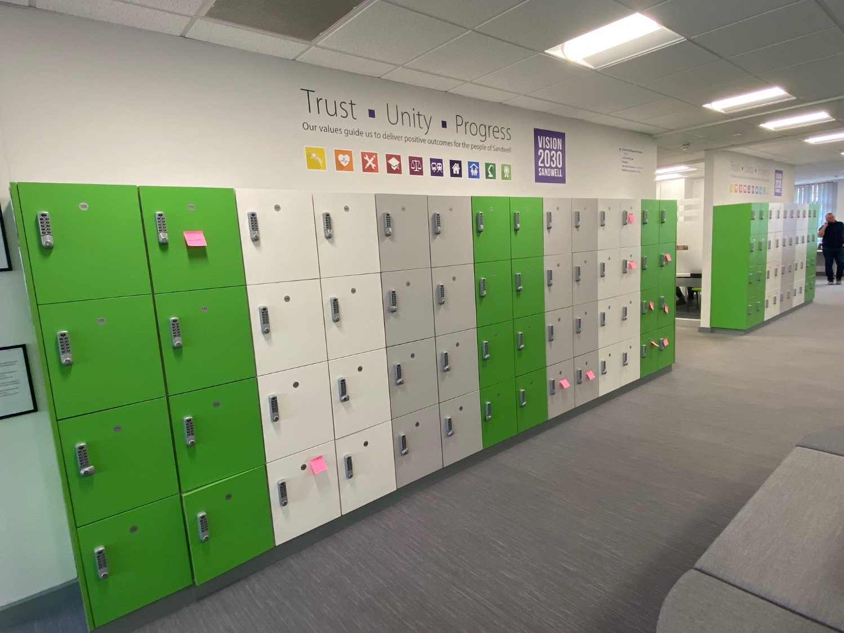

## Appendix A Rest Centre Box Equipment List

|  |  |  |  |  |  |  |
| --- | --- | --- | --- | --- | --- | --- |
| **Item Description** | **Standard**  **Quantity** | | **Present?** | **Replace Before** | **Checked by** | **Date** |
| **SETTING UP** | | | | | | |
| Assorted Signage | 1 Pack | |  |  |  |  |
| Laminated Floor Plan | 1 | |  |  |  |  |
| Laminated Map | 1 | |  |  |  |  |
| Rest Centre Leaflets | 20 | |  |  |  |  |
| Rest Centre Plan | 1 | |  |  |  |  |
| Rest Centre Summary Sheet | 1 | |  |  |  |  |
| Tabards | 5 | |  |  |  |  |
| **REGISTRATION** | | | | | | |
| Initial **\* Registration Forms** **\*** | | 100 |  |  |  |  |
| I/D chains for ID Cards | | 100 |  |  |  |  |
| I/D Plastic Badge Holders | | 100 |  |  |  |  |
| Multilingual Phrase Book | | 1 |  |  |  |  |
| Pick and Point Multi Lingual Card | | 1 |  |  |  |  |
| String Tag Labels | | 100 |  |  |  |  |
| **STATIONERY** | | | | | | |
| Blu-tak | | 1 |  |  |  |  |
| Chinagraph Pencils | | 2 |  |  |  |  |
| Clipboards | | 3 |  |  |  |  |
| Duplication Book | | 1 |  |  |  |  |
| Hard Back Note Book | | 1 |  |  |  |  |
| Hole Punch | | 1 |  |  |  |  |
| Note Pad (A4) | | 2 |  |  |  |  |
| Note Pad (A5) | | 1 |  |  |  |  |
| Pencil Sharpener | | 2 |  |  |  |  |
| Pencils | | 4 |  |  |  |  |
| Pens – Black/Blue | | 5 |  |  |  |  |
| - Green | | 2 |  |  |  |  |
| - Red | | 2 |  |  |  |  |
| Scissors | | 1 |  |  |  |  |
| Sellotape | | 1 |  |  |  |  |
| Sticky Labels | | 1 box |  |  |  |  |
| **MISCELLANEOUS** | | | | | | |
| Animal Waste Bags | | 1 pack |  |  |  |  |
| Bin Liners | | 20 |  |  |  |  |
| Cable Ties | | 1 bunch |  |  |  |  |
| Disposable Gloves | | 1 box |  |  |  |  |
| String | | 1 ball |  |  |  |  |
| Torch | | 1 |  |  |  |  |

**\*** **If additional registration forms or any other stationary is required, more can be sourced from the crash box located in the bunker office at Oldbury Council House** **\***

## Appendix B Multi Agency Roles & Responsibilities

This section outlines the evacuation and shelter responsibilities of the following key organisations:

**Police:** probable evacuation lead, decision to evacuate, informing the local authority, establishing a casualty bureau, assisting with the crime prevention strategy.

**Fire and Rescue Service:** probable evacuation lead, verifying safety of shelter plans, decontamination, urban search and rescue, providing pumping equipment and water rescue for floods, making areas safe for return.

**Ambulance Service:** triage, treatment, and transportation for the casualties and the vulnerable with assistance from NHS and local authorities, including at rest centres.

**Local Authorities:** decision on location of rest centres, transport to rest centres and welfare support (including food and medical). Also, responsible for the safety and preparedness of schools, children’s homes and care homes, public highways that are not motorways or major trunk roads, structural assessment of buildings, the recovery phase and public health advice, advocacy and challenge to protect the health of the population.

**Voluntary and Community Sector:** the LRF representative establishes ongoing links with a wide range of organisations through the Voluntary Sector Civil Protection Forum in order to provide support during incidents and at rest centres.

**UK Health Security Agency?** provision of health advice to the Strategic Coordinating Group.

**Health Sector:** Both NHS England and ICB (Integrated Care Boards), through Primecare (OOH), will provide primary care for the evacuated population working with local authorities to identify and support vulnerable people needing health support. NHS Trusts plans will be activated for the evacuation of hospitals.

**Environment Agency:** preventing and minimising environmental impacts, investigating the causes of incidents, issuing flood warnings, mobilising flood defence assets and providing waste disposal capabilities.

**National Highways:** closing major roads or motorways, dealing with abandoned/damaged cars and providing roadblocks.

## Appendix C Risk Assessment

|  |  |  |
| --- | --- | --- |
| **DYNAMIC RISK ASSESSMENT TEMPLATE** | **ESTABLISHMENT: Designated Rest Centres**  All designated Rest Centres are public buildings with current risk assessments covering their normal business activity. This risk assessment should be seen as additional to cover the change in purpose of the building. | **Risk Assessment Completion** Undertaken by:  Date:  Signed by:  Review Date: |

|  |  |  |  |  |  |
| --- | --- | --- | --- | --- | --- |
| **HAZARD** | **RISK RATING** | **WHAT IS THE RISK? AND WHO MIGHT BE HARMED?** | | **HOW IS THE RISK CONTROLLED?** | **WHAT FURTHER ACTION IS NECESSARY TO CONTROL THE RISK?** |
| Hazard type/description | Likelihood x Severity = Risk  Low (1,2,3)  Medium (4,5,6)  High (7,8,9) | List groups of people who are likely to be at risk from the hazards which have been identified | | List the existing control measures (or where the information can be found) | List the issues linked to the hazard or risk and the action required to eliminate or reduce it. Take cost into account, unless the risk is high |
| **HAZARD** | **RISK RATING** | **RISK** | **GROUP** | **CONTROL MEASURES** | **ACTION** |
| Transportation  Marshalling Area | 4 | Crush to board transport | Evacuees | Police/Forward Liaison Officer (FLO) on scene |  |
| Boarding/ Disembarking | 4 | Slips, Trips and Falls | Evacuees | Accessible buses Police/FLO assistance |  |
| Road Traffic Collision | 4 | Injury/Death | Evacuees | Use of appropriate transport provider/drivers |  |

|  |  |  |  |  |  |
| --- | --- | --- | --- | --- | --- |
| **HAZARD** | **RISK RATING** | **RISK** | **GROUP** | **CONTROL MEASURES** | **ACTION** |
| External Environment  Uneven surface | 2 | Slips, Trips and Falls | Evacuees and staff | Area check before arrival Meet and greeters aware |  |
| Poor lighting | 4 | Slips, Trips and Falls | Evacuees and staff | High visibility jackets Torches |  |
| Poor signage | 8 | Become lost, distressed | Evacuees | Signage to be displayed before arrival Location details in RC box |  |
| Poor access control | 6 | Unauthorised access | Evacuees and staff | Evacuees to be marshalled into the building |  |
| Internal Environment  Poor Hygiene | 4 | Spread of germs/disease | Evacuees and staff | Health and Safety guidelines Regular rubbish disposal |  |
| Equipment Safety | 4 | Injury – inc. electrocution | Evacuees and staff | PAT – Portable Appliance Testing Visual equipment checks of chairs/tables |  |
| Fire Safety | 6 | Unable to exit or fight fire resulting in injury or death | Evacuees and staff | Fire Safety regulations  Inspections | Ongoing visual checks of equipment and exits |
| Overcrowding | 4 | Injury/Safety | Evacuees and staff | Building capacity guidelines First Aid on site | Full use of available space |
|  | 4 | Tensions/ Distress | Evacuees and staff | Quiet Rooms Crisis Support | Request Police presence if available |

## Appendix D Evacuee Information Leaflet

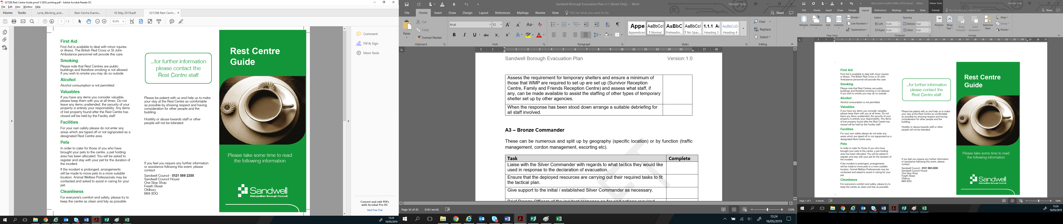

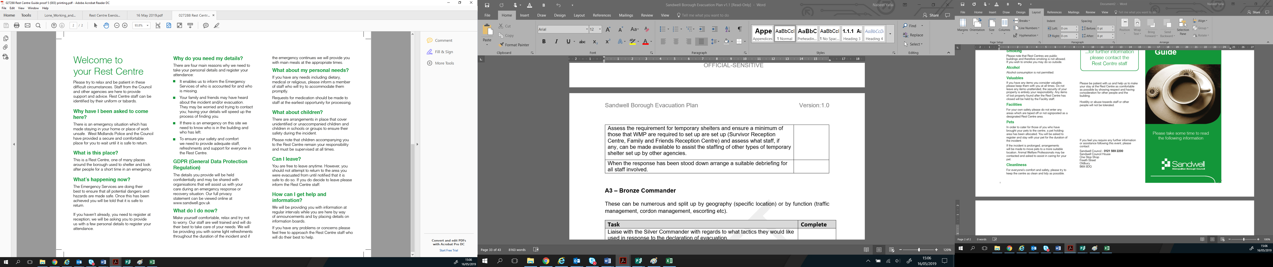

## Appendix E Staff Debrief Form

To help the Resilience Team review the suitability of this Rest Centre facility, the resources provided, and the overall running of the facility please answer the following questions.

Please tick the appropriate box against each of the aspects listed, reflecting your experience during the Rest Centre Operation.

|  |  |  |  |  |  |  |
| --- | --- | --- | --- | --- | --- | --- |
|  | | **Poor** | | **Adequate** | **Good** | **Excellent** |
| **FACILITIES** | | | | | | |
| Access |  | |  | |  |  |
| Suitable Layout |  | |  | |  |  |
| Set Up |  | |  | |  |  |
| Space/Capacity |  | |  | |  |  |
| **REGISTRATION PROCESS** | | | | | | |
| Ease of completion |  | |  | |  |  |
| Documentation relevance |  | |  | |  |  |
| **RESOURCES** | | | | | | |
| Staff numbers | |  | |  |  |  |
| Appropriate staff | |  | |  |  |  |
| Equipment – tables/chairs | |  | |  |  |  |
| Rest Centre Box contents | |  | |  |  |  |
| Timeliness | |  | |  |  |  |
| **REST CENTRE OPERATION** | |  | | | | |
| Internal communication | |  | |  |  |  |
| Coordination | |  | |  |  |  |
| **MULTI AGENCY WORKING** | | | | | | |
| Communication | |  | |  |  |  |
| Cooperation/Support | |  | |  |  |  |
| Information sharing | |  | |  |  |  |

|  |
| --- |
| What Service do you work for? |
| What was your role within the Rest Centre/Evacuation? |
| What short term issues have been identified? e.g. additional contact details |
|  |
|  |
| What long term issues have been identified? e.g. additional training, services/responders |
|  |
|  |
| What improvements could be made to the centre/ response? |
|  |
|  |

|  |
| --- |
| **COMMENTS ON YOUR EXPERIENCE:** |

Please leave your details below if you would like a response or to be contacted:

|  |  |
| --- | --- |
| **NAME:** | **EMAIL:** |
| **ADDRESS:** | **PHONE NUMBER:** |
|  |  |
|  | **THANK YOU** |

## Appendix F Rest Centre Feedback Questionnaire

To help Sandwell Council review the level of support you received during your stay at this Centre please answer the following questions.

Please tick the appropriate box against each of the aspects listed, if applicable, reflecting your experience during your time at the Centre.

|  |  |  |  |  |  |  |
| --- | --- | --- | --- | --- | --- | --- |
|  | | **Poor** | | **Adequate** | **Good** | **Excellent** |
| **ARRIVAL** | | | | | | |
| Transport (if provided) |  | |  | |  |  |
| Building access |  | |  | |  |  |
| **REGISTRATION PROCESS** | | | | | | |
| Easy to understand |  | |  | |  |  |
| Completion time |  | |  | |  |  |
| **FACILITIES** | | | | | | |
| Signage | |  | |  |  |  |
| Toilets | |  | |  |  |  |
| Security | |  | |  |  |  |
| Lighting | |  | |  |  |  |
| Quiet or Faith area | |  | |  |  |  |
| Seating | |  | |  |  |  |
| Overnight arrangements | |  | |  |  |  |
| **SERVICES** | |  | | | | |
| First Aid | |  | |  |  |  |
| Refreshments (dietary needs) | |  | |  |  |  |
| Information – Leaflets, Updates | |  | |  |  |  |
| **STAFF** | | | | | | |
| Helpful | |  | |  |  |  |
| Knowledge | |  | |  |  |  |
| Availability | |  | |  |  |  |
| **REST CENTRE EXPERIENCE** | | | | | | |
| Overall | |  | |  |  |  |

**Monitoring Information**

Please take a moment to fill out the below monitoring information which will enable the council to better understand the needs and concerns of residents during an evacuation and Rest Centre stay.

**Please Tick:**

|  |  |  |  |  |
| --- | --- | --- | --- | --- |
| **SEX:** | FEMALE | MALE | |  |
| **AGE:** | 16-24 | 25-34 | | 35-44 |
|  | 45-54 | 55-64 | | 65+ |
| **ETHNICITY:** | AFRICAN | BANGLEDESHI | | BRITISH |
| CARIBBEAN | CHINESE | | INDIAN |
| PAKISTANI | DUAL HERITAGE | | OTHER |
| **RELIGION:** | BUDDHIST | CHRISTIAN | | HINDU |
| JEWISH | MUSLIM | | SIKH |
| NONE | OTHER | |  |
| **REST CENTRE USAGE:** | INDIVIDUAL | COUPLE | | WITH  CHILDREN |
| **DISABILITY:** Do you consider yourself as having a disability?  **Under the Disability Discrimination Act 1995 the definition of disability is:-**  **“A person has a disability for the purpose of this Act if s/he has a physical or**  **mental impairment which has a substantial and long term adverse effect on his/her ability to carry out normal day to day activities.”** | | | | |
|  | YES | NO |  | |

|  |
| --- |
| **COMMENTS ON YOUR EXPERIENCE:** |

Please leave your details below if you would like a response or to be contacted:

|  |  |
| --- | --- |
| **NAME:** | **EMAIL:** |
| **ADDRESS:** | **PHONE NUMBER:** |
|  |  |
|  | **THANK YOU** |

## Appendix G Pet Management Guidelines for Rest Centres

**Management of pets in the centre**

* Assign one staff member during each shift for the focal point for pet management and queries.
* The supervision of petsis the responsibility of the pet owner.
* While house-trained pets are generally suitable for rest centres, remember that in an emergency, the animal itself will be in an unfamiliar environment and is likely to be stressed, similar to the owner. Consequently, unpredictable behaviour may arise.

**Handling Injured or ill Pets**

If an animal is injured or becomes illwhile at the Rest Centre:

• **Contact the vet:** Ask the owner to contact their vet for advice and potential treatment. Owners can leave the rest centre to take their animal to the vet.

• **24 hour vets:** If necessary, Ring one of the 24 hour vets listed below. Arrange transportation to take the owner and pet to the animal hospital/vets. However, the owner is responsible for any associated costs.

• **Unregistered Pets:** If the pet is not registered to a vet, contact the council’s Dog Warden Service who may be able to assist with their emergency vet cover. The owner will be responsible for the costs.

• **Emergency Contact:** In an emergency contact the RSPCA on [**0300 123 8585**](tel:0300%20123%208585)

• **Reporting a stray dog:** To report a stray dog**call Noah's Ark on 0333 577 5070**

**Pet Registration**

During the registration process, record the details of any pets in the centre. If

possible obtain the following information:

• Name of pet

• Type of pet

• Age of the pet

• Microchip number (if available)

• Name, address, and telephone number of owner

• Any medical or behavioural problems

If an evacuee has left a pet behind and expresses concern about its safety:

• Notify a member of the Resilience Team and ask them to speak to the emergency services and RSPCA.

• If possible and safe to do so, the pet will be collected. The council’s Dog Warden Service has an appropriate van for collection. Call **Tel. 0333 577 5070**

If you require pet foodat the centre, please contact the Resilience Team / DEPO. They may be able to source supplies for you. In an emergency, contact the Dog Warden’s service who may be able to assist. **Tel. 0333 577 5070** (Via Noah’s Ark).

**Moving from the rest centre to temporary accommodation**

It may not be possible to take animals to temporary accommodation if the evacuation becomes long term. You should ensure the Housing Options/out of hours team are aware of people who have pets. Owners should be encouraged to contact boarding kennels as an alternative.

|  |
| --- |
| **List of 24 hour vets in Sandwell:**   * **Vets for Pets:** 139 Hill Top, West Bromwich. Tel. **0121 567 3250** * **YourVetsSmethwick:** 300 Londonderry Lane, Smethwick, B67 7EW. Tel. **0121 516 1999** * **Black Vets in Dudley:** 50A Hall St, Dudley, DY2 7BT. Tel. **01384 252509** (near Tividale and Rowley Regis) |

|  |
| --- |
| **List of vets in Sandwell open during business hours:**   * **Pets at Home:** Unit 6, Oldbury Green Retail Park, Oldbury, B69 3DD. Tel. **0345 600 9544** * **The Veterinary Clinic:** 130 Lodge Road, West Bromwich, B70 8PL. Tel. **0121 553 0070** * **Orchard Veterinary Centre:** 410 Birchfield Lane, Oldbury, B69 1AD Tel. **0121 544 0404** * **Stewart vets – Tipton:** 206 High Street, Princess End, Tipton. DY4 9JB Tel. **0121 522 2118** * **Orchard Veterinary Centre:** 210 Holyhead Road, Wednesbury, WS10 7DQ Tel. **0121 556 6890** |

|  |
| --- |
| **Animal Charities in Sandwell:**   * **Wild Acre Rescue:** 20 High Street, Cradley Heath, B64 5HG Tel. **07581 015789** * **Petsearch rescue West Midlands**: (appointment needed before arrival):Tel. **07462 355 784** * The Animal House Rescue: (serves West Midlands) Tel. **0121 475 8729** |

## Appendix H Rest Centre Role Instructions & Checklist

|  |  |
| --- | --- |
| **Tasks** | **Checklist** |
| Conduct a dynamic risk assessment upon arrival |  |
| Initiate and maintain a Log sheet and ensure that key decisions are logged within a decision log. Document any specific needs or concerns raised by evacuees. |  |
| Establish a communication plan to keep all staff informed of updates & changes (regular check-ins/meetings where possible to ensure smooth operations) |  |
| Carry out a staff briefing prior to rest centre opening and ensure they are briefed on their roles & responsibilities |  |
| Locate the Rest Centre Emergency box and admin documentation |  |
| Assign roles to rest centre staff (recommended numbers):  Registration staff (minimum of 2 staff)  Information Officer x 1  Refreshments handlers (minimum of 1)  Security (minimum of 1) |  |
| Maintain a volunteer sign-in/out sheet |  |
| Ensure there is a staff rota, ensuring staff members are having regular breaks |  |
| Ensure evacuation points are made clear to both staff and the public using the building |  |
| Ensure the following facilities have been sign posted around the rest centre:   * Toilets * Pet friendly area * Refreshments * Quiet zone / multi-faith room * Sleeping location * Childrens play zone * First Aid Room |  |
| Ensure an information point/desk is set up preferably in evacuee seating area, to keep evacuees updated and assist with enquires, (i.e. utilise a Whiteboard/flip chart, whichever is available) |  |

Appendix I **Rest Centre Facilities checklist**

Please note that the following checklist is not exhaustive, and adjustments may be necessary based on specific incident and evacuee needs. The list serves as a fundamental guideline for essential facilities within a Rest Centre.

|  |  |
| --- | --- |
| **Rest Centre Facilities** | **Checklist** |
| 1. Quiet room / multi-faith room |  |
| 1. Command & Control – Staff/volunteers meeting room & rest area, rest facilities |  |
| 1. Animal friendly zone if required (consider zone outside of building if possible) |  |
| 1. Children play area (indoor/outdoor) |  |
| 1. First Aid room |  |
| 1. Changing rooms (particularly important for overnight stay) |  |
| 1. Security provisions  * initially council staff/volunteers * followed by council security staff |  |
| 1. Kitchen area |  |

Appendix J **Rest Centre Role Instructions & Checklist**

Rest Centre Manager / Rest Centre Liaison Officer (RCLO):

|  |  |
| --- | --- |
| **Tasks** | **Checklist** |
| Conduct a dynamic risk assessment upon arrival |  |
| Initiate and maintain a Log sheet and ensure that key decisions are logged within a decision log. Document any specific needs or concerns raised by evacuees. |  |
| Establish a communication plan to keep all staff informed of updates & changes (regular check-ins/meetings where possible to ensure smooth operations) |  |
| Carry out a staff briefing prior to rest centre opening and ensure they are briefed on their roles & responsibilities |  |
| Locate the Rest Centre Emergency box and admin documentation |  |
| Assign roles to rest centre staff (recommended numbers):   * Registration staff (minimum of 2 staff) * Information Officer x 1 * Refreshments handlers (minimum of 1) * Security (minimum of 1) |  |
| Maintain a volunteer sign-in/out sheet |  |
| Ensure there is a staff rota, ensuring staff members are having regular breaks |  |
| Ensure evacuation points are made clear to both staff and the public using the building |  |
| Ensure the following facilities have been sign posted around the rest centre:   * Toilets * Pet friendly area * Refreshments * Quiet zone / multi-faith room * Sleeping location * Childrens play zone * First Aid Room |  |
| Ensure an information point/desk is set up preferably in evacuee seating area, to keep evacuees updated and assist with enquires, (i.e. utilise a Whiteboard/flip chart, whichever is available) |  |

**Registration Staff:**

|  |  |
| --- | --- |
| **Tasks** | **Checklist** |
| Ensure **registrations forms** are readily available on the registration table |  |
| Ensure **Rest Centre Information leaflets** are on the registration table for distribution to evacuees. |  |
| Ensure the **multi-language phrase book** is easily accessible |  |
| Have **lanyards** set up, ready to be issued out to evacuees. |  |
| Note any **special needs** identified during the registration process and promptly **notify the Rest Centre Manager** |  |
| **Document Collection:** Ensure all completed forms are collected and passed to the Rest Centre Manager in a timely manner |  |
| ***Note:*** *This checklist guides Registration Staff in carrying out essential tasks for a smooth registration process. Flexibility and adaptability may be required depending on the specific circumstances of the incident and evolving needs.* |  |

**Information Officer:**

|  |  |
| --- | --- |
| **Tasks** | **Checklist** |
| Ensure a clearly visible **Information Point** is set up. |  |
| **Notice board** – ensure the information board displays the Rest Centre name, address and up-to-date information. |  |
| **Information Leaflet Distribution** - Check that evacuees are being provided with the information leaflet. Ensure the leaflet is placed on the **registration table** for easy distribution as evacuees enter the Rest Centre.. |  |
| **Regular Information Updates:**  Conduct regular updates at the **Information Point** to inform evacuees about the ongoing situation, available services, and any changes within the Rest Centre. |  |
| Display essential emergency contact information prominently at the Information Point. |  |
| ***Note:*** *This checklist outlines the key tasks for the Information Officer to ensure effective communication and the provision of essential information within the Rest Centre. Adjustments may be necessary based on the unique circumstances of the incident and the evolving needs of evacuees.* | |

### **Appendix K – Rest Centre Roles and Responsibilities**

**Duty Emergency Planning Officer (DEPO)** Coordination of response and resources

* Ascertain details of the incident: number of people to be cared for and the expected duration as soon as possible.
* establish whether the Police will have overall control (Survivor Reception Centre/Family Assistance Centre) or whether the Local Authority will have overall management control (Rest Centre).
* ensure that arrangements to open premises have been activated, and record in the Log Sheet the action taken.
* notify the British Red Cross to manage the Rest Centre.
* make arrangements to locate the Rest Centre Resources Box and administrative documentation at the premises.
* ensure arrangements are in hand for the provision of services, being available in time for the arrival of the evacuees.
* make all necessary resources available and take action to meet any shortfalls.
* ensure ongoing communication with the Forward Liaison Officer and the Rest Centre.
* consider maintaining a rota of staff and volunteers for the duration of the incident.
* provide the staff and public with information as it becomes available, if appropriate.
* refer media interest to the Police or the Local Authority Duty Press Officer.
* adhere to the control measures outlined in the Risk Assessment (Appendix C).
* consider the security of the Rest Centre.

**Forward Liaison Officer (FLO)**

|  |
| --- |
| In the event that the FLO is at the Rest Centre rather than at the scene of the incident, they should assist in the completion of any tasks to support the operation.   * Ensure that the Duty Emergency Planning Officer is kept up to date to facilitate distribution of SitReps. * refer media interest to the Police or the Local Authority Duty Press Officer. * adhere to the control measures outlined in the Risk Assessment (Appendix C). * complete all FLO roles and responsibilities as per attending the scene of an incident. * Whilst reporting to the DEPO they may take direction from the Rest Centre Manager. |

**Rest Centre Liaison Officer (RCLO)**

|  |
| --- |
| * Identify the most appropriate rest centre facility in consultation with the Duty Resilience Officer. * ensure the Rest Centre facility is opened in as timely a manner as possible. * locate the Rest Centre Box and administrative documentation at the premises. * work with the British Red Cross to identify the facilities required at the Rest Centre and allocate the space available. * If feeding is required for displaced persons, coordinate with the local facility and or the Salvation Army. For larger food needs (i.e., a greater number of evacuees), contact the Rapid Relief Team (RRT), which has a 2-hour response time for providing hot meals, both during and outside of business hours (Red Tent Events). Please note however, that food boxes require a 2-hour approval time and an additional 3-hour response time for delivery. * maintain the security of the Rest Centre. * ensure that the Duty Emergency Planning Officer is kept up to date to facilitate distribution of SitReps. * ensure the following arrangements are satisfactory and monitored: * health and safety, * toilets facilities, * kitchen facilities, * traffic/car parking, * provision for pets, * availability of communications. * refer media interest to the Police or the Local Authority Duty Press Officer. * provide the staff and public with information as it becomes available, if appropriate. * adhere to the control measures outlined in the Risk Assessment (Appendix C). |

**Rest Centre Manager and Staff – British Red Cross**

|  |
| --- |
| * Conduct a dynamic risk assessment upon arrival. * Ensure that you are clearly identifiable as the Rest Centre Manager and that all staff wear tabards and identification badges. * initiate and maintain a Log Sheet to record decisions/actions. * identify the required facilities at the Rest Centre and allocate the space available in accordance with identified requirements. * conduct initial assessments on all evacuees and arrange for the provision of specialised services dependant on individual requirements or observations made. * ensure all evacuees receive the care and attention appropriate to their needs. * consider maintaining a rota of staff and volunteers for the duration of the incident. * ensure refreshment arrangements are made. * ensure the following arrangements are satisfactory and monitored: * toilets facilities, * kitchen facilities, * traffic/car parking, * provision for pets, * availability of communications, * health and safety. * report any issues to the Duty Emergency Planning Officer. * provide the staff and public with information as it becomes available, if appropriate. * refer media interest to the Police or the Local Authority Duty Press Officer, * record outgoing expenditure and incoming donations. * adhere to the control measures outlined in the Risk Assessment (Appendix C).issue debrief forms to staff and evacuees, collect the forms before closure of the Rest Centre. |

**Facility Staff**

|  |
| --- |
| Management and staff from a rest centre facility could support its operation by:   * Locating and collecting the Rest Centre Resources Box from its storage point, prior to the arrival of the British Red Cross or Rest Centre Liaison Officer (RCLO). * maintaining the security of the building and reporting any problems to the Rest Centre Manager or Local Authority contact. * keeping a record of damage or other costs incurred. * referring any media interest to the Police or Local Authority Duty Press Officer. * adhere to the control measures outlined in the Risk Assessment (Appendix C). * ensuring other users of the building are able to use the facilities as normal whilst keeping the Rest Centre areas separate if possible. |

**Registration Officer**

Ensure accurate documentation of all evacuees entering and leaving. Essential to enable missing persons to be identified, families reunited, and information given to relatives.

* Set up registration areas
* A member of staff with complete the form with an evacuee, ideally as soon as they enter.
* Note any special needs and notify the Rest Centre Manager.
* Check forms can be read.
* File registration forms.
* Issue ID Cards/holders.
* Monitor numbers entering.
* Liaise with managers and staff.