Feeding you and your family on a budget

A collection of recipes for feeding a family on a budget shared by our community groups. You can adapt these depending on how many you are cooking for.

Eating on a Budget:

Buying ingredients in bulk may cost more are the time but can save you money in the long run as per 100g they often work out cheaper.
Shopping at specific times of the day can have its benefits especially when purchasing ‘yellow sticker items’. Although these often have a short date (many can be frozen) they offer great discount compared to what you usually would pay.
- By cooking a double portion, you can save money buying ingredients in bulk and then freezing half
- Frozen meals can be easily defrosted and cooked and the whole family can enjoy them
- Frozen food can be good for breakfast, dinner and tea
- Some frozen meal ideas include: lasagne, stew, casserole, cauliflower/ broccoli cheese, pies, pasta sauces, soups, curries, chilli and many more

Healthy Eating:

A healthy diet gives you the right amounts of energy, vitamins and minerals so that your body can work properly. It also helps to reduce the risk of heart disease, diabetes, strokes and certain cancers. For more information on how to eat a healthy, balanced diet see the NHS website https://www.nhs.uk/live-well/eat-well/.
You should try to aim to eat at least five portions of fruit and vegetables a day. Here are some cheaper ways to stock up on fruit and vegetables https://www.nhs.uk/live-well/eat-well/5-a-day-on-a-budget/.

Eating breakfast is a really good way to start your day, the right breakfast provides you with all the nutrient’s and energy you need in the morning and can help prevent unhealthy snacked throughout the morning and can also help increase concentration levels. Here are some great, healthy breakfast ideas https://www.nhs.uk/change4life/recipes/breakfast.

Contents
Useful websites 3
Tasty Tomato Soup 4
Leek and Potato Soup 5
Easy Lentil Soup 6
Golden Vegetable Lentil Soup 7
Easy Peasy Cottage Pie 8
Cottage Pie with Lentils 9
Macaroni Cauliflower Cheese 10
Macaroni and Broccoli Bake 11
Tomato Pasta 12
Lentil Ragu with Pasta 13
Tomato Tuna Pasta Sauce 14
Tuna Pasta Bake 15
Tuna and Mushroom Pasta Bake 16
Sardine and Tomato Pasta 17
Butterbean and Tuna Pasta Salad 18
Mexican Tuna Bean Salad 19
Pilaf 20
Tomato and Chickpea Curry 21
Really Easy Chickpea Curry 22
Peach and Chickpea Curry 23
Easy Lentil Curry 24
Mexican Bean Chilli 25
Butterbean and Mushroom Casserole 26
Sausage and Butterbean Casserole 27
Butterbean and Tomato Stew 28
Moroccan Stew 29
Tinned Pilchard Fishcakes 30
Tuna Sweetcorn Burgers 31

Useful websites
https://www.nhs.uk/start4life/weaning/what-to-feed-your-baby/around-6-months/
https://www.nhs.uk/start4life/weaning/recipes-and-meal-ideas/
https://www.nhs.uk/change4life/recipes
https://www.bbcgoodfood.com/howto/guide/10-easy-budget-family-meals
https://cookingonabootstrap.com/category/recipes-food/
https://www.bbcgoodfood.com/recipes/collection/storecupboard
https://www.netmums.com/life/guide-to-cooking-on-a-budget
https://www.lovefoodhatewaste.com/recipes
https://www.bbcgoodfood.com/recipes/collection/cheap-eat
https://www.bbc.co.uk/food/programmes/b0520lz9/recipes
https://www.healthysandwell.co.uk/our-services/healthy-weight/healthy-eating/

This recipe provides a nutritious soup that is cheap and can be frozen in portions or kept in the fridge for up to 48 hours. It can be served hot or cold, so will warm you up on a winter’s day or provide a refreshing Gazpacho (cold, Spanish-style tomato soup) in summertime.
(Buy cut-price, overripe tomatoes, cucumber and peppers from the supermarket, local fruit and vegetable shop or market stall.
Tomatoes are a good source of vitamin C, which supports immunity, provides anti- oxidants and promotes healthy cell growth. Tomatoes contain many other vitamins and minerals, including iron and vitamin A, as well as lycopene, which supports prostate gland health in men.)

Ingredients:
500g/1lb ripe tomatoes
10cm/4 inches chopped, peeled cucumber 3 chopped spring onions
½ a chopped pepper (any colour combination is fine)
2 peeled and chopped cloves of garlic (or ½ tsp garlic paste) 1 tsp fresh or dried mixed herbs, including thyme and basil 300ml/½ pint cold water
1 tbsp olive oil
1 tbsp white wine or balsamic vinegar (optional) Tomato purée to taste
Ground black pepper to taste

Method:
- Boil a kettle, take a sharp knife and score the tomatoes across and round. Place them in a large bowl and immerse them in the boiling water for 10 minutes.
- Meanwhile, prepare the other vegetables (peel and chop the cucumber, chop the pepper and spring onions).
- Skin the tomatoes and chop them. Discard the seeds, if preferred.
- Put all the ingredients, apart from the purée and black pepper, in a clean, large bowl and mix.
- Either use a hand blender or a jug liquidizer to blend the ingredients into a smooth liquid. Add tomato purée to improve the colour, if desired.
- Divide into 4 portions and store or serve as suggested.
- If serving hot, stir in a pan on a gentle heat for 5 minutes.

This soup is always a favourite and is quick and easy to make. Potatoes are cheap and provide the body with vitamin C and fibre. For this recipe, it is fine to use potatoes that have gone a little soft in the cupboard. Leeks are a tasty alternative to onions and are cheap to buy. They are a good source of B vitamins, which support the nervous system and the formation of new blood cells.
This recipe makes two generous portions so one can be saved for the next day if you are cooking for one, or you could invite a friend for lunch.

Ingredients:
1 medium leek, washed and thinly sliced 225g/½lb finely grated (or chopped) potatoes 600ml / 1-pint milk or vegetable/ chicken stock
A splash of olive oil or a knob of butter/ margarine

Method:
- Heat the oil or butter/margarine in a medium-sized saucepan.
- Add 300ml/½ pint milk, (which makes the soup creamier) (for dairy-free soup, add the stock) and stir.
- Add the chopped leeks and stir until the leeks start to wilt.
- Add the potatoes to the pan and stir until simmering.
- Add the rest of the milk or stock, and a pinch of black pepper to taste.
- Simmer for 20–25 minutes.
- Cool slightly and serve with granary bread.
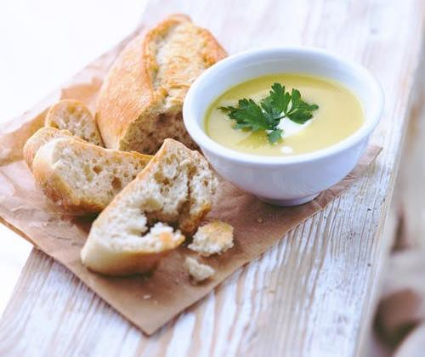

Ingredients:
150g red lentils
6 carrots peeled and chopped
2 medium leeks cleaned and sliced Any leftover bacon or ham if you have it Tablespoon of tomato purée
2 vegetable stock cubes
3 pints boiling water Salt & pepper to taste
Method:
- If you have any bacon or ham fry it up in a pan in a splash of oil until cooked.
- Add the boiling water to the pan then add the stock cubes and allow to melt in the water and then simmer.
- Add lentils and tomato purée to pan and again bring back to boil and allow lentils to soften.
- While the lentils are boiling in pan it is an ideal time to prepare your carrots & leeks (peel and chop the carrots, clean and slice the leeks)
- Add vegetables and any salt or pepper to pan (don't add salt if you use ham for soup as it will make it saltier)
- Bring to boil, turn heat down cover and simmer for 45-60 minutes
- Serve with bread and butter

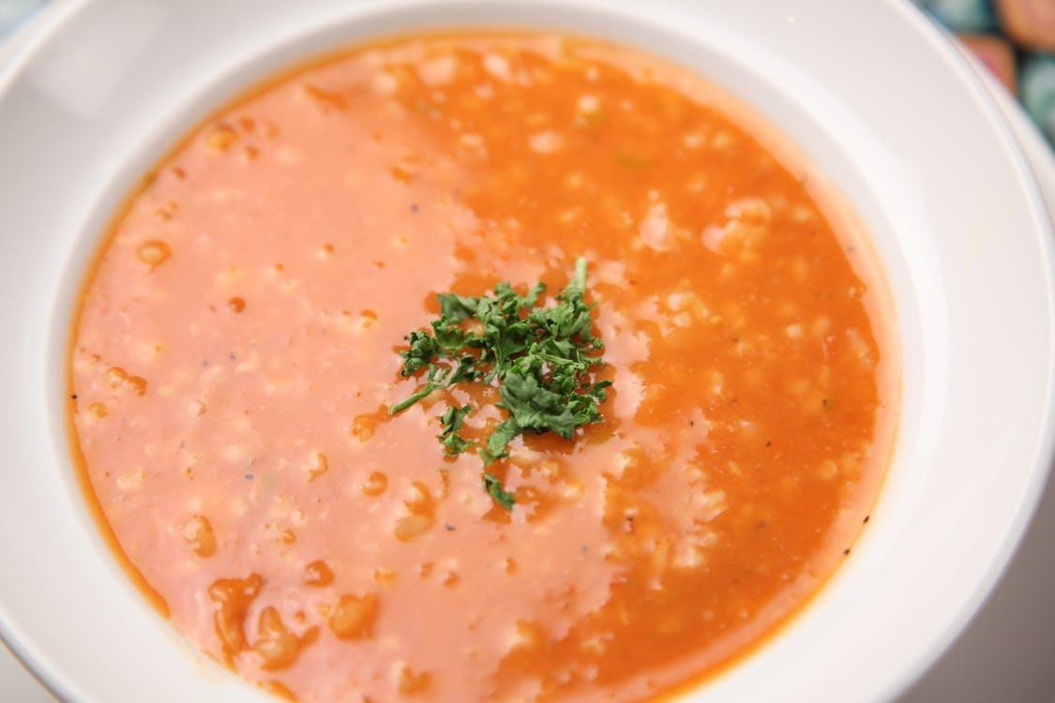

Ingredients:
1 small onion
3 cloves of garlic 2 carrots
200g yellow lentils 1 butternut squash
1/2 tbsp turmeric powder 1/2 tbsp black pepper 1/2 tbsp salt
1 tbsp oil
4 bread rolls Pinch of coriander 400ml water
4 tsp natural yoghurt

Method:
- Peel the onion, cut it in small dices.
- Heat the oil in a saucepan, fry onion with garlic for 5 mins until softened and lightly coloured.
- Add turmeric powder.
- Cut the carrot in small dices, peel the squash, cut it in small cubes, wash and drain the lentils.
- Add vegetables and lentils to the saucepan.
- Add 400ml of boiling water.
- Boil and then simmer for 20 mins.
- When vegetables are soft, and soup becomes thicker, season with black pepper, salt and freshly chopped coriander.
- Serve it with bread rolls.
- To make it look fancy, top it up with swirl of natural yoghurt.

Ingredients:
1 tin of mince and onions 6 small potatoes or Smash 1 tin of tomatoes
3 carrots or tin of carrots 1 tbsp oil
Method:
- Chop the carrots and fry lightly in a saucepan in the oil, add the tinned mince and tomatoes and bring to a gentle simmer to reduce the liquid.
- Meanwhile peel and half the potatoes and boil until soft. Mash these with butter or milk if available. Alternatively make Smash as instructed.
- Put the mince in an oven proof dish and cover with the mash.
- Bake until golden on the top.
- Serve with green vegetables or baked beans.
- Leftovers...- Reheat in the oven or microwave until piping hot.

This recipe uses a small amount of meat, which is partnered with lentils. Lentils are a good
alternative source of protein and are cheaper and lower in saturated fat than meat. The four portions can be divided into individual dishes and extra portions can be frozen to save cooking time and fuel costs on other days.
With the meat/lentils for protein, potatoes for energy release and carrots and tomatoes for vitamins and minerals all in one dish, there is no need to add anything else to have a completely balanced meal.

Ingredients:
110g/4oz lean minced beef 2 finely chopped onions
2 grated carrots
900g/2lb chopped and peeled potatoes 1 large tin tomatoes
50g/2oz red lentils (if they need pre-soaking, follow instructions for soaking before starting the recipe)
1 cup of water Splash of milk
1 vegetable or beef stock cube or 1 tsp yeast extract dissolved in a cup of boiling water
Black pepper to taste

Method:
- Place the minced beef in a saucepan and add a little water or oil.
- Break up and cook until brown, then pour off the fat.
- Add the onion, carrots, tomatoes, pepper and lentils.
- Add the stock, bring to the boil and then simmer for 25–30 minutes, stirring occasionally.
- Meanwhile, boil the potatoes and mash them with a splash of milk.
- Transfer the mince mixture to a large, ovenproof dish (or individual ones if you are going to freeze portions).
- Spread the potato on top.
- Bake in the oven at gas mark 4/200°C for 30 minutes, or until the potato is light brown in
- colour.
- For frozen portions, defrost thoroughly first and then reheat for 30 minutes in the oven.

Ingredients:
300g short pasta, like penne, or macaroni 1 tbsp oil
200g cauliflower, grated or broken into small florets 200g bacon, chopped
2 eggs 200ml milk Black pepper
100g hard, strong cheese, grated

Method:
- Bring a medium saucepan of water to the boil. Add the pasta and reduce to a simmer according to packet instructions, usually around 8 minutes, to cook and soften.
- Meanwhile, gently heat the oil in a large saucepan, then add the grated cauliflower and bacon. You can finely slice the cauli instead of grating it, but the key is to get it into little pieces, so it cooks quickly. If you have a decent blender, you can fling it in raw to pulse it to a fine grain– you’ll lose the ‘cauli cheese’ element of the dish but save yourself some chopping.
- Back to the mac! In a separate bowl, beat together the eggs, milk and pepper. Add a few tablespoons of the pasta cooking water to bring it to a warmish temperature (so it doesn’t turn to startled scrambled eggs when you pop it in the oven) and beat in.
- When the pasta is al dente (cooked firm to the bite), drain it and add to the pan with the cauliflower and bacon. Pour in the egg mixture and mix through.
- Tip the lot into an ovenproof baking dish, top with the grated cheese and bake for 12-15 minutes until the sauce is thickened and the cheese is golden and crispy.

Cooking from scratch means that you can make a healthy version of this dish using low-fat.
ingredients and not adding salt. If you need to put on weight, and do not need to cut out saturated fat, you could use full-fat dairy products.
Macaroni is a slow-release carbohydrate, so as well as being cheap and filling, it also keeps blood sugar levels stable. Cheese and milk contain calcium for healthy bones.
With mature cheddar cheese, a small amount still gives a good flavour. Broccoli is a super-food, full of vitamins and minerals, and one of your five a day. Bacon, which is an optional addition, is fatty and salty, so for a healthier alternative, substitute chicken breast.

Ingredients:
225g/9oz dried macaroni
25g/1oz butter or low-fat margarine 25g/1oz plain flour
300ml/½ pint semi-skimmed milk 35g/1½oz grated, mature cheddar cheese 175g/7oz broccoli
2 tomatoes
Optional: 2 slices of lean back bacon or a chicken breast fillet cut into strips
Method:
- Boil the macaroni in water for about 10 minutes.
- Meanwhile, make a sauce by melting the butter/margarine in a saucepan, stirring in the flour.
- When it is smooth, gradually add the milk, stirring continuously until you have a sauce that is smooth and thick.
- Take off the heat and mix in half the grated cheese.
- Stir the sauce into the cooked macaroni.
- Steam or boil the broccoli for about 10 minutes until the stalks are soft.
- At the same time, grill the halved tomatoes (with the bacon or chicken strips if required) for 8–10 minutes until cooked through. Cut the bacon into pieces when cooked.
- Put the macaroni cheese into an ovenproof dish. Add the bacon/chicken, tomatoes and broccoli and top with the rest of the cheese.
- Grill for a few moments until the cheese is bubbling.
- Serve with a green salad.

Ingredients:
1 tin of tomatoes 300g pasta
2 cloves of garlic finely chopped 1 teaspoon of sugar
1 tbsp oil
Grated cheese to serve

Method:
- Heat the oil in the pan, add the garlic and fry until softened and lightly golden.
- Add the tomatoes and simmer for about 20 minutes until reduced to a nice consistency.
- Add the sugar.
- Meanwhile cook the pasta in boiling water.
- Mash the tomato sauce with a potato masher to reduce the tomato lumps (optional)
- Serve over the cooked pasta.
- Serving suggestions... Add some herbs or chilli flavours. Grate some cheese on top.
- Leftovers...Put in an ovenware dish, you could top it off with some bread crumbs, cheese or even crumpled crisps.
- Bake in the oven for 30 minutes until bubbling.

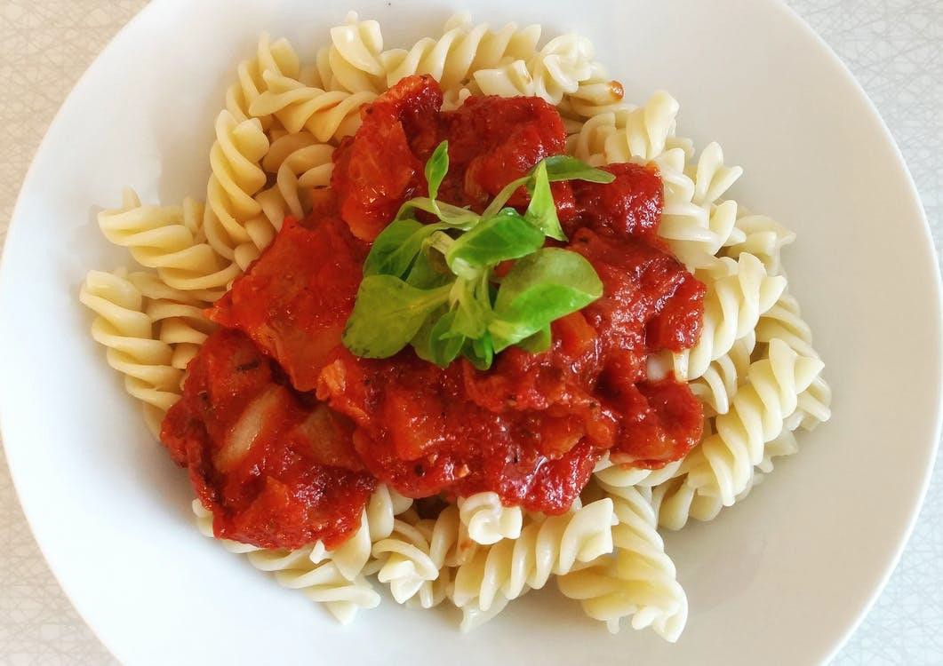

Ingredients:
1 tbsp oil
2 onions, finely chopped
3 carrots, finely chopped
3 celery sticks, finely chopped 3 garlic cloves, crushed
500g bag dried red lentils
2 x 400g cans chopped tomatoes 2 tbsp tomato purée
2 tsp mixed herbs
3 bay leaves if you have them
1litre stock made with either a chicken or vegetable stock cube 500g spaghetti, plus cheese, grated, to serve

Method:
- Heat the oil in a large saucepan and add the onions, carrots, celery and garlic. Cook gently for 15-20 mins until everything is softened.
- Stir in the lentils, chopped tomatoes, tomato purée, herbs and stock.
- Bring to a simmer, then cook for 40-50 mins until the lentils are tender and saucy – splash in water if you need to.
- Season with salt and pepper to taste.
- If eating straight away, keep on a low heat while you cook the spaghetti, following pack instructions. Drain well, divide between pasta bowls or plates, spoon sauce over the top and grate over some cheese.
- Alternatively, cool the sauce and chill for up to 3 days or freeze for up to 3 months. Simply defrost portions overnight at room temperature, then reheat gently until piping hot to serve with freshly cooked pasta.

Ingredients:
1 tbsp oil
3 tbsp finely chopped fresh or dried parsley 2 cloves garlic, peeled and finely chopped 1/2 tsp dried chili flakes
450g/1lb carton, bottle passata or tinned chopped tomatoes 400g/14oz tin of tuna fish in oil, drained and roughly chopped Salt
375g/13oz dried pasta Freshly ground black pepper

Method:
- Heat the oil and gently fry two tablespoons of the parsley, the garlic and chilli for a few minutes until slightly soft.
- Add the tomatoes and continue to cook for another few minutes. Stir in the tuna and salt.
- Meanwhile, cook the pasta for 8-10 minutes or until al dente, and drain.
- Toss with the sauce and serve sprinkled with the remaining parsley and freshly ground pepper to taste.

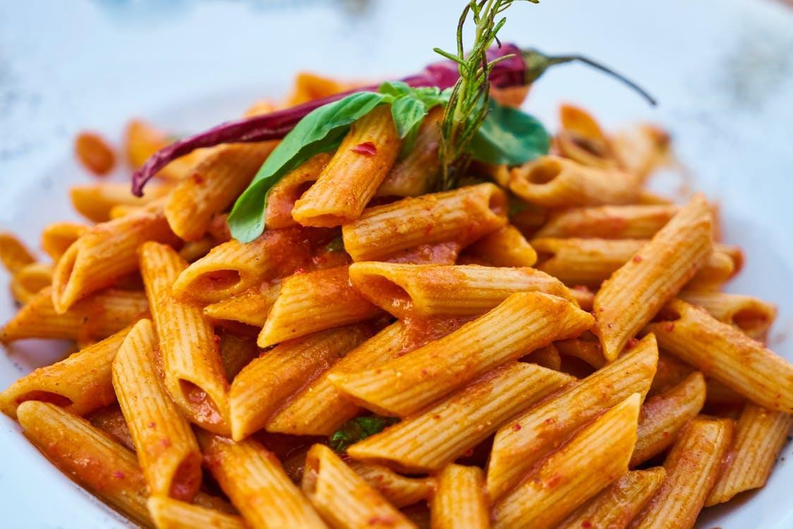

Ingredients:
400g/1lb 5oz pasta 50g/2oz butter 50g/2oz plain flour 600ml/20fl oz milk
200g/7oz cheddar, grated 100g/3½oz can sweetcorn, drained 100g/3½oz peas
3 spring onions, sliced
2 x 185g/6½oz cans tuna in spring water, drained

Method:
- Preheat the oven to 180°C/Gas 4.
- Cook the pasta in a saucepan of plenty of boiling water according to packet instructions. Drain.
- Meanwhile, for the sauce, melt the butter in a saucepan over a low heat and stir in the flour with a wooden spoon.
- Cook for one minute, or until the mixture darkens slightly.
- Slowly stir in the milk, stirring until smooth after each addition of milk and continue to cook until the mixture thickens enough to coat the back of the spoon.
- Remove the pan from the heat and stir in most of the cheese, and all the sweetcorn, peas and spring onion.
- Season, to taste, with salt and freshly ground black pepper.
- Stir the cooked pasta into the sauce.
- Spoon the tuna into the bottom of an ovenproof dish. Pour over the pasta and sauce. Tap the dish gently so the sauce pours into every nook and cranny. Sprinkle over the remaining grated cheese.
- Bake for 15-20 minutes, or until the sauce is bubbling and the top is a golden-brown.

Ingredients:
425g cooked macaroni 100g frozen garden peas 1 (185g) tin tuna, drained
1 (295g) tin condensed cream of mushroom soup 120g grated Cheddar cheese
100g corn flakes, crushed or breadcrumbs

Method:
- Preheat oven to 180°C / Gas 4.
- In a baking dish, combine the macaroni, peas, tuna and soup.
- Mix well, and then top with cheese.
- Bake at 180°C / Gas 4 for about 20 minutes, or until bubbly. Sprinkle with crushed corn flakes or breadcrumbs and bake for another 10 minutes. Serve hot.

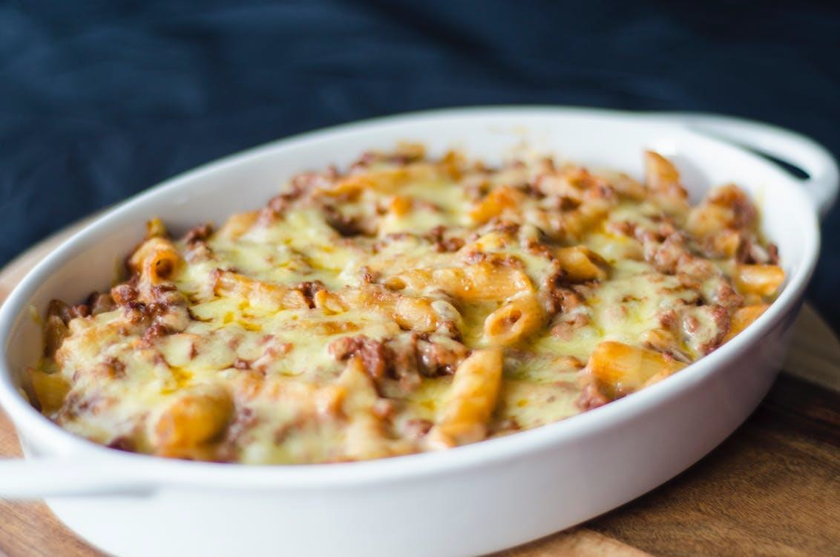

Ingredients:
1 tin of sardines 250g of any pasta
1 tin of sweetcorn or peas
1 clove of garlic finely chopped 1 tbsp oil
1 tin chopped tomatoes

Method:
- Cook the pasta in boiling water.
- Heat the oil in another pan and add the fish, tinned tomatoes and chopped garlic. Fry until softened and lightly golden.
- Add the sweetcorn/peas and the cooked pasta. Stir and serve.
- Put in an ovenware dish, and top it off with some bread crumbs, cheese or even crumpled crisps.
- Bake in the oven for 30 minutes until bubbling and piping hot.

Ingredients:
175g fusilli pasta
2 hard-boiled eggs, chopped
- (170g) tins tuna, drained and flaked 90g grated Cheddar cheese
  - sticks celery, chopped
1/2 small onion, finely chopped
1/2 (400g) tin butter beans, drained 150g mayonnaise
1/2 lemon, juiced
You can also throw in some tinned sweetcorn or chopped red peppers if you have them

Method:
    - Boil pasta in salted water for 8 to 10 minutes or until al dente (cooked but firm to bite); drain and cool.
    - In a large bowl, combine pasta, eggs, tuna, Cheddar cheese, celery, onion, corn, red peppers and butter beans.
    - Whisk together mayonnaise and lemon juice.
    - Season with salt and pepper.
    - Pour dressing over pasta mixture and mix together.

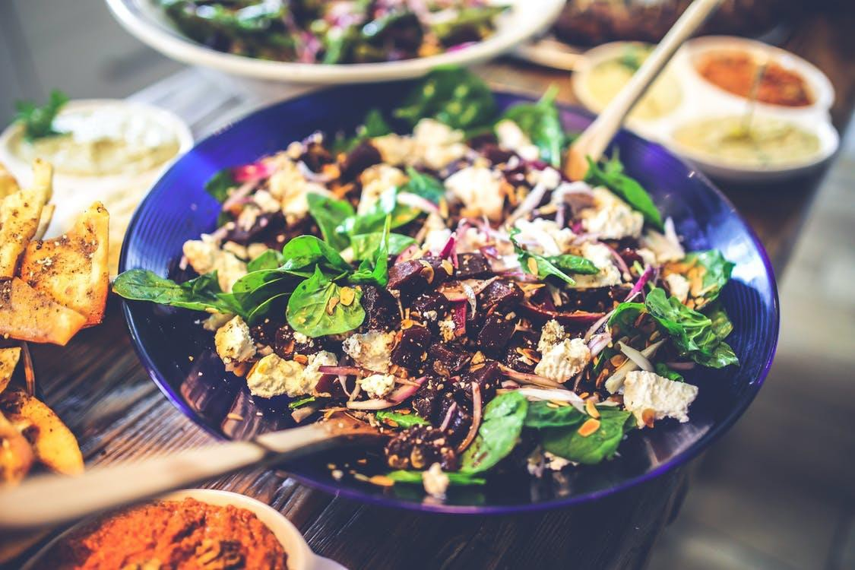

Ingredients:
500g pack new potatoes 1 tbsp oil
1 tbsp lemon juice
½ tsp chilli powder
1 plump garlic clove, finely chopped
410g can kidney or cannellini beans, drained and rinsed
A couple of spring onions or 1 small red onion or half a medium one, finely chopped 200g can tuna, drained

Method:
- Boil the potatoes for about 15 minutes, until tender.
- Meanwhile, make the dressing. - Whisk the oil, lemon juice, chilli powder and garlic in a bowl big enough to take all the salad. Tip in the beans and onion.
- Drain the potatoes and when cool enough to handle cut them in half lengthways.
- Now gently stir the potatoes into the salad and flake in the tuna.

Ingredients:
1 tin of tuna 250g rice
1 tin of green beans 1 tin of tomatoes
1 teaspoon mixed herbs 1 tablespoon oil
Method:
- Heat the oil in the saucepan.
- Fry your rice until coated in the oil.
- Add the herbs and then the tin of tomatoes and a tin of water.
- Just before the rice has absorbed all the water (after approx. 15 minutes) add the drained green beans and the drained tuna.
- Stir through and once the rice is tender and there is no water left, serve steaming hot.
- Season well with salt and pepper.
- Serving suggestions... Add a chilli spice for a bit of heat if desired.
- Leftovers... If there are any leftovers, ensure the rice is kept in the fridge.
- Heat some oil in a pan and, if you have an egg, beat it and cook it in the pan. Add the rice and stir through for egg fried rice.

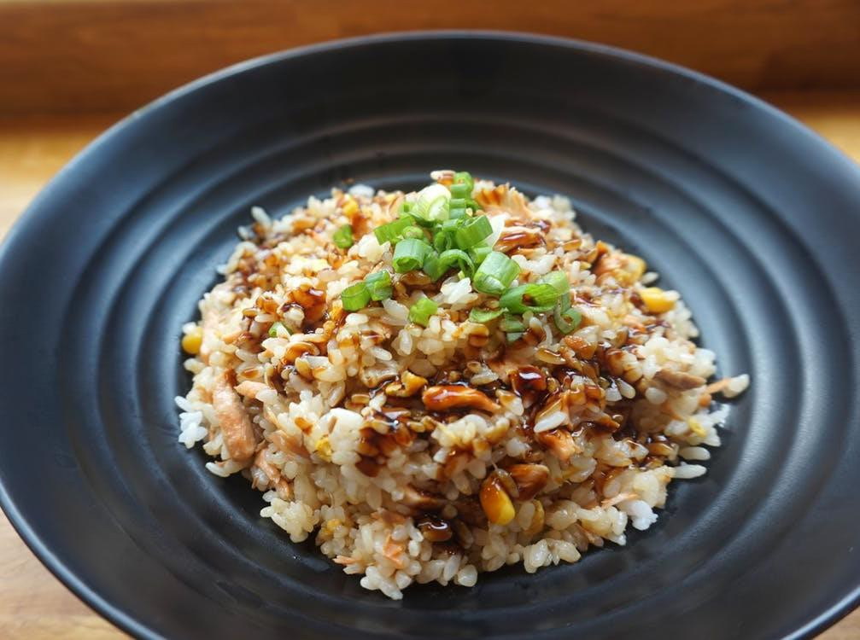

Ingredients:
1 tin of tomatoes 1 tin of chickpeas
1 onion or tin of onions
2 teaspoon garam masala 1 teaspoon sugar
1/2 teaspoon chilli powder 1/2 teaspoon salt
1 tablespoon butter
1 tablespoon oil Method:
- Melt the butter and oil together with the chopped onions (sprinkle on the salt to stop the onions burning).
- Cook until the onions are softened
- Add the spices and sugar.
- Add the tin of tomatoes and reduce the sauce down for about 10-15 minutes.
- Add the drained and rinsed chickpeas and heat through until hot.
- Serving suggestions...Serve with either potatoes or rice.
- Leftovers...Reheat in a pan and serve as above.

Ingredients:
1 onion, chopped
1 tbsp oil
1/2 cup stock made with a vegetable or chicken stock cube 2 x 400g cans chickpeas, drained
1 tsp curry powder
1 tsp coriander powder or turmeric 1 tsp cumin
3 tbsp mango chutney if you have it 2 x 400g cans diced tomatoes
Optional extras: Diced potato and/or frozen peas

Method:
- Lightly fry the chopped onions until soft (about 3-5 minutes)
- Add the rest of the ingredients and stir to combine well
- Cover and allow to cook gently for at least 15 minutes, stirring occasionally, until heated through

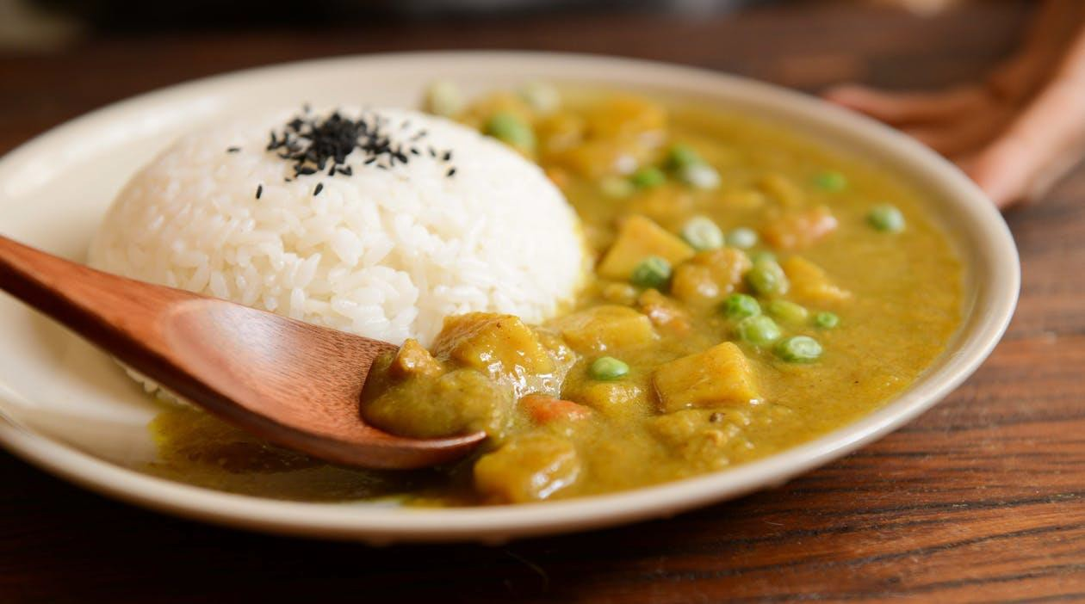

Ingredients:
250g canned chickpeas (drained weight) 1 onion
1 clove of garlic 1 chilli
1 tbsp oil
1 rounded tsp cumin (ground or seeds)
1 x 400g tin of peaches (or apricots or mandarins) 1 x 400g carton or tin of chopped tomatoes Handful of fresh coriander, finely chopped
1 stock cube, vegetable or chicken

Method:
- First drain your chickpeas and rinse them vigorously to get rid of the stagnant water that they’ll have been sitting in. Pop them in some fresh water in a saucepan and boil rapidly for 10 minutes to soften.
- Meanwhile, peel and finely chop the onion and garlic, and chop the chilli.
- Pour a little oil into a medium, heavy bottomed pan, and add the onion, garlic and chilli, then the cumin, and cook gently on a low heat for a few minutes to soften the onion.
- Drain the peaches, reserving the juice, and chop into small pieces. Add to the onion mixture in the pan, along with the reserved juice. By this time, the chickpeas should have finished boiling, so remove them from the heat and drain them, and tip them into the peaches-and-onion pan.
- Pour the chopped tomatoes in, add the coriander, and crumble over the stock cube, then stir everything together. Reduce the heat to a low setting and cook gently for 30 minutes. You may need to add a cup of water to the sauce if it starts to get a bit thick.
- Stir well and serve with rice.

Ingredients:
1 tbsp oil
2 medium onions, cut into rough wedges 4 tbsp curry paste or powder
850ml vegetable stock
750g stew pack frozen vegetables 100g red lentils
200g rice
1 tsp turmeric
Optional: - handful of raisins and roughly chopped parsley Poppadum’s and mango chutney, to serve

Method:
- Heat the oil in a large pan.
- Add the onions and cook over a high heat for about 8 minutes or until they are golden brown.
- Stir in the curry paste and cook for a minute.
- Slowly pour in a little of the stock so it sizzles, scraping any bits from the bottom of the pan.
- Gradually pour in the rest of the stock.
- Stir in the frozen vegetables, cover and simmer for 5 minutes.
- Add the lentils and simmer for a further 15-20 minutes or until the vegetables and lentils are cooked.
- While the curry is simmering, cook the rice according to the packet instructions, adding the turmeric to the cooking water. Drain well once cooked.
- Season the curry with salt, toss in a handful of raisins and chopped parsley, then serve with the rice, poppadum’s and chutney.

Ingredients:
1 tbsp oil
1 large carrot, chopped into small dice
1 large stick celery, chopped into small dice 1 medium onion, finely chopped
1 clove of garlic, finely chopped 1/2-1tsp dried chilli flakes
1 tbsp tomato puree 1 tsp ground cumin
1 tsp ground coriander 1 bay leaf
1/2 tsp cinnamon
400g tin chopped tomatoes
1 chicken or vegetable stock cube
100g each dried kidney beans, chickpeas and black eye beans, or a 400g can of each, drained
Method:
- If using dried beans, soak and cook as recommended on the packaging prior to starting the chilli.
- Add the carrot, celery, onion, garlic to the oil in a large wide pan on a medium hot heat and sweat until onions are translucent, about 10 mins
- Add tomato puree and stir for 30 seconds, then add the cumin, coriander and cinnamon and dried chilli. Stir fry for a minute.
- Add chopped tomatoes and stock cube, bring to simmer, cover and leave on low heat for 10-20mins, stirring occasionally, until vegetables are cooked through.
- Add all the beans, stir, bring to simmer, cover and cook on low heat for 10-15 minutes until beans are hot. Keep an eye on it, add a couple of tbsp of water if it is a bit dry.
- Serve with rice, tortillas or French bread, salad and grated cheese

Ingredients:
1 tbsp oil
2 medium onions
2 carrots
Garlic 2 cloves, peeled and thinly sliced Mushrooms 240g
2 x 400g cans of tomatoes 2 x 400g cans butter beans

Method:
- Peel the onions, cut them in half, then into thick segments. Soften them in a pan with a tablespoon of oil.
- Scrub the carrots, roughly chop, then add to the onions with the garlic.
- As the vegetables soften, slice the mushrooms and stir them into the vegetables.
- Once they soften and colour, tip in the tomatoes, the rinsed beans and 2 cans of water.
- Season with salt and black pepper then bring to the boil. Lower the heat and simmer the beans for 30 minutes, until the mixture is thick.
- Set to one side and transfer to an ovenproof dish.
- Set the oven at 180C/gas mark 4.
- Bake for about 35 minutes.
Optional cheesy crisp crumb topping:
Rolled oats 40g
Crisp white breadcrumbs 40g Grated Parmesan 4 tbsp
- Mix the oats, crumbs and cheese and scatter over the casserole and continue cooking for a further
- 30 minutes until it is golden and crisp.

Ingredients:
8 sausages
1 onion, diced
1 garlic clove, chopped 1 tsp dried mixed herbs
1 x 400g/14oz tin butter beans, rinsed and drained
½ bunch parsley, rough chopped 400g/14oz tin chopped tomatoes
500ml/18fl oz chicken stock, made from stock cube Salt and freshly ground black pepper
For the herby crumb topping
100g/3½oz bread (ideally day old), crusts removed
½ bunch parsley, finely chopped 1 tbsp oil
Method:
- Preheat the oven to 200C/400F/Gas 6.
- Heat a large frying pan over a medium heat. Once hot, add the sausages and cook for 6-8 minutes, turning now and again to colour evenly.
- Add the onion and continue to cook for three minutes, then add the garlic and dried herbs and cook for two more minutes, stirring from time to time.
- Meanwhile, for the herby crumb topping, tear the bread into small crumbs (or put into a food processor if you have one) and mix it with the finely chopped parsley.
- Add the butter beans, parsley, tomatoes and chicken stock to the pan. Stir to mix everything together and season well with salt and pepper.
- Transfer to a medium ovenproof baking dish.
- Sprinkle the herby crumbs evenly over the surface of the stew, drizzle with olive oil, season with salt and pepper and bake for 25 minutes, or until the topping is crisp.
- Serve while hot.

Ingredients:
1 tbsp oil
1 clove garlic
1 onion, diced
2 carrots, diced
1 large onion, sliced
6 large tomatoes, chopped and sprinkled with a little salt 400g can butter beans, drained
Small bunch flat-leaf parsley, chopped

Method:
- In a large pan, heat the oil and add the onion, garlic, carrots and onion.
- Gently sweat, stirring, until soft but not coloured.
- Add tomatoes and slowly cook for 15 mins.
- Add the beans, reduce the heat to nearly nothing and warm through.
- Taste, season, then stir in the parsley.

Ingredients:
1 tin of tomatoes 1 tin of chickpeas
1 onion or tin of onions 3 carrots or tin of carrots 1 clove of garlic
1 teaspoon paprika
2 tablespoon orange juice (optional) 1 tbsp oil

Method:
- Fry the onion in the oil (sprinkle on the salt to stop the onions burning).
- Add the chopped garlic and paprika and cook until the onions are softened.
- Add the chopped carrot, tin of tomatoes and the drained and rinsed chickpeas. Add the orange juice if desired.
- Simmer until the carrots are tender.
- Serving suggestions... Serve with either rice or bread.
- Leftovers… Reheat in a pan or bake in the oven and serve as above.

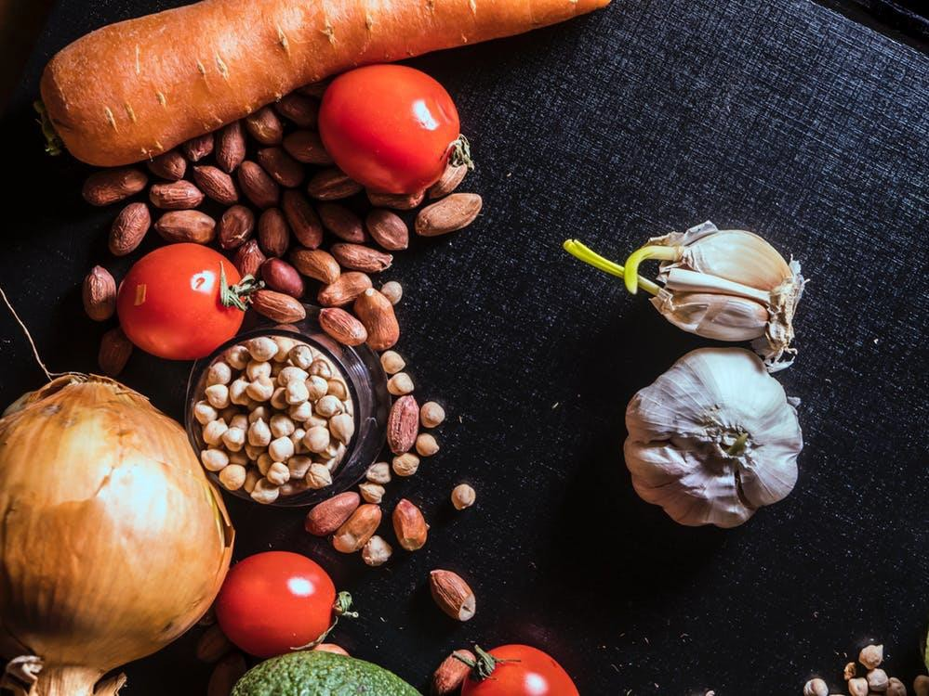

Ingredients:
2 (445 g) cans pilchards in tomato sauce
1 and a half pounds/ 850g of mashed potatoes 4 onions, finely chopped
2 eggs, beaten Salt
Pepper Mixed herbs
Grated cheese to serve

Method:
- Drain the pilchards, retaining the tomato sauce.
- Add pilchards to mashed potato and beaten egg, mixture must be quite stiff.
- Add onion and seasoning.
- Form into cakes and bake at 200°C for approximately 30 minutes, turning over half way through.
- (If desired, allow to cool and freeze - can be re-heated in microwave).
- Serve with reserved tomato juice, simmered with Italian herbs and grated cheese.

Ingredients:
85g white bread, torn into pieces 198g can sweetcorn, drained
- x 185g cans tuna in water, drained well 25g grated cheddar
- spring onions, finely chopped
- egg, beaten
- tbsp vegetable oil
Wholegrain bread rolls, lettuce, salsa or mayonnaise to serve

Method:
  - Whizz the bread in a food processor to crumbs or grate on a cheese grater to make breadcrumbs and tip into a bowl.
  - Finely chop half the sweetcorn.
  - Add the chopped corn, remaining whole corn, tuna, cheese, spring onions and some seasoning into the bowl with the bread and mix well.
  - Add the egg, bit by bit (you may not need it all), until the mixture is sticky enough to be shaped into four even-size burgers.
  - Heat the oil in a non-stick pan, then cook the burgers for 5 mins on each side until golden and hot through the middle.
  - Stuff into wholemeal buns with your favourite lettuce and a good dollop of salsa or mayonnaise.

