ADULT SAFEGUARDING CONCERN FORM

Please provide as much information as possible regarding this concern in order that it can be considered for a Care Act 2014 adult safeguarding Section 42 enquiry.
Please make sure you reflect the wishes and views of the adult at risk of harm when completing this form.

 | 1 - CONSENT/WISHES OF THE ADULT
 | Do you have the consent of the adult to complete this form and to share the content? |  |  |  |  |  |  |  |  |  |  |  |  |  |  |  |  |  |  |  |  |  |  |  |  |  |  |  |  |  |  |  |  |  |  |  | Yes/No
 | Have you spoken to the adult about this safeguarding concern? |  |  |  |  |  |  |  |  |  |  |  |  |  |  |  |  |  |  |  |  |  |  |  |  |  |  |  |  |  |  |  |  |  |  |  | Yes/No
Was the individual or individual’s representative asked what their desired outcomes were?

- Yes they were asked and outcomes were expressed
- Yes they were asked but no outcomes were expressed
- No not asked

 | Please consider all statements below and those which best indicate the persons own wishes and what outcomes they want?
 | - I want the abuse to stop and feel safe
 | - I want help to protect myself in the future
 | - I want to feel more confident
 | - I want to be involved in what happens next
 | - I want the people involved in my case to carry out the actions they will say they will do
 | - I want the police to prosecute
 | - I want to access any help that may be available to me
 | - Other, please specify:
 | 2 - MENTAL CAPACITY
 | Do you have any concerns about the adult’s mental capacity to make particular decisions in respect of the safeguarding concerns of abuse/neglect being currently reported -see Guidance Notes for advice. |  |  |  |  |  |  |  |  |  |  |  |  |  |  |  |  |  |  |  |  |  |  |  |  |  |  |  |  |  |  |  |  |  |  |  | Yes / No
 | If you have ticked ‘Yes’ please give details
 | 3 - DETAILS OF THE ADULT
 | Name of adult
 | Usual address (to include postcode) |  |  |  |  |  |  |  |  |  |  |  |  |  |  |  |  |  |  |  | Current place of residence-if different to usual address
 | Contact telephone number
 | Title | Mr/Mrs/Ms |  |  |  |  |  |  |  |  | Date of birth |  |  |  |  |  |  |  |  |  |  |  |  |  |  |  |  | Gender |  |  |  |  |  |  |  | Male/Female
 | Ethnic Origin |  |  |  |  |  |  |  |  |  | Main Language |  |  |  |  |  |  |  |  |  |  |  |  |  |  |  |  | Religion (if known)
 | Are there any support needs to aid communication - e.g. is an interpreter or specialist equipment required?
 | GP
 | Surgery address and contact details
 | 4 - TYPE OF ABUSE AND NEGLECT SUSPECTED - see detailed guidance notes at the back of this form for further information. Consider use of body map on Page 9 if appropriate
 | Physical abuse |  |  |  |  |  |  |  |  |  |  | Domestic violence |  |  |  |  |  |  |  |  |  |  |  |  |  |  |  |  |  | Sexual abuse  Sexual exploitation
 | Psychological abuse |  |  |  |  |  |  |  |  |  |  | Financial or material abuse |  |  |  |  |  |  |  |  |  |  |  |  |  |  |  |  |  | Modern slavery
 | Discriminatory abuse |  |  |  |  |  |  |  |  |  |  | Organisational abuse |  |  |  |  |  |  |  |  |  |  |  |  |  |  |  |  |  | Neglect/Acts of omission
 | Self neglect
 | TIME AND DATE OF ALLEGED INCIDENT AND LOCATION USING THE OPTIONS LISTED. |  |  |  |  |  |  |  |  |  |  |  |  |  |  |  |  |  |  |  |  |  |  |  |  | - Own Home (including extra care and supported accommodation)  - In the Community (excluding community services)  - In a community service  - Care Home – Nursing  - Care Home – Residential  - Hospital – Acute  - Hospital – Mental Hospital  - Hospital – Community  - Other
 | Address where alleged abuse has taken place if different from the person’s home address.
 | If the adult is receiving services in their own home/care home/hospital/other care provider have you reported the incident to the Regulator – Care Quality Commission |  |  |  |  |  |  |  |  |  |  |  |  |  |  |  |  |  |  |  |  |  |  |  |  | Yes/No/NK/n/a
 | 5 - BRIEF DESCRIPTION OF CONCERNS AND ACTIONS TAKEN TO SECURE IMMEDIATE SAFETY (incident, injuries, witnesses and who/what brought this to your attention and immediate actions taken) If you require further space there is an extra box on Page 7.
 | Actions taken:
 | 6 – OTHER PEOPLE LIVING WITH THE ADULT - (if children are included have you considered a referral to Children’s Services?) Contact Sandwell Council on 0121 569 2266
 | Name |  |  |  |  | DOB / Age |  |  |  |  |  |  |  |  |  |  | Gender |  |  |  |  |  |  |  | Relationship |  |  |  |  |  |  |  |  |  | Main Language
 | 7 - INITIAL RISK ASSESSMENT
 | Is the adult safe now? |  |  |  |  |  |  |  |  |  |  |  |  |  |  |  |  |  |  |  |  |  |  |  |  |  | Yes/No/NK
 | Does risk remain? |  |  |  |  |  |  |  |  |  |  |  |  |  |  |  |  |  |  |  |  |  |  |  |  |  | Yes/No/NK/Identify the risk
 | Has the risk been reduced? |  |  |  |  |  |  |  |  |  |  |  |  |  |  |  |  |  |  |  |  |  |  |  |  |  | Yes/No/NK/Identify the risk
 | Has the risk been removed? |  |  |  |  |  |  |  |  |  |  |  |  |  |  |  |  |  |  |  |  |  |  |  |  |  | Yes (please evidence)  No
 | If No what action does the adult want you to take?
 | If you contacted the Police were you given a Police Log number? |  |  |  |  |  |  |  |  |  |  |  |  |  |  |  |  |  |  |  |  |  |  |  |  |  | Yes/No Crime Log number (if any)
 | Are you aware of any risks for a person visiting this adult at their home address?
 | 8 - OTHER SIGNIFICANT PEOPLE
 | Name |  |  |  |  | DOB / Age |  |  |  |  |  |  |  |  |  |  | Gender |  |  |  |  |  |  |  | Relationship |  |  |  |  |  |  |  |  |  | Main Language
 | 9 - KEY AGENCIES INVOLVED
 | Agency |  |  |  |  | Name |  |  |  |  |  |  |  |  |  |  |  |  |  |  |  |  |  |  | Role |  |  |  |  |  |  |  | Contact Number
 | 10 – DETAILS OF ALLEGED PERSON CAUSING THE HARM
 | Name of alleged person causing the harm
 | Address of person causing the harm
 | Title |  |  |  |  |  |  | Gender |  |  |  |  |  |  |  |  |  |  |  |  |  |  |  | M/F |  |  |  |  | Age/Date of Birth
 | What is the relationship to the adult at risk?
 | What action has been taken, if any, regarding the alleged person causing the harm?
 | Is the person causing the alleged harm an adult at risk? |  |  |  |  |  |  |  |  |  |  |  |  |  |  |  |  |  |  |  |  |  |  | Yes/No/NK
 | Is this person known to him or her? |  |  |  |  |  |  |  |  |  |  |  |  |  |  |  |  |  |  |  |  |  |  | Yes/No/NK
 | Are there any concerns about the mental capacity of the person allegedly causing the harm? If you have concerns, please detail |  |  |  |  |  |  |  |  |  |  |  |  |  |  |  |  |  |  |  |  |  |  | Yes/No/NK
 | Are there any agencies involved with the person allegedly causing the harm? If yes, please detail with name/s and contact details |  |  |  |  |  |  |  |  |  |  |  |  |  |  |  |  |  |  |  |  |  |  | Yes/No/NK
 | 11 - PERSON COMPLETING THIS FORM
 | Name of person completing form |  |  |  |  |  |  |  |  |  |  |  |  |  |  |  |  |  |  |  |  |  | Signature
 | Organisation |  |  |  |  |  |  |  |  |  |  |  |  |  |  |  |  |  |  |  |  |  | Address
 | Date form completed |  |  |  |  |  |  |  |  |  |  |  |  |  |  |  |  |  |  |  |  |  | Contact telephone number/s
12 – BODY MAP
Date wound was seen:
Size |  |  |  |  |  |  |  |  |  |  |  |  |  |  |  | Colour |  |  |  |  |  |  |  |  |  |  |  |  |  |  |  |  |  | Shape
Pressure area/sore |  |  |  |  |  |  |  |  |  | Yes |  |  |  |  |  |  |  |  | No |  |  |  |  |  |  | Grade
Position of observed injury:
Can you provide as much detail as possible about the injury/sore as possible and mark on the diagram their location. Also if you have any relevant information such as dates of the injury please add in box below the diagram
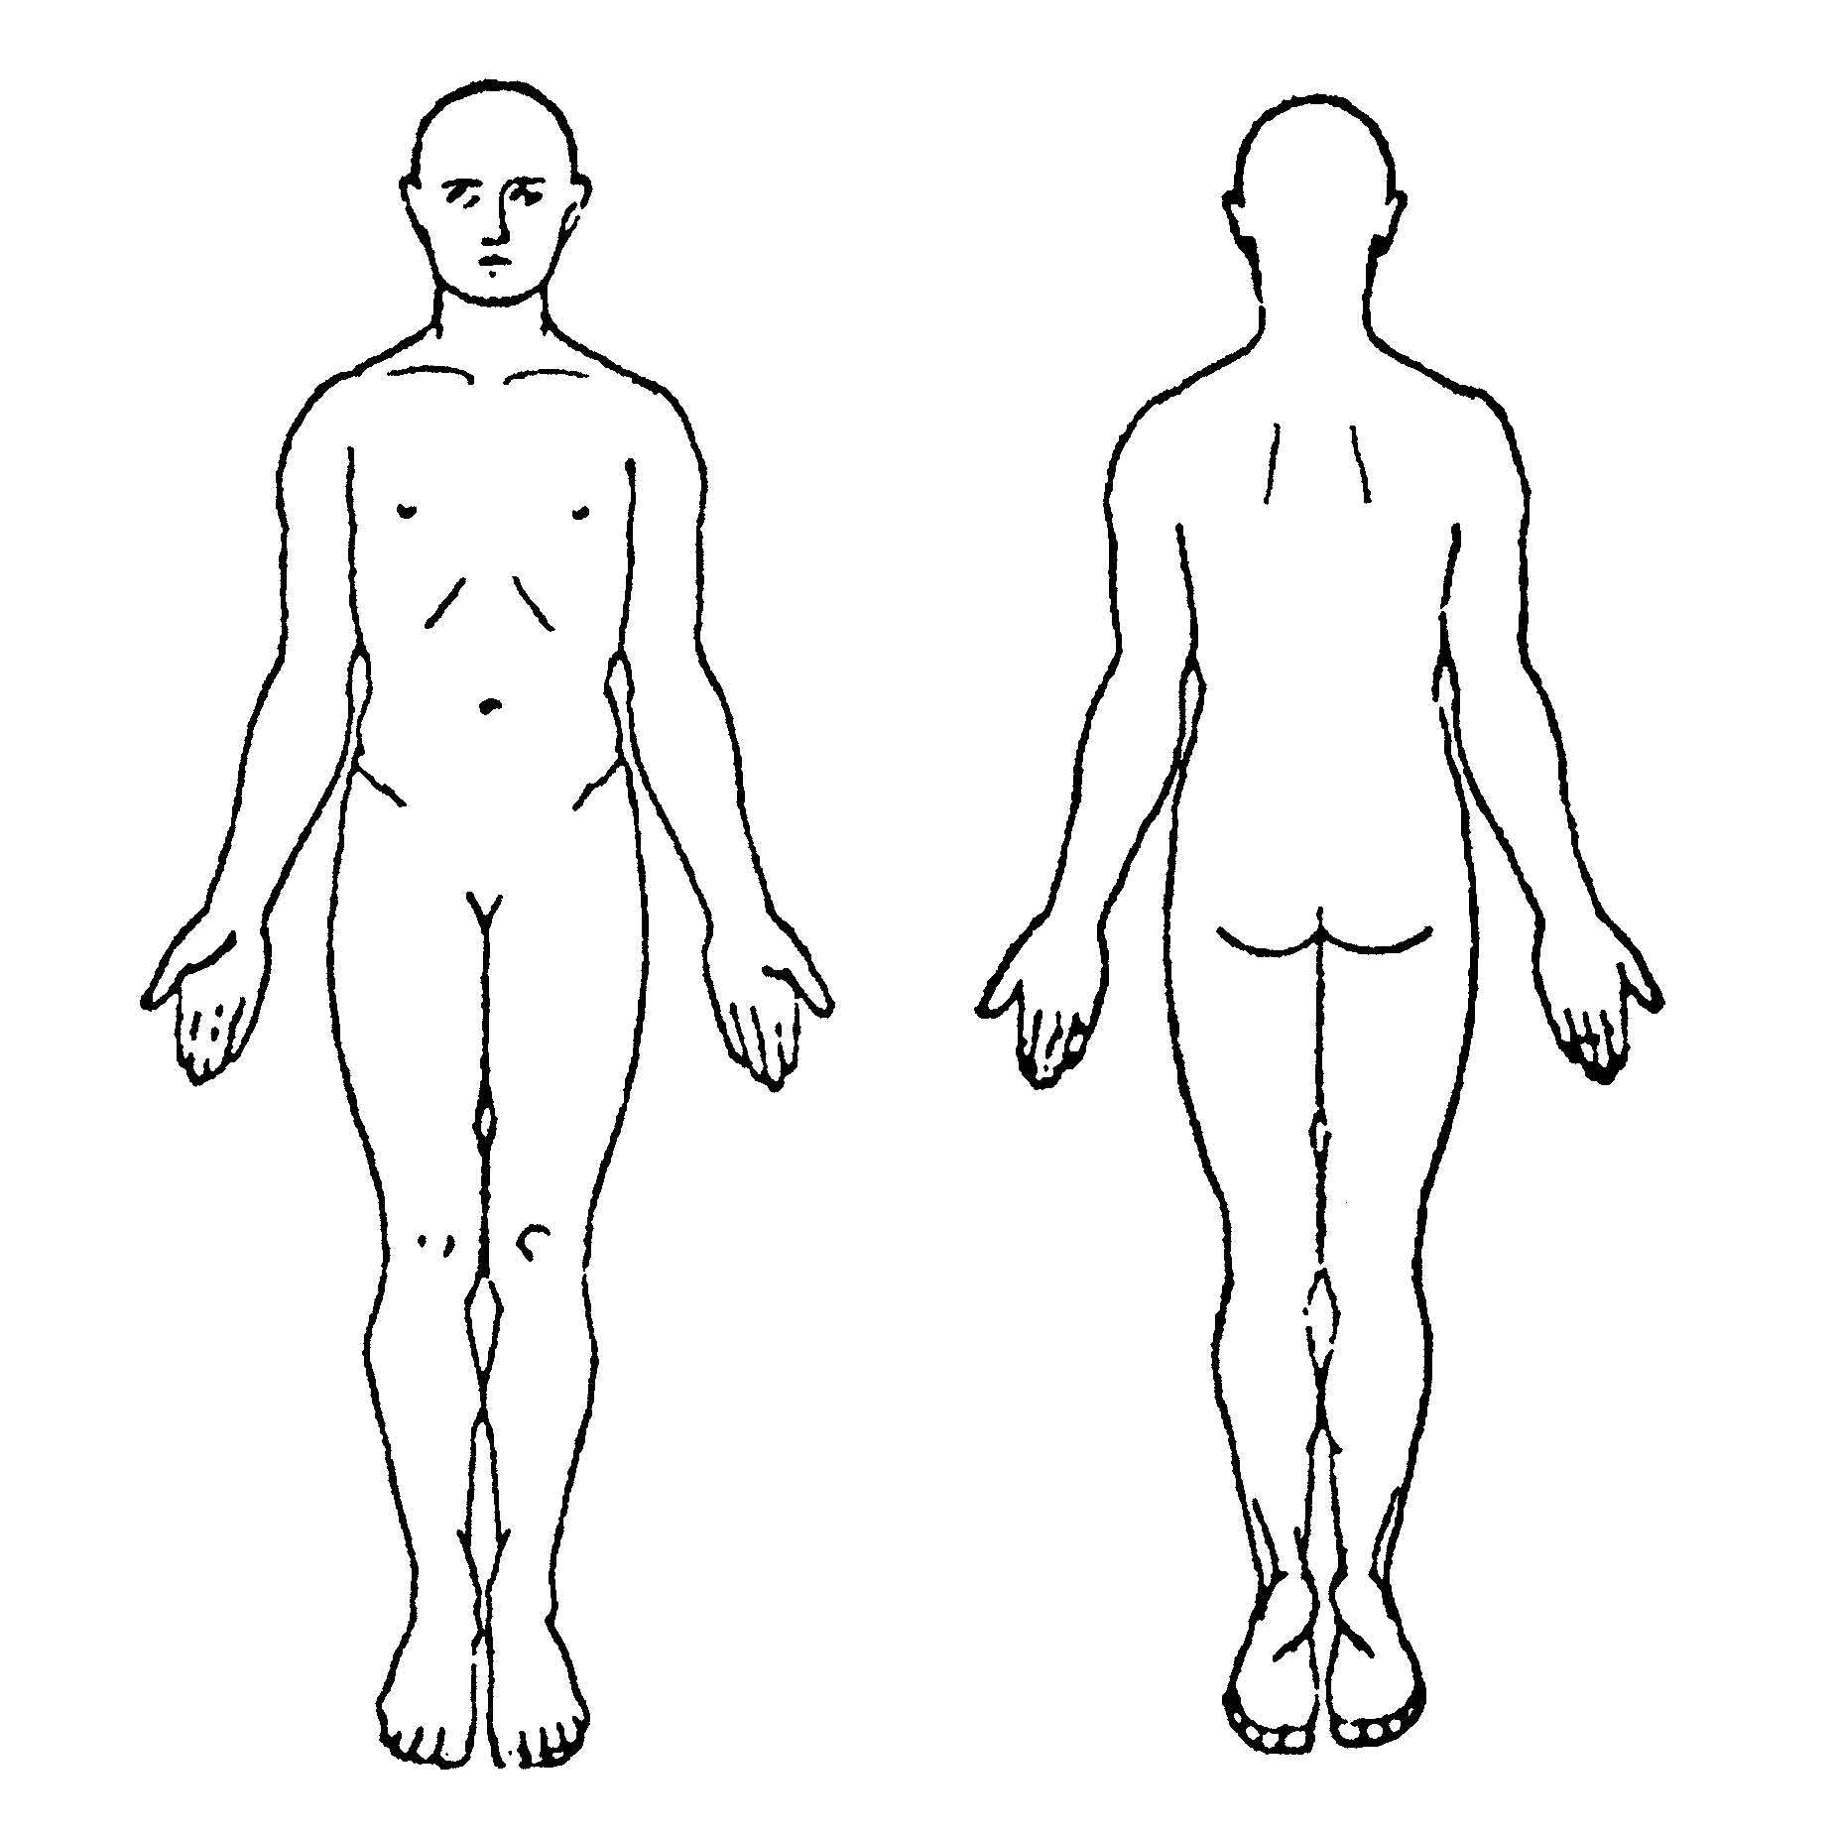

 | BOX FOR EXTRA INFORMATION REGARDING CONCERN-alternatively if you attach any extra sheets please state number added here
All Partner agencies must send pages 1 – 5 of the Concern form (if you wish to provide further information please use additional pages 6-7)
You can email the Concern form to the following secure Email address;
sandwell_enquiry@sandwell.gov.uk
You can fax the Concern form to - 0121 569 5789
Sandwell Council Independent Living Team (Enquiry) service can be contact by telephone on 0121 569 2266
The postal address is Sandwell Council Independent Living Team (Enquiry),
PO Box 15825, OLDBURY, B69 9EL
Between 5.30PM and 9AM Monday to Thursday and 5.00PM and 9.00AM on Friday’s and every weekend and Bank Holiday please contact the Emergency Duty Team on 0121-569-2355.
To understand more about why we collect your information, what we do with your information, how you can access your information, your personal information rights, how and to whom to raise a complaint about your information, please visit our privacy notice page at http://www.sandwell.gov.uk/privacynotices

GUIDANCE NOTES FOR COMPLETION OF THE CONCERN FORM
Sandwell Council, the lead safeguarding agency, and its other statutory partners, NHS Clinical Commissioning Group and Police, and all organisations should make safeguarding personal by ensuring the voice of the adult is heard to determine what outcomes they want from the multi agency safeguarding process.
CARE ACT 2014
The Care Act replaces all the safeguarding guidance that was previously provided in No Secrets which was published in 2010.In the section of the Care Act concerning adult safeguarding it states that when the local authority has reasonable cause to suspect that an adult in its area
(a) Has needs for care and support (whether or not the authority is meeting any of those needs),
(b) Is experiencing, or is at risk of, abuse or neglect, and
(c) As a result of those needs is unable to protect himself or herself against the abuse or neglect or the risk of it.
The local authority must make (or cause to be made) whatever enquiries it thinks necessary to enable it to decide whether any action should be taken in the adult’s case and, if so, what and by whom.
The Care Act 2014 accompanying statutory guidance emphasises the importance of obtaining the view of the adult as to whether he/she wishes that information concerning them should be passed on to the local authority. If the person has mental capacity to make decisions in relation to the safeguarding concern raised and does not wish concern(s) about them to be passed on to the local authority their view must be considered. If the person does not have the mental capacity to give an opinion an appropriate family member, key decision maker or advocate should be consulted.

There are 10 categories of abuse and neglect
- Physical abuse – including assault, hitting, slapping, pushing, misuse of medication, restraint or inappropriate physical sanctions.
- Domestic violence – including psychological, physical, sexual, financial, emotional abuse; so called ‘honour’ based violence.
- Sexual abuse – including rape, indecent exposure, sexual harassment, inappropriate looking or touching, sexual teasing or innuendo, sexual photography, subjection to pornography or witnessing sexual acts, indecent exposure and sexual assault or sexual acts to which the adult has not consented or was pressured into consenting.
- Psychological abuse – including emotional abuse, threats of harm or abandonment, deprivation of contact, humiliation, blaming, controlling, intimidation, coercion, harassment, verbal abuse, cyber bullying, isolation or unreasonable and unjustified withdrawal of services or supportive networks.
- Financial or material abuse – including theft, fraud, internet scamming, coercion in relation to an adult’s financial affairs or arrangements, including in connection with wills, property, inheritance or financial transactions, or the misuse or misappropriation of property, possessions or benefits.
- Modern slavery– encompasses sexual exploitation, slavery, human trafficking, forced labour and domestic servitude. Traffickers and slave masters use whatever means they have at their disposal to coerce, deceive and force individuals into a life of abuse, servitude and inhumane treatment.
- Discriminatory abuse – including forms of harassment, slurs or similar treatment; because of race, gender and gender identity, age, disability, sexual orientation or
- Organisational abuse – including neglect and poor care practice within an institution or specific care setting such as a hospital or care home, for example, or in relation to care provided in one’s own home. This may range from one off incidents to on-going ill-treatment. It can be through neglect or poor professional practice as a result of the structure, policies, processes and practices within an organisation.

- Neglect and acts of omission – including ignoring medical, emotional or physical care needs, failure to provide access to appropriate health, care and support or educational services, the withholding of the necessities of life, such as medication, adequate nutrition and heating
- Self-neglect – this covers a wide range of behaviour neglecting to care for one’s personal hygiene, health or surroundings and includes behaviour such as hoarding.
CONSENT
When an adult is able to make an informed decision regarding his/her personal circumstances where risk has been identified and does not give consent to the safeguarding alert being raised, then his/her wishes must be respected. The exception is the following-

- a public interest, for example, not acting will put other adults or children at risk
- a duty of care to intervene, for example, a crime has been or may be committed.

If you have any concerns regarding this matter, please speak to your Line Manager or seek advice from the Operational Safeguarding Team via Sandwell ASSIST on 0845 352 2266
MENTAL CAPACITY
Below is a basic summary of points to consider when assessing a person’s capacity to make a specific decision; (This is not a definitive list and for further guidance please consult the Mental Capacity Act 2005 Code of Practice)
Presuming someone has capacity
The starting assumption must always be that a person has the capacity to make a decision, unless it can be established that they lack capacity.
Understanding what is meant by capacity and lack of capacity
A person's capacity must be assessed specifically in terms of their capacity to make a particular decision at the time it needs to be made.
Treating everyone equally
A person's capacity must not be judged simply on the basis of their age, appearance, condition or an aspect of their behaviour.
Supporting the person to make the decision for themselves
All possible practical steps to assist the person to make a decision for themselves have to be considered.
Assessing capacity
Anyone assessing someone's capacity to make a decision for themselves should use the two-stage test of capacity-
- Is there an impairment of, or disturbance in the functioning of a person's mind or brain? if so
- Is the impairment or disturbance sufficient that the person lacks the capacity to make a particular decision?
Assessing ability to make a decision
Does the person have a general understanding of what decision they need to make and why they need to make it?
Does the person have a general understanding of the likely consequences of making, or not making, this decision?
Is the person able to understand, retain, use and weigh up the information relevant to this decision?
Can the person communicate their decision (by talking, using sign language or any other means)? Would the services of a professional (such as a speech and language therapist) be useful?
VITAL INTEREST
This is a term used in the Data Protection Act 1998 to permit the sharing of information where it is critical to prevent serious harm or distress in life threatening situations.
Communication Passport Tool:
http://www.changingourlives.org/resources/category/2-accessible-communication

