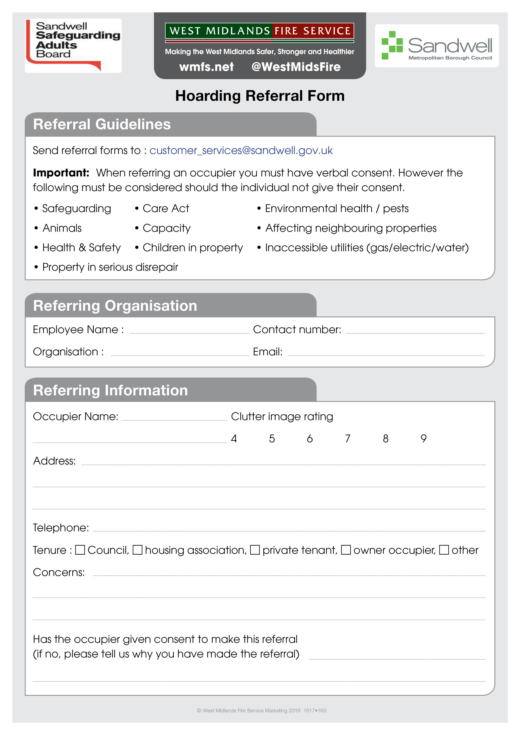
Type here
Type here
Type here
Type here
Type here
Type here
Type here
Type here
Type here
Type here
X
X
X
X
X
Type here
Type here
Type here
Yes/No

