###### Fire Risk Assessment

**Peartree House**

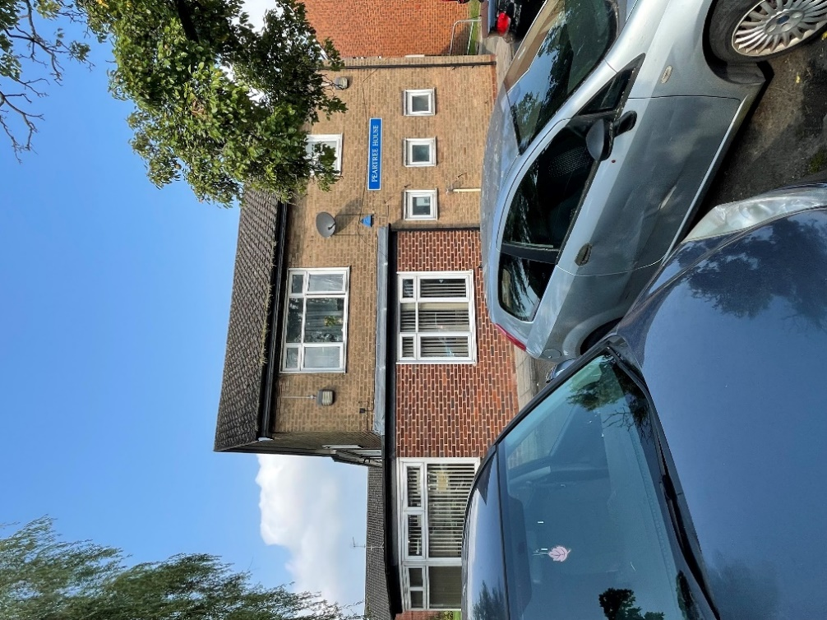

**Flats 1 – 17**

**Peartree House**

**Vicarage Road,**

**Oldbury,**

**B68 8JD.**

**Date Completed:** 05/09/2024.

**Review Period:** 3 years.

**Officer:** A Jones **Fire Risk Assessor**

**Checked By:** C. Hill **Fire Risk Assessor.**

|  |  |
| --- | --- |
| **Current Risk Rating = Tolerable** |  |

**Subsequent reviews.**

|  |  |  |
| --- | --- | --- |
| **Review date** | **Officer** | **Comments** |
|  |  |  |
|  |  |  |
|  |  |  |
|  |  |  |
|  |  |  |

**Contents**

|  |  |  |
| --- | --- | --- |
| Section 0 | **Introduction** |  |
| Section 1 | **Significant Findings (executive summary)** |  |
| Section 2 | **People at Significant Risk of Fire** |  |
| Section 3 | **Contact Details** |  |
| Section 4 | **Description of Premises** |  |
| Section 5 | **Building Plan** |  |
| Section 6 | **External Envelope** |  |
| Section 7 | **Means of Escape from Fire** |  |
| Section 8 | **Fire Detection and Alarm Systems** |  |
| Section 9 | **Emergency Lighting** |  |
| Section 10 | **Compartmentation** |  |
| Section 11 | **Fire Fighting Equipment** |  |
| Section 12 | **Fire Signage** |  |
| Section 13 | **Employee Training** |  |
| Section 14 | **Sources of Ignition** |  |
| Section 15 | **Waste Control** |  |
| Section 16 | **Control and Supervision of Contractors and Visitors** |  |
| Section 17 | **Arson Prevention** |  |
| Section 18 | **Storage Arrangements** |  |
| Section 19 | **Additional Control Measures.**  **Fire Risk Assessment – Action Plan.** |  |
|  |  |  |
| Appendix 1 | **Significant Hazards on Site and Information to be provided for the Fire Service Risk Rating of Block.** |  |

|  |  |  |
| --- | --- | --- |
| **Section**  **0** |  | Introduction |

The [Regulatory Reform (Fire Safety) Order 2005 (RR(FS)O)](https://www.legislation.gov.uk/uksi/2005/1541/contents/made) places a legal duty on landlords to complete a fire risk assessment (FRA). Specifically, RR(FS)O article *9. — (1)*

*“The responsible person must make a suitable and sufficient assessment of the risks to which relevant persons are exposed for the purpose of identifying the general fire precautions he needs to take to comply with the requirements and prohibitions imposed on him by or under this Order*”.

This fire risk assessment has been written to comply fully with the above legislation which is enforced locally by West Midlands Fire Service. If required, complaints can be made to them by telephone on 0121 380 7500 or electronically on <https://www.wmfs.net/our-services/fire-safety/#reportfiresafety>. In the first instance however, we would be grateful if you could contact us directly via <https://www.sandwell.gov.uk/info/200195/contact_the_council/283/feedback_and_complaints> or by phone on 0121 569 6000.

The date of the fire risk assessment is on the front page, followed by any subsequent reviews. A recurring time frame is not set in legislation, but the Council will as a minimum review:

* High Risk Residential Buildings annually
* Other Buildings every 3 years

The council has procedures and policies in place that will trigger a review of the fire risk assessment. This then is recorded on the fire risk assessment. If the review suggests the fire risk assessment is not currently suitable and sufficient, then a new fire risk assessment will be undertaken and become the current fire risk assessment. The previous fire risk assessment will be retained in the building safety case for that building.

The following diagrams illustrate those procedures and persons that support the effective planning, organisation, control, monitoring, and review of the preventive and protective measures. This information is provided as required under the RR(FS)O.

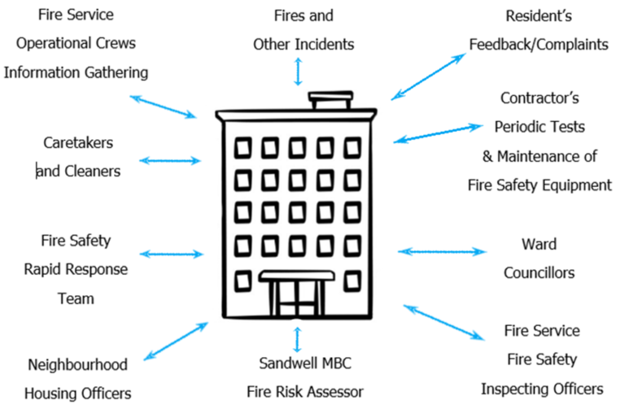

The above processes and procedures are overseen by the Fire Safety, Manager who reports to the Head of Building Safety.

These managers attend the Building Safety and Compliance Group for scrutiny which is part of the governance structure below.

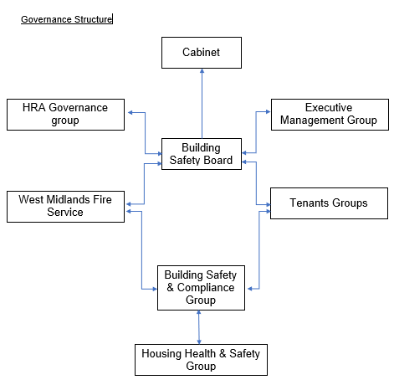

To summarise the fire risk assessment, in this scenario the RR(FS)O requires the prescribed information to be recorded. The prescribed information is the significant findings of the fire risk assessment and those groups or persons especially at risk from fire.

This is recorded here in Section 1. Also required to be recorded under article 11, are the fire safety arrangements for the planning, organisation, control, monitoring, and review of the preventative and protective measures. The information shown above is part of this requirement.

|  |  |  |
| --- | --- | --- |
| **Section**  **1** |  | Significant findings |

The significant findings (executive summary) of the fire risk assessment include those measures that have been or will be undertaken by the responsible person in order to comply with the RR(FS)O 2005.

Groups of people especially at risk of fire include such people as remote or lone workers, at risk due to layout of the building, visitors, and contractors unfamiliar with the building layout as well as those with physical, sensory, or mental health issues.

A third requirement that under the order must be recorded is the fire safety arrangements. This is the effective planning, organisation, control, monitoring, and review of the preventive and protective measures. These are shown in the introduction.

**Significant findings**

*Include a brief summary of protective and preventative measures where relevant along with any issues found.*

The escape strategy is **‘Stay Put Unless’.** This means in the event of a fire in your flat you should evacuate. If there is a fire elsewhere in the building you should stay put unless you are affected by fire, smoke or you have been advised by the emergency services to leave.

|  |  |  |
| --- | --- | --- |
| **Section number** | **Section Area** | **Individual Risk Level** |
| Section 6 | **External Envelope**  The exterior of the buildings is primarily traditional brick, concrete construction with a pitched, tiled roof.  One area of the building is covered with timber cladding. (See section 6).  Individual flat windows are UPVC double glazed units.  Staircase/common area windows are of UPVC double glazed (openable) units. | Trivial |

|  |  |  |
| --- | --- | --- |
| Section 7 | **Means of Escape from Fire**  There are two means of escape staircases that incorporate final exits.  All communal doors along the means of escape are self-closing notional fire doors with combined intumescent strips / cold smoke seals & vision panels.  The electrical cupboard door on the ground floor should be of a minimum of FD30s. Therefore, this door should be enhanced to include cold smoke seals. | Tolerable |
| Section 8 | **Fire Detection and Alarm Systems**  Early warning is limited to hard wired or battery smoke alarms within each of the resident’s flats.  These are installed to LD2 standard with smoke detectors to the hall / living room and a heat detector within the kitchen.  The building is protected by a communal alarm system that covers all common areas. The system incorporates detector heads, sounders & manual call points. **To comply with BS5839 Part 1: 2017 al**l zone plans should include a diagrammatic representation of the building, listing all of its zones. It should also show the building exits, stairs and located next to the fire alarm panel.  The ‘Stay Put’ Unless policy and testing regime of the fire alarm system were discussed with some residents from the premise. Knowledge was consistent and residents that were sampled, understood the ‘Stay Put Unless policy. | Trivial |
| Section 9 | **Emergency Lighting**  Emergency/escape lighting is provided throughout the building.  Servicing & maintenance is conducted at regular intervals in accordance with BS5266. | Trivial |

|  |  |  |
| --- | --- | --- |
| Section 10 | **Compartmentation**  The building is designed to provide as a minimum 1-hour vertical fire resistance and 1-hour horizontal fire resistance around flats.  Doors are 30-minute notional fire doors, including those in 1-hour rated walls.  It was noted that the ground floor corridor stretching from flat 1 to flat 4 has no subdivision corridor door. This should be provided when any refurbishment works are conducted to the building.  There is no access to the roof voids in any of the common areas of the building. Access to the roof is gained from individual flats on the first floor.  Therefore, access to the roof was gained from flat 13. This was to sample compartmentation and to ensure that appropriate fire separation was in place, upon inspection, compartmentation appeared to be acceptable.  In the electrical cupboard on the ground floor expanding foam has been used to seal voids above electrical equipment & cabling. This is poor practice and should be rectified using appropriate fire stopping materials at the earliest opportunity. | Tolerable |
| Section 11 | **Fire Fighting Equipment**  Fire extinguishers are provided in areas of the building including corridors and other rooms such as the community room.  There is a bracket provided in the electrical cupboard but no fire extinguisher. A Carbon Dioxide fire extinguisher should be provided.  Generally, extinguishers consist of water and Carbon Dioxide.  These are serviced at frequent intervals in accordance with BS 5306-3. | Tolerable |

|  |  |  |
| --- | --- | --- |
| Section 12 | **Fire Signage**  Generally, signage was in place, the ‘no smoking’ signage at the rear of the premise should be replaced.  When communal doors are replaced, escape/exit signage should be reviewed to meet the standards set out in BS 5499-4 which covers all safety warning sign. | Trivial |
| Section 13 | **Employee Training**  All staff receive basic fire safety awareness training. | Trivial |
| Section 14 | **Sources of Ignition**  The fixed electrical installation should be tested every 5 years. The date of the next 5-yearly inspection is 23/09/2024. | Trivial |
| Section 15 | **Waste Control**  Regular cleaning services and regular checks from caretakers help with waste control at the block.  It was noted that bins outside the main entrance were close to the main access and egress door. Ideally, these should be re-located and stored away from the main access doors. They should be chained to a secure post at least 8 metres away from the building.  There are other areas of the building where combustible items need to be removed. Richard Webb is dealing with this point. | Trivial |
| Section 16 | **Control and Supervision of Contractors and Visitors**  Contractors are controlled centrally, and hot works permits are required where necessary**.** | Trivial |
| Section 17 | **Arson Prevention**  A secure door entry system is provided to the premise at the front elevation to restrict unwanted access. | Trivial |
| Section 18 | **Storage Arrangements**  Residents should not store fuel or LPG Cylinders in their home or storage facilities. This documented in the tenancy agreement. | Trivial |

**Risk Level Indicator**

The following simple risk level estimator is based on commonly used risk level estimator:

|  |  |  |  |
| --- | --- | --- | --- |
| **Likelihood of fire** | **Potential consequences of fire** | | |
| **Slight harm** | **Moderate harm** | **Extreme harm** |
| **Low** | Trivial risk | Tolerable risk | Moderate risk |
| **Medium** | Tolerable risk | Moderate risk | Substantial risk |
| **High** | Moderate risk | Substantial risk | Intolerable risk |

Considering the fire prevention measures observed at the time of this risk assessment, it is considered that the hazard from fire (likelihood of fire) at these premises is:

Low  Medium  High

In this context, a definition of the above terms is as follows:

**Low** Unusually low likelihood of fire because of negligible potential sources of ignition.

**Medium** Normal fire hazards (e.g., potential ignition sources) for this type of occupancy, with fire hazards generally subject to appropriate controls (other than minor shortcomings).

**High** Lack of adequate controls applied to one or more significant fire hazards, such as to result in significant increase in likelihood of fire.

Considering the nature of the premises and the occupants, as well as the fire protection and procedural arrangements observed at the time of this fire risk assessment, it is considered that the consequences for life safety in the event of fire would be:

Slight Harm  Moderate Harm  Extreme Harm

In this context, a definition of the above terms is as follows:

**Slight harm** Outbreak of fire unlikely to result in serious injury or death of any occupant (other than an occupant sleeping in a room in which a fire occurs).

**Moderate harm** Outbreak of fire could foreseeably result in injury including serious injury) of one or more occupants, but it is unlikely to involve multiple fatalities.

**Extreme harm** Significant potential for serious injury or death of one or more occupants.

Accordingly, it is considered that the risk to life from fire at these premises is:

Trivial  Tolerable  Moderate  Substantial  Intolerable

**Comments:**

In conclusion, the likelihood of a fire is at a medium level of risk prior to the implementation of the action plan because of the unusually low likelihood of fire because of negligible potential sources of ignition that have been highlighted within the risk assessment. Some issues have been discussed with the Housing Officer for the building and these points have been resolved. When compartmentation issues have been resolved this rating can be downgraded too Trivial.

After considering the use of the premise and the occupants within the block, the consequences for life safety in the event of a fire would be moderate harm.

The ‘Stay Put’ Unless policy and testing regime of the fire alarm system was discussed with some residents from the premise. Knowledge was consistent and residents that were sampled, understood the ‘Stay Put Unless policy. To comply with BS5839 Part 1: 2017 all zone plans should include a diagrammatic representation of the building, listing all of its zones. It should also show the building exits, stairs and located next to the fire alarm panel.

A suitable risk-based control plan should involve effort and urgency that is proportional to risk. The following risk- based control plan is based on one that has been advocated for general health and safety risks:

|  |  |
| --- | --- |
| **Risk level** | **Action and timescale** |
| **Trivial** | No action is required, and no detailed records need to be kept. |
| **Tolerable** | No major additional fire precautions required. However, there might be a need for reasonably practicable improvements that involve minor or limited cost. |
| **Moderate** | It is essential that efforts are made to reduce the risk. Risk reduction measures, which should take cost into account, should be implemented within a defined time. Where moderate risk is associated with consequences that constitute extreme harm, further assessment might be required to establish more precisely the likelihood of harm as a basis for determining the priority for improved control measures. |
| **Substantial** | Considerable resources might have to be allocated to reduce the risk. If the premises are unoccupied, it should not be occupied until the risk has been reduced. If the premises are occupied, urgent action should be taken. |
| **Intolerable** | Premises (or relevant area) should not be occupied until the risk is reduced. |

***(Note that, although the purpose of this section is to place the fire risk in context, the above approach to fire risk assessment is subjective and for guidance only. All hazards and deficiencies identified in this report should be addressed by implementing all recommendations contained in the following action plan. The fire risk assessment should be reviewed regularly.)***

|  |  |  |
| --- | --- | --- |
| **Section**  **2** |  | People at Significant Risk of Fire |

Persons at significant risk of fire does not just refer to those people with physical, sensory, or mental health issues. It also includes those at risk due to the layout or features of the building such as inner rooms or dead-end conditions. Persons may also be at risk due to remote or lone working.

The RR(FS)O requires that these people be identified in any fire risk assessment.

Sandwell Council takes the health, safety and wellbeing of its colleagues, contractors, residents, and leaseholders seriously. It is our policy to exceed, where possible, the minimum health and safety requirements of the law.

Residents are responsible for letting us know whether they might need a Personal Emergency Evacuation Plan (PEEP). The Resident Engagement Officers (Fire Safety) will conduct an assessment visit upon request. Any risk-reduction measures that are found where a PEEP is necessary and completed will be documented and taken quickly.

With the consent of the resident, we will make a referral for West Midlands Fire Service to conduct a Safe and Well visit.

When a PEEP is in place, the relevant information will be kept in the secure Premise Information Box (High Rise Buildings only), which is set up to help WMFS in an emergency. The data is classified as level 1, which means it complies with the General Data Protection Regulations.

|  |  |  |
| --- | --- | --- |
| **Section**  **3** |  | Contact Details |

The Chief Executive of Sandwell Metropolitan Borough Council has ultimate responsibility for the site as the responsible person identified by the RR(FS)O 2005.

The Chief Executive has put a structure in place to support the management of the site.

This includes the role of Building Safety Manager who has duties as defined within the Regulatory Reform (Fire Safety) Order 2005.

The contact names to support the management of the site are as follows:

**Chief Executive**

Shokat Lal

**Directorate of Place**

Alan Lunt

**Assistant Director Building Compliance**

Phil Deery

**Fire Safety Manager**

Tony Thompson

**Team Lead Fire Safety**

Jason Blewitt

**Fire Risk Assessor(s)**

Adrian Jones

Anthony Smith

Carl Hill

Louis Conway

**Resident Engagement Officer - Fire Safety**

Abdul Monim Khan

Lee Mlilo

**Housing Office Manager**

Susan Geddes

*Please note, the above details are correct at the time of the production of the risk assessment and may be subject to change.*

|  |  |  |
| --- | --- | --- |
| **Section**  **4** |  | Description of Premises |

Flats 1 – 17,

Peartree House,

Vicarage Road,

Oldbury.

B68 8JD.

**Description of the Property:**

The communal, any workplace areas and the external envelope of the building are subject to the Regulatory Reform (Fire Safety) Order 2005 as confirmed by the Fire Safety Act 2021.

The enforcing authority is West Midlands Fire Service.

This Low-rise block constitutes two storeys (inclusive of the ground floor), the ground floor contains 8 flats, and the first floor contains 9 flats. The building was constructed circa 1966.

The building is of traditional construction including brick, block, concrete, plastered internal walls, double glazed UPVC window frames surmounted by a pitched, tiled roof.

Peartree House has previously provided sheltered accommodation hence a communal fire alarm system and communal lounge area. (out of use).

The main entrance is located at the right hand side elevation of the building & incorporates a secure entry system, fob reader, there is a fire service drop key for emergency/trade access. There are further exit doors located around the building.

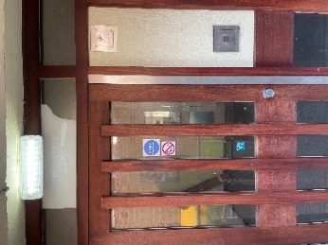 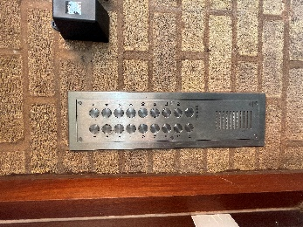 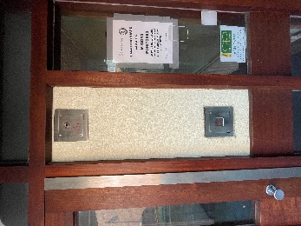 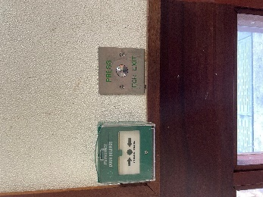

There is another access door located on the opposite side of the building. These doors are supplemented by additional emergency exit doors which are UPVC and have a ‘push bar’ mechanism to escape.

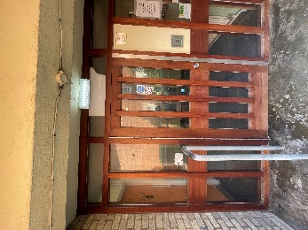 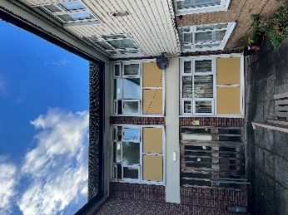 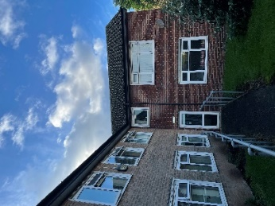 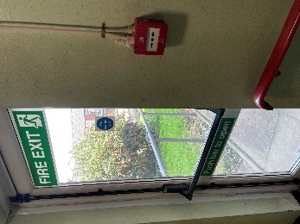

The building has two staircases that serve dwellings on both floors.

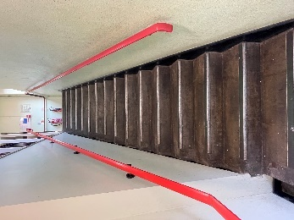 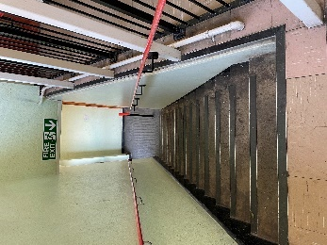

Communal corridor & windows close to the staircase are openable UPVC double glazed windows.

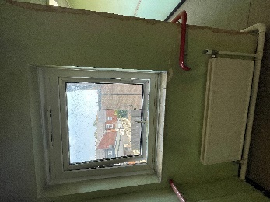 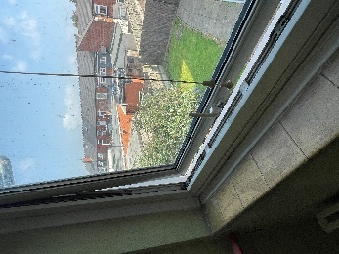 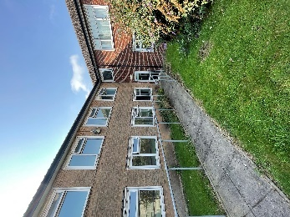

Cross Corridor doors and vision panels are timber construction with single glazed Georgian wired glass.

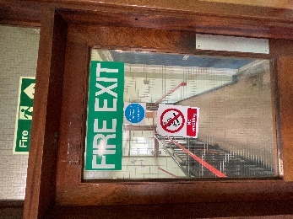 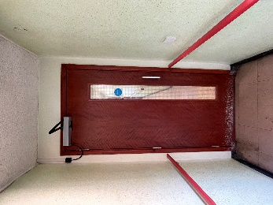 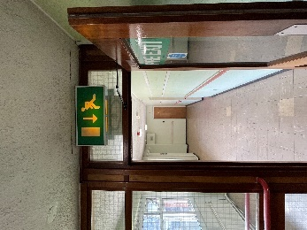

There is no access to the roof voids in common araes of the buildings. Access to the roof is gained from individual flats on the first floor.

There is a passenger lift provided for residents and visitors, this serves both floors of the building.

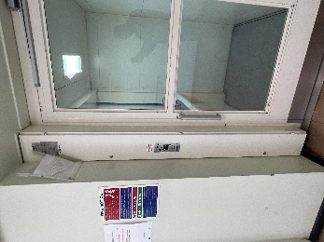 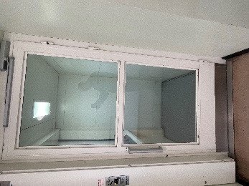 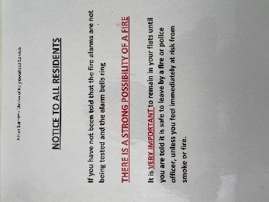

The Communal area (lounge) is presently locked as some residents were found to be smoking in this area.

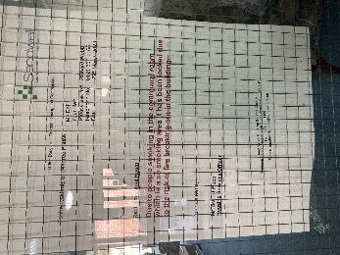 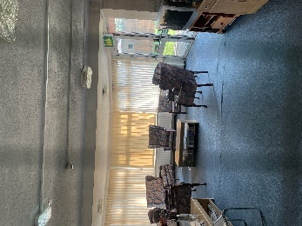 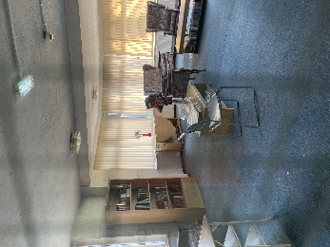 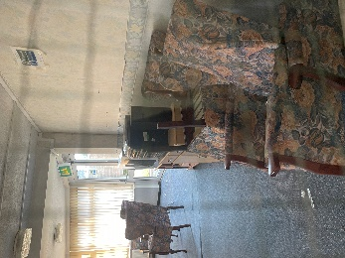

The main incoming electrical supply to the building is located in the electrical room on the ground floor.

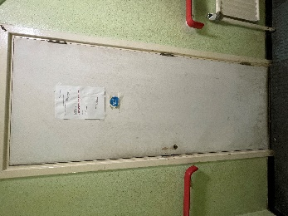 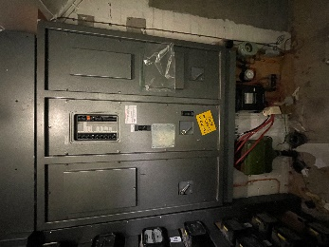 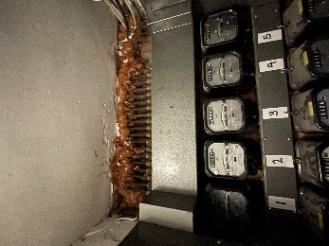

With regard to waste, residents use refuse bins, these are located at the side of the premise close to the main entrance.

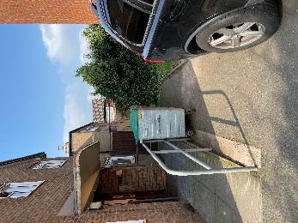

The gardens are secured by fencing, access point for the gardens is either timber side gate(s), which were unlocked at the time of the assessment or access through the main building using the rear door.

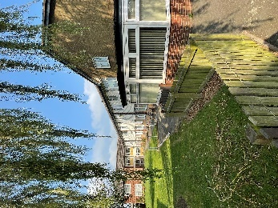 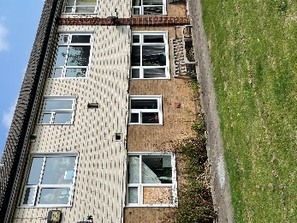 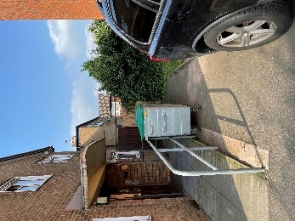

There is a small area for parking set out on the front elevation for the use of residents & visitors. This accommodates approx. four vehicles.

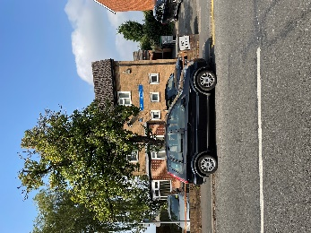 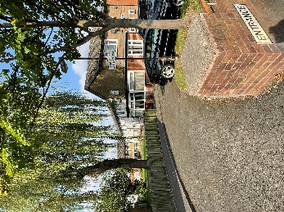 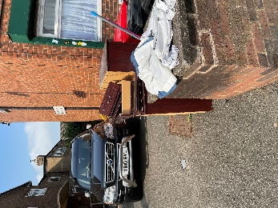

|  |  |
| --- | --- |
| High/Low Rise | Low Rise |
| Number of Floors | 2 |
| Date of Construction | 1966 |
| Construction Type | Traditional Brick Cavity |
| Last Refurbished | Unknown |
| External Cladding | Timber to first floor |
| Number of Lifts | 1 |
| Number of Staircases | 2 |
| Automatic Smoke Ventilation to communal area | No |
| Fire Alarm System | Yes |
| Refuse Chute | No |
| Access to Roof | Access to roof is external via ladder or scaffolding  Individual flats |
| Equipment on roof (e.g. mobile phone station etc) | No |

**Persons at Risk**

Residents / Occupants of 17 flats (1-17)

Visitors,

Sandwell MBC employees,

Contractors,

Service providers (e.g. meter readers, delivery people etc)

Statutory bodies (e.g. W.M.F.S, Police, and Ambulance)

|  |  |  |
| --- | --- | --- |
| **Section**  **5** |  | Building Plan |

A general plan showing the building location.

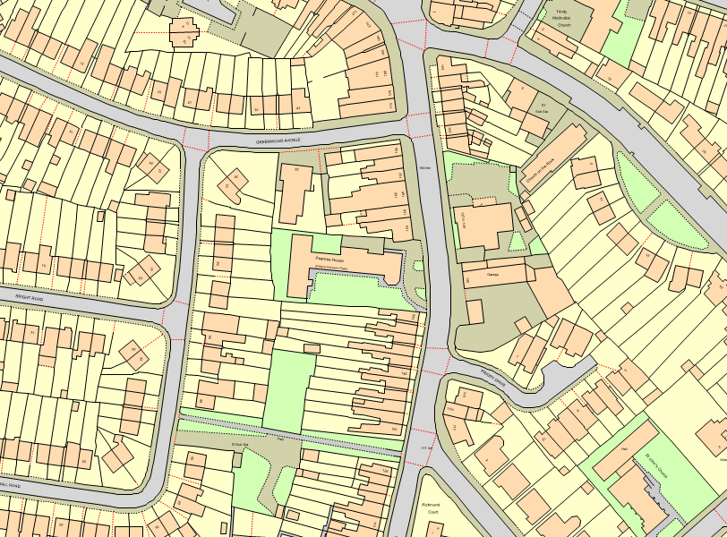

Ground & First Floor Plan.

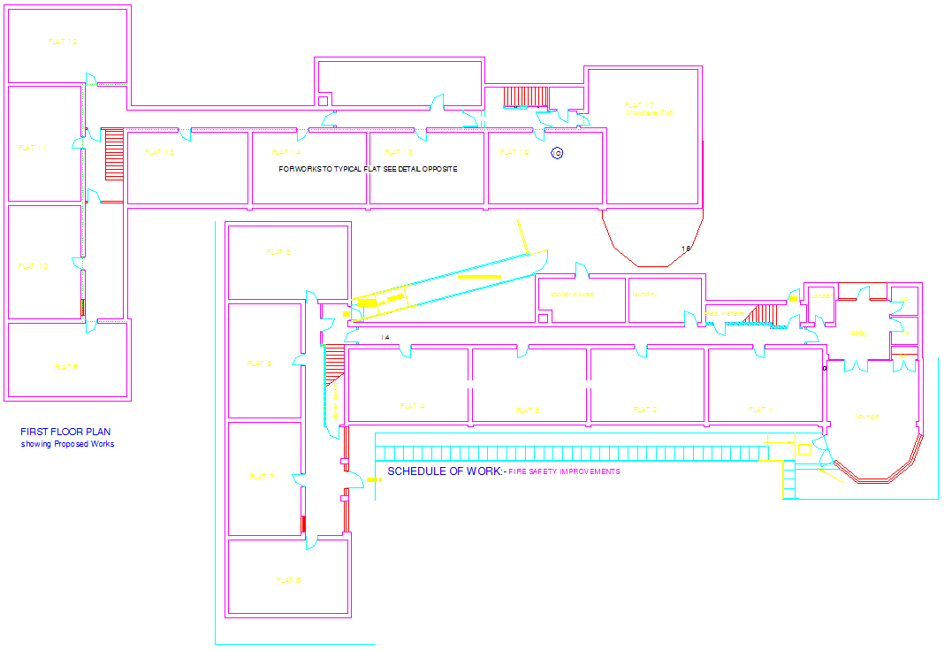

|  |  |  |
| --- | --- | --- |
| **Section**  **6** |  | External envelope |

Following the introduction of the Fire Safety Act 2021, consideration needs to be given to the external envelope of the building for any fire risk. This predominantly means the external wall construction including any insulation filler. It also includes balconies and any other fixtures as well as doors and windows.

Below is a breakdown of the materials used within the external envelope and, as part of the external wall system.

It is deemed that the combination and application of these materials presents an acceptable level of fire risk.

1. The external envelope of the premises is predominantly traditional brick, block & concrete construction, surmounted by a pitched tiled roof.

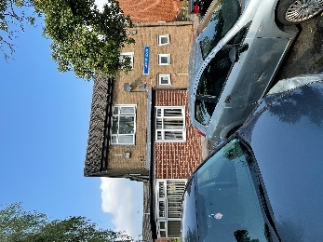 

1. It was noted that part of the building was clad with timber, this was at first floor level on the left-hand side elevation. There were also combinations of timber and panelled walls.

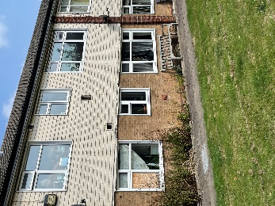 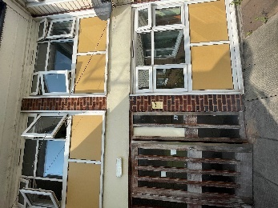

1. Individual flat windows are UPVC double glazed window frames.

 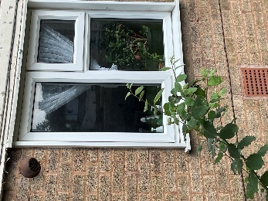

1. The building has a Pitched roof with concrete interlocking tiles.

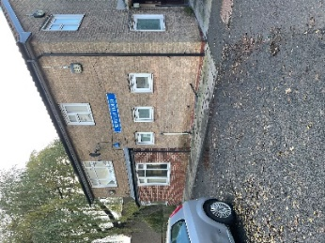 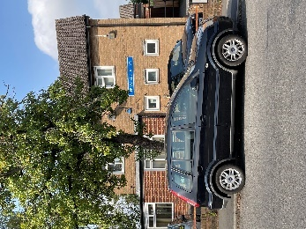

1. Communal entrance/ exits are a combination of timber & UPVC construction.

 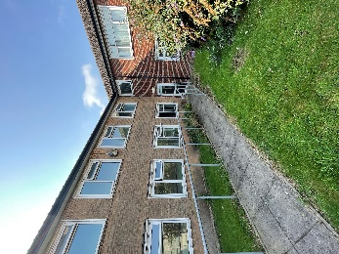

1. There are no balconies on any elevation of these buildings.

|  |  |  |
| --- | --- | --- |
| **Section**  **7** |  | Means of Escape from Fire |

1. The building has two staircases that provide the means of escape, both staircases provide access to a final exit.

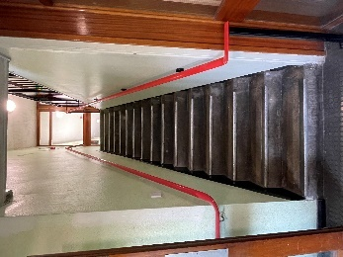  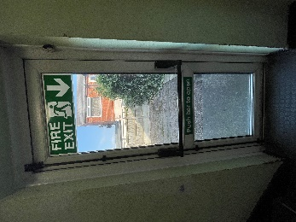

1. The final exit doors have door entry systems installed with a push button/push bar to exit. These systems are designed to fail safe i.e. door unlocked in the event of a power failure. This prevents residents being locked in or out of the building.



1. The means of escape are protected to prevent the spread of fire and smoke by fire rated walls and notional FD30s doors to flat entrances.

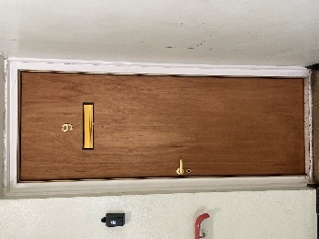 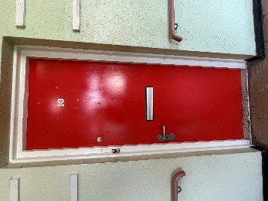

1. All corridors are of adequate width (at least 1.35m) and will be maintained clear to that width as a minimum.

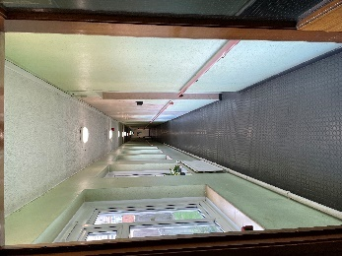 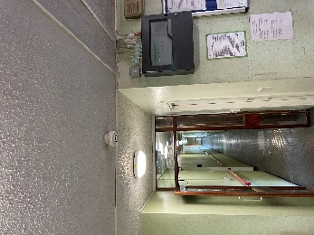

1. Communal doors are fitted with automatic overhead door closures that are linked to the fire alarm. These are checked on a quarterly basis by members of the Fire Safety Rapid Response Team.

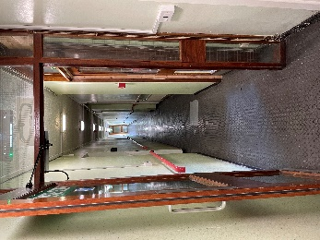 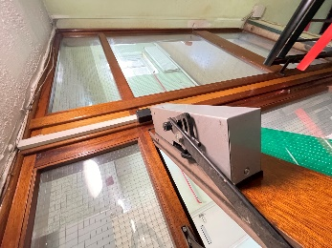 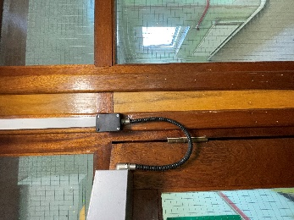

1. It was noted that the ground floor corridor stretching from flat 1 to flat 4 has no subdivision corridor door. This should be provided when any refurbishment works are conducted to the building.
2. **The electrical cupboard door on the ground floor should be of a minimum of FD30s. Therefore, this door should be enhanced to include cold smoke seals.**
3. All communal fire doors are also subject to an annual check by the Fire Safety Rapid Response Team.
4. An automatic smoke ventilation system is not commissioned; however, corridors & staircase windows are openable and could be used to ventilate the communal area in an emergency.
5. Communal areas should be kept free of flammable items. The communal areas should be checked on a regular basis by Caretaking / Cleaning teams and all items of rubbish removed.

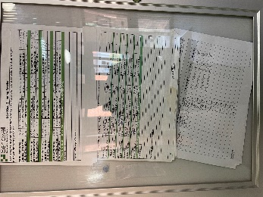

1. Surface coatings to the walls in the communal areas appear to be Class 0 rated.
2. The means of escape are protected to prevent the spread of fire and smoke with notional type composite type entrance doors.

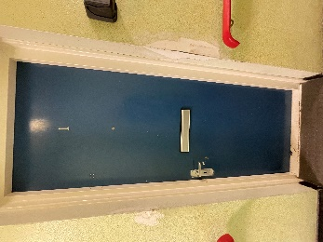 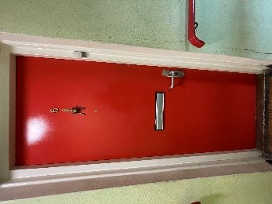 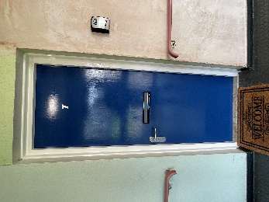 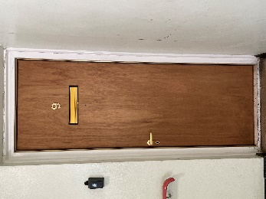

1. The premises have emergency lighting installed.

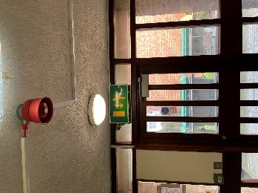 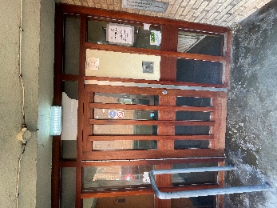 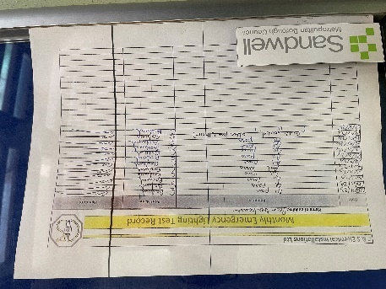

1. The fire rating of individual door mats outside flat entrance doors is unknown, they are deemed to be of low risk.

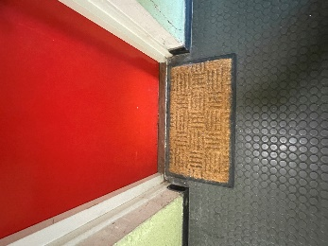 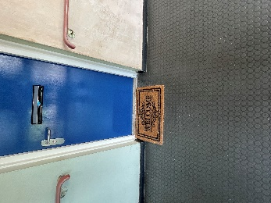

1. The building has sufficient passive controls that provide effective compartmentation in order to support a Stay Put Policy Therefore residents are advised to remain in their flat unless the fire directly affects them.
2. The ‘Stay Put’ Unless policy and testing regime of the fire alarm system were discussed with some residents from the premise. Knowledge was consistent and residents that were sampled, understood the ‘Stay Put Unless policy.

|  |  |  |
| --- | --- | --- |
| **Section**  **8** |  | Fire Detection and Alarm Systems |

1. The fire alarm system comprises of two distinct elements. Firstly, a communal system as the premise was formerly a sheltered accommodation scheme. And finally, a system whereby smoke/heat detection is provided in all flats.
2. The fire alarm system fitted within the communal aspect of the premise consists of a fire alarm panel, located in the ground floor lobby on the right-hand wall, supported by a zone plan.

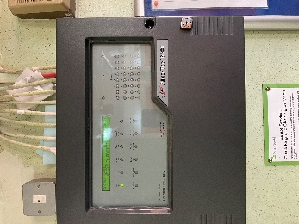

1. However, it was noted that the zone plan for the building was non-compliant. **To comply with BS5839 Part 1: 2017 al**l zone plans should include a diagrammatic representation of the building, listing all of its zones. It should also show the building exits, stairs and is located next to the fire alarm panel. It can immediately identify where any potential fire situation may have occurred. (Email sent to John Nash to update the zone plan for a diagrammatic representation of the building.)

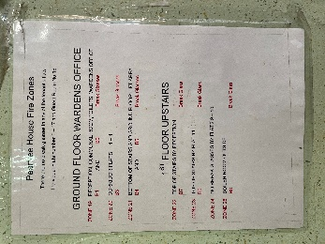

1. The system consists of a series of detector heads located in corridors and high risk rooms throughout the building.

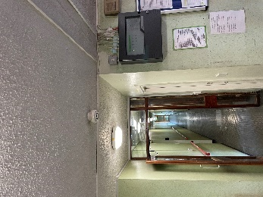 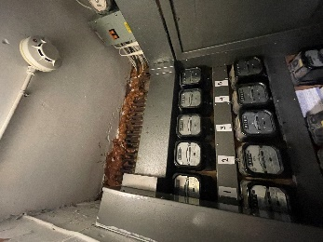 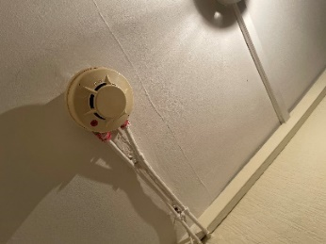

1. There are Fire Alarm manual call points (MCP’S) located at exit doors and a change of floor level.

 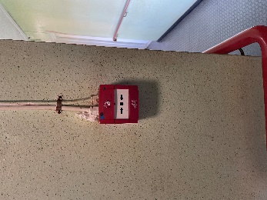

1. The type of warning is by means of sounders located strategically throughout the building.

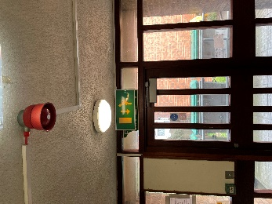 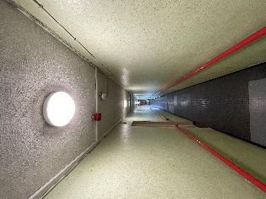

1. The system in residents flats that provide early warning is limited to hard wired or battery smoke alarms within each of the premises. The equipment is subjected to a cyclical test.
2. Based on the sample of properties accessed during the fire risk assessment the smoke alarms within resident’s flats are installed to an LD2 Standard. Flats accessed were: -

Flat 07 – LD2, Detectors in: Living room, hallway & a heat detector in Kitchen.

Flat 13 – LD2, Detectors in: Living room, hallway, and heat detector in Kitchen.

*For information*

*LD1 all rooms except wet rooms.*

*LD2 all-risk rooms e.g., Living Room, Kitchens, and Hallway.*

*LD3 Hallway only.*

|  |  |  |
| --- | --- | --- |
| **Section**  **9** |  | Emergency Lighting |

1. The premises have sufficient emergency lighting system in place. Test points are located strategically throughout the building.



1. All installed equipment is checked and tested frequently by Sandwell metropolitan borough council in house electrical team or approved contractor in accordance with BS 5266.

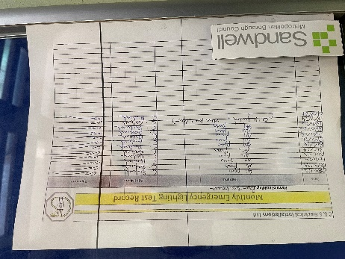

1. The last annual maintenance & service date for emergency lighting was recorded as 18/07/2024.

|  |  |  |
| --- | --- | --- |
| **Section**  **10** |  | Compartmentation |

*The high degree of fire separation between flats and the common parts is achieved by making each flat a fire-resisting enclosure. This is known as compartmentation. A*

*compartment is simply a part of a building bounded by walls and floors that will resist the passage of fire for a specified period of time. The fire resistance of this construction is such that, normally, a fire will burn itself out before spreading to other parts of the building.*

1. The building is designed to provide as a minimum 1-hour vertical fire resistance and 1-hour horizontal fire resistance around flats. All flat entrance doors are 30-minute notional/nominal doors, including those in 1-hour rated walls.
2. Generally, the means of escape is protected from flats with the use of notional rated timber/composite doors. These doors should either be upgraded to certified FD30’s when any future upgrades of the building are carried out or, FD30s certifiaction of the current doors should be provided.

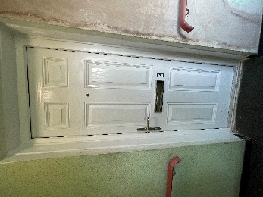 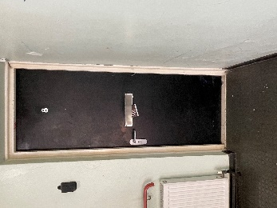  

1. All front entrance doors appear to be notional timber/composite fire rated FD 30’s. Refer to the sheet below.

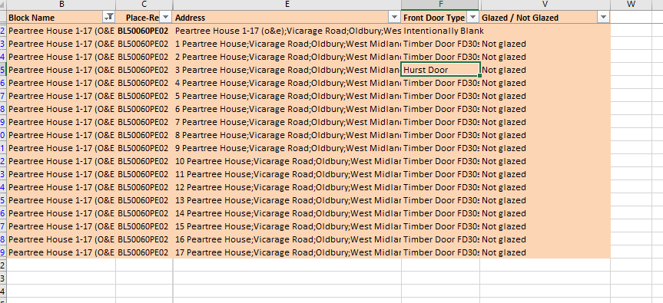

*It is accepted that, in older blocks, fire doors, particularly flat entrance doors, do not meet current test standards for FD30S doors. However, these doors may still be acceptable if the doors remain in good condition, and they met the relevant standards at the time of construction of the block.*

1. **In the electrical cupboard on the ground floor expanding foam has been used to seal voids above electrical equipment & cabling. This is poor practice and should be rectified using appropriate fire stopping materials at the earliest opportunity.**

 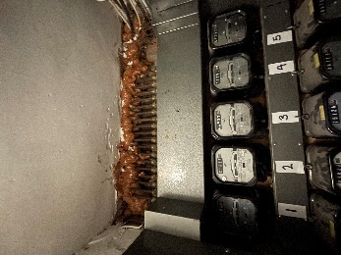

1. The building has sufficient passive controls that provide effective compartmentation to support a Stay Put -Unless policy. Therefore, residents are advised to remain in their flat unless the fire directly affects them or if they are advised to evacuate by the emergency services.
2. There is no access to the roof voids in any of the common areas of the building. Access to the roof is gained from individual flats on the first floor.
3. Therefore, access to the roof was gained from flat 13. This was to sample compartmentation and to ensure that appropriate fire separation was in place. Upon inspection, compartmentation appeared to be acceptable.
4. The fire stopping / compartmentation of the premises is subject to an annual inspection by the Fire Safety Rapid Response Team.
5. A variety of methods / materials have been used to achieve fire-stopping, methods observed were expanding foam ( not acceptable) and fire cement. Expanding foam will be replaced following this fire risk assessment.

Please refer to the table(s) below.

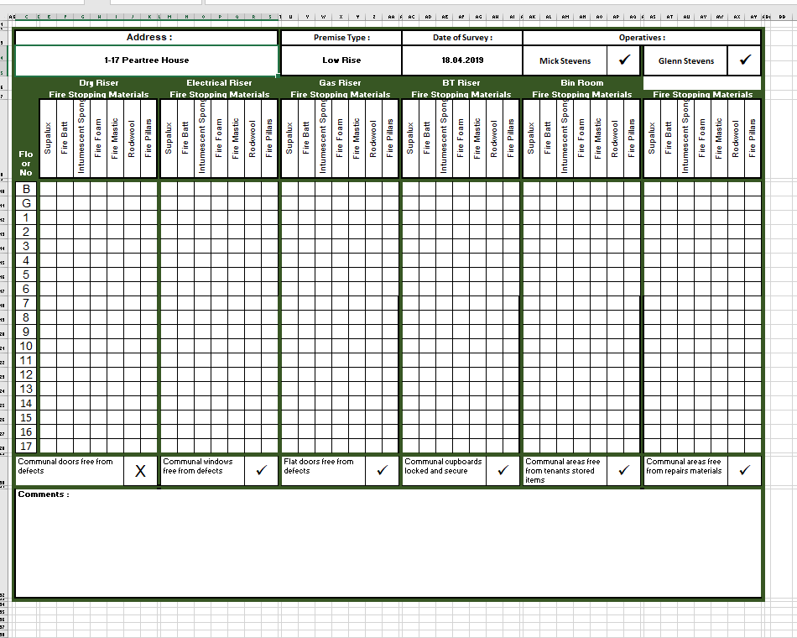

1. The passenger lift should be protected by lobbied doors at ground and first floor level. When any upgrades of the building are carried out consideration should be given to providing a lobbied area outside the lift access doors at both levels.

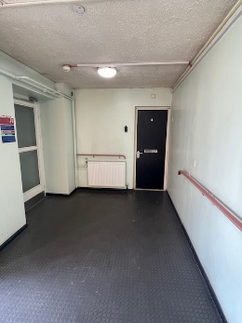 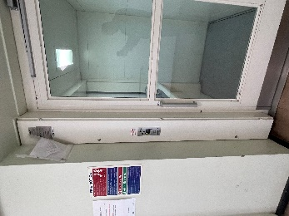

|  |  |  |
| --- | --- | --- |
| **Section**  **11** |  | Fire Fighting Equipment |

1. A number of Fire Extinguishers were located at strategic points throughout the building. These consisted of Water & Carbon Dioxide.

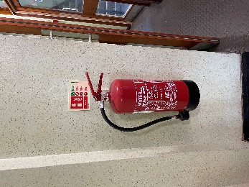 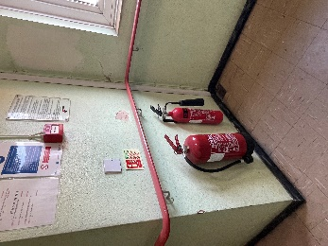

1. It was noted the Fire Extinguisher in the Laundry was partially obscured. If extinguishers are required, this extinguisher should be relocated by the exit door which provides egress from the room. (rectified whilst onsite).

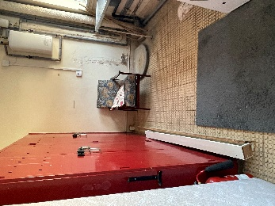 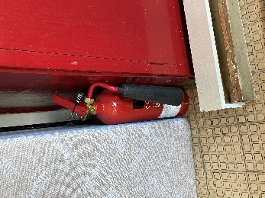

1. **It was noted in the electrical cupboard that a bracket was located on the wall for a fire extinguisher. However, no fire extinguisher was in place. A carbon dioxide extinguisher should be provided for use in an emergency.**
2. It could not be established where the nearest firefighting hydrant is located.

|  |  |  |
| --- | --- | --- |
| **Section**  **12** |  | Fire Signage |

1. Exit Signage consists of various signs and is deemed acceptable. However, when any refurbishment work take place consideration should be given to reviewing this signage throughout the building. This is based on location and number of signs.

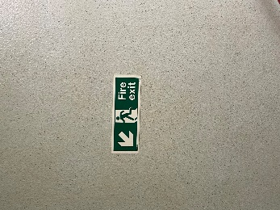 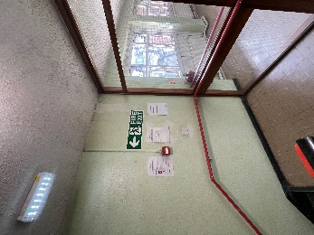

1. Fire Action Notices are displayed within the building.

 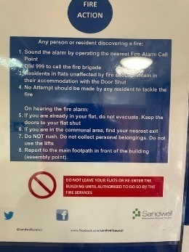

1. Communal fire doors display “Fire Door Keep Shut” where appropriate.
2. No smoking (Smoke Free England) signage is displayed at the front entrance to the premise and throughout the building.
3. **The no smoking sign outside the rear door of the building, adjacent to flat 7 has perished and should be replaced.**

|  |  |  |  |
| --- | --- | --- | --- |
| **Section**  **13** |  |  | Employee & Resident Training/Provision of Information |

* 1. All Caretaking / Cleaning Employees have undertaken fire safety training. This includes use of bespoke ‘Fire Safety in High / Low Rise Flatted Accommodation’ Video.
  2. All employees are encouraged to complete ‘In the line of fire’ training on an annual basis.
  3. Caretaking Teams are not currently trained in the effective use of fire extinguishers. Caretaking Teams are not expected to tackle fires in this area.
  4. Employees within the Neighbourhoods Directorate assigned to undertake Fire Safety Inspections have received IFE approved training via West Midlands Fire Service.
  5. Staff undertaking fire risk assessments are qualified to Level 4 Diploma in Fire Risk Assessment.
  6. Fire safety information has been provided as part of tenancy pack. Information regarding the Stay Put Unless fire evacuation strategy is provided to tenants.

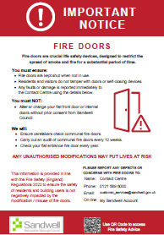 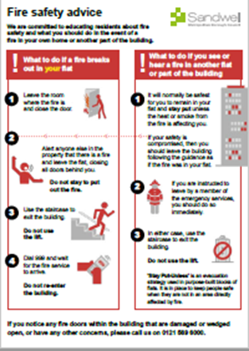

|  |  |  |
| --- | --- | --- |
| **Section**  **14** |  | Sources of Ignition |

1. Smoking is prohibited within any communal parts of the building in line with Smoke Free England legislation.
2. Combustible items were noted in several areas of the building. These include: - (Email sent to Prabha Patel/Richard Webb).

The Laundry – Old Bed frame, mattress & armchair.

Outside main reception – old furniture.

Ladies Toilet – Door, glazing & other items.

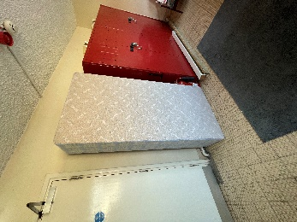 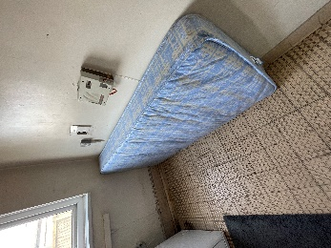 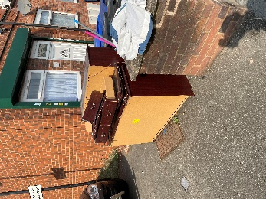 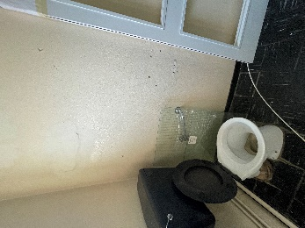

1. There is evidence of Smoking in the Ladies toilet as discarded cigarettes were noted on the floor. (Email sent to Prabha Patel/Richard Webb).

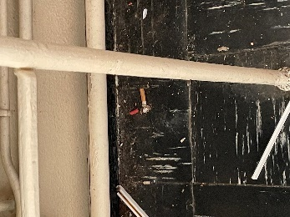 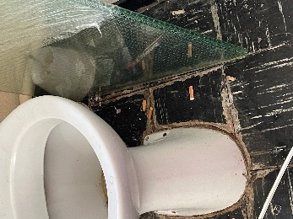

1. Hot working is not normally conducted. If essential maintenance requires the use of hot work processes, then corporate policies and procedures are to be followed.
2. The fixed electrical installation should be tested every 5 years. At the time of the assessment, it was confirmed that the next ECIR inspection has been scheduled for 23/09/2024.
3. Should the communal lounge be brought back into use all furniture should be inspected to ensure they comply with current Fire Safety regulations. Such as, the furniture and furnishings ( Fire Safety) Regulations 1988 (amended 1989, 1993 & 2010).

 

1. Portable electrical equipment used as part of the Caretaking / Cleaning regime is subject to annual PAT Testing. This information is held by the Estate Services Manager Bryan Low.
2. Portable heaters are not allowed in any common parts of the premises.
3. Gas appliances and pipework (where installed) are subject to annual testing and certification. This cyclical contract is managed by the in-house Gas Team.
4. As per tenancy agreements, flammable liquids or gas cylinders should not be stored on site.

|  |  |  |
| --- | --- | --- |
| **Section**  **15** |  | Waste Control |

1. Refuse containers are emptied at regular intervals under a service contract.
2. With regard to waste, residents use refuse bins, these are located outside the main entrance to the building.



1. Ideally, these bins should be re-located and stored away from the main access doors and chained to a secure post at least 8 metres from the building.
2. There is an ‘Out of Hours’ service in place to remove bulk items.

|  |  |  |
| --- | --- | --- |
| **Section**  **16** |  | Control and Supervision of Contractors and Visitors |

1. Responsive Repairs service delivered by Sandwell MBC necessitates the production of an order via the computerised repairs system. Details of any known risks are documented on the repair order.
2. Owing to the nature of low-rise flatted accommodation it is difficult to manage/control individual contractors/utility companies.
3. Hot works are not permitted unless authorisation is given via the approved officer. The hot works procedure is to be followed.
4. Utility companies are not allowed to access any service cupboard or secure area. They must request and collect maintenance keys from the local housing office. This allows scrutiny of what is the scope of any works such as installation of tenant’s broadband / phone line etc.
5. Where contractors are appointed to undertake major refurbishment works, Sandwell MBC Urban Design team will put control measures in place. Such Measures include: -
   1. Pre-Contract Meetings – where contractor is made aware of

all working arrangements and safe systems of work to be adopted. Issues covered in this meeting will include:

* Health and Safety.
* Site security.
* Safety of working and impact on children/school business.
* Fire risk, if any.
* Site Emergency plan.
  1. Monthly Site Meetings – to monitor, review and share any new information including any new risks.
  2. Site monitored daily whilst work is in progress by Clerk of Works / Health and Safety Officers.
  3. Final Contractor review on completion of works undertaken.

|  |  |  |
| --- | --- | --- |
| **Section**  **17** |  | Arson Prevention |

1. Regular checks are undertaken by Caretakers / Cleaning Team(s) 365 days per year which helps reduce the risk of arson.
2. There is restricted access to the premises by means of an electronic door entry system.
3. There have been no reported fire incidents since the last FRA.

|  |  |  |
| --- | --- | --- |
| **Section**  **18** |  | Storage Arrangements |

1. Residents are instructed not to bring L.P.G cylinders into block. This information is contained within the tenants’ handbook.
2. The tenancy conditions, Section 7 – Condition 5.6 stipulates “If you live in a flat or maisonette, you, people living with you and any visitors to your property must not keep or use paraffin oil, petrol, bottled gas appliances or any other explosive, FLAMMABLE, or dangerous material in the property. This restriction also applies to any storage facility situated in or attached to the block, which has been provided for your use.”
3. No Flammable liquids stored on site by Caretakers / Cleaners.
4. Most store/service cupboards are kept locked, these doors were in good condition at the time of the assessment.
5. As per tenancy agreements, flammable liquids or gas cylinders should not be stored on site.

|  |  |  |
| --- | --- | --- |
| **Section**  **19** |  | **Additional Control Measures.** Fire Risk Assessment - Action Plan |

Significant Findings

**Action Plan.**

It is considered that the following recommendations should be implemented to reduce fire risk to, or maintain it at, the following level:

Trivial  Tolerable 

Definition of priorities (where applicable):

P1 Arrange and complete as urgent – Within 10 days.

P2 Arrange and complete within 1-3 Months of assessment date.

P3 Arrange and complete within 3-6 Months of assessment date.

P4 Arrange and complete exceeding 6 months under programmed work.

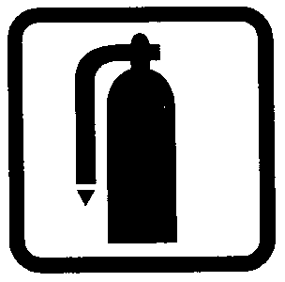Fire Risk Assessment

Action Plan

|  |  |  |
| --- | --- | --- |
| Name of Premises or Location: |  | Flats 1 – 17 – Peartree House, Vicarage Road. |
|  |  |  |
| Date of Action Plan: |  | 13/09/2024 |
|  |  |  |
| Review Date: |  | <Insert date> |

|  |  |  |  |  |  |
| --- | --- | --- | --- | --- | --- |
| **Question/**  **Ref No** | **Required Action** | **Supporting photograph** | **Priority** | **Timescale and Person Responsible** | **Date**  **Completed** |
| 07/07 | Upgrade the electrical cupboard door on the ground floor by supplying cold smoke seals. |  | P2 | 1 -3 months  Repairs. |  |
| 10/04 | In the electrical cupboard on the ground floor, remove expanding foam and replace/enhance with appropriate fire stopping materials. |  | P2 | 1 -3 months  Fire Rapid Response. |  |
| 12/05 | Replace the no smoking sign outside the rear entrance door of the building.  (Adjacent to flat 7). |  | P3 | 3 -6 months  Repairs. |  |

When undertaking future improvement program(s), it is advised that the observations listed below should be given consideration (noting that the safety of the residents is not jeopardised by these, and all steps to reduce any known risks have been taken).

|  |  |
| --- | --- |
| Observations | |
| Should any refurbishment of the building take place then consideration should be given to replacing the timber cladding with a non-combustible type material. |  |
| Flat entrance doors should be upgraded to certified FD30’s when any future upgrades of the building are carried out. |  |
| During the next planned improvement programme consideration should be given to providing fire resisting subdivision (fire door and frame) across the ground floor corridor approx. mid way along the corridor. |  |
| When any new communal door sets are fitted, review existing exit signage throughout the building. In areas, there is too much signage which could cause confusion. |  |
| The passenger lift should be protected by lobbied doors at ground and first floor level. When any upgrades of the building are conducted consideration should be given to providing a lobbied area outside both lifts. |  |
| Refuse bins should be re-located and stored away from the main access doors and chained to a secure post at least 8 metres from the building. |  |
| Upgrade the Zone plan to provide a diagrammatic representation of the building, listing all of its zones & building exits. It should be located next to the fire alarm panel. |  |

Signed

|  |  |  |
| --- | --- | --- |
|  | Fire Risk Assessor | Date: 18/09/2024 |
|  | Quality Assurance Check | Date: 23/09/2024 |

**Appendix 1**

**Significant Hazards on Site and**

**Information to be Provided for the Fire Service**

**Name of property:**  Flats 1 – 17 Peartree House, Vicarage Road. Oldbury.

**Updated: 26/06/2023**

**Premise Manager: Tony Thompson. Tel. No.: 0121 569 2975**

|  |  |
| --- | --- |
| **Hazard** | **Information/Comments** |
| Asbestos | An asbestos survey has been undertaken of the communal areas. Survey held by Sandwell Housing (Derek Still <Tel:-> 0121 569 5077). |

