**Directorate of Place**

**Housing Services**

**Property Compliance Policy**







|  |  |  |  |
| --- | --- | --- | --- |
| Document title | *Housing & Asset Management Property Compliance Policy* | | |
| Owner | *Head of Building Safety & Compliance* | | |
| Approved by | *Cabinet 11 Sept 24* | | |
| Version Control Status | *Draft* | Version | *1.0* |
|  | *New Document* |  |  |
| Approved Date | *11/9/24* | In use Date | *18/9/24* |
| Last updated | *New Policy* | Last updated by | *N/A* |
| Review date | *3 years from Approved date* | | |
| Purpose | *How SMBC manages compliance in its domestic stock, covering Gas, Electric, Water, Asbestos, Lifting Equipment, Fire & Building Safety.* | | |

Table of Contents

**1.** **Purpose** 3

**2.** **Scope** 3

**3.** **Related Documents** 3

**4.** **Legal Framework** 4

**5.** **Glossary** 9

**6.** **Equality and Diversity** 9

**7.** **Policy Statement** 9

Statement of Intent 9

**8.** **Key Roles and Responsibilities** 10

**9.** **Resident Engagement** 12

**10.** **Management Arrangements, Reporting, Competency and Assurance** 12

Delivery Procedures 13

Competency 13

SMBC Agreed Review of key Compliance Certification and Assessments 13

Access Policy 14

Reporting on agreed performance measures 15

Assurance and Governance 15

**11.** **Escalation** 16

**12.** **Monitoring and Review** 16

**13.** **Policy Document Version Control** 17

# **Purpose**

* 1. The Property Compliance Policy details how we meet the legal obligations we have as a landlord and as an employer. This critical in enabling us to deliver our strategic goals and to provide quality and safe homes for our residents. The specific compliance themes and the requirements associated with them range from ‘threat to life’ responsibilities such as gas safety and fire safety through to administrative technicalities set out in various regulations. This policy document confirms our objectives and intent. It also goes on to describe.
     + How we organise ourselves to meet this objective,
     + Our headline commitments, and
     + How we report performance.
  2. As a registered social landlord, we operate in a unique regulatory environment whereby the effect of any non-conformance with regulatory requirements can be amplified through the impact on our relationship with the Regulator for Social Housing, (RSH), and notably their assessment of our governance arrangements and our performance in meeting the Decent Homes Standard. We operate in the spirit of co-regulation with the RSH. We also have important working relationships with some of our local regulators such as other departments within Sandwell Metropolitan Borough Council and local fire services as well as national regulators such as the Health & Safety Executive, (The Building Safety Regulator, BSR sits under here) and the Environment Agency.
  3. We manage this, and other risks, through our risk management framework and our three lines of defence. These include:
* effective operational management,
* risk and compliance management and
* our internal audit and governance functions, providing independent and objective assurance.

# **Scope**

The focus of this policy is on the residential portfolio the Housing function of the Place Directorate are responsible for but aligns with the Corporate H&S policies.

# **Related Documents**

* 1. The Following Documents that must be read in conjunction with this policy.
* Strategic Compliance Plan
* H&S Strategy
* All Property Compliance Procedures and Briefing Notes
  + Fire Safety
  + Building Safety
  + Gas
  + Lifts
  + Asbestos
  + Water
  + Electrical

# **Legal Framework**

Sandwell Metropolitan Borough Council (SMBC) will adhere to all relevant legislation under The Health and Safety at Work Act and related such as the Housing Act 2004, the Management of Health and Safety at work Regulations 1999, Building Regulations and the approved documents etc. The table below lists those specific to each of the Big 6 as targeted in this Compliance Policy and SMBC obligations.

|  |  |  |
| --- | --- | --- |
| No | Title | Obligation |
| 1 | **Gas**  The Gas Safety (Installation and Use) Regulations 98 (as amended 2018) and ACOP’s and any subsequent amendments. | To adhere to the Landlords main duties as listed in “A guide to landlords’ duties: Gas Safety (Installation and Use) Regulations 1998 As amended”.   * Ensure gas Appliances, fittings and flues are maintained in a safe condition. Ensure that an annual safety check is carried out on Gas Appliances and Flues and that ongoing maintenance is carried out. Gas appliances should be serviced in accordance with the manufacturer’s instructions and done annually by a Gas Safe registered engineer. * Ensure an annual safety check is carried out on each gas appliance/flue and pipework Before any new lease starts, you must make sure that these checks have been carried out within one year before the start of the lease date, unless the appliances in the property have been installed for less than 12 months, in which case they should be checked within 12 months of their installation date. * Keep the record of the gas safety check until two further checks have been carried out (this may be longer than two years). * Issue a copy of the latest safety check record to existing tenants within 28 days of the check being completed, or to any new tenant before they move in (in certain cases there is an option to display the record). |
| 2 | **Fire and Building Safety**  The Fire Safety Order 2005 as amended by the Fire Safety Act 21, The Fire Safety England Regulations 22, Building Safety Act 2022 (BSA) & subsequent secondary legislation. | **Fire Safety Order 2005** - To Adhere to all Landlords Duties including articles 8-24. Noting 8 and 9 below. Has been updated by the **Fire Safety Act** 21 - to include external wall and attachments in the FRA.  8. Duty to take general fire precautions  9. Risk assessment  **The Fire Safety England Regs 22** - These regulations made it a requirement in law for responsible persons of high-rise blocks of flats to provide information to Fire and Rescue Services to assist them to plan and, if needed, provide an effective operational response.  Also, the regulations require responsible persons in multi-occupied residential buildings which are high-rise buildings, as well as those above 11 metres in height, to provide additional safety measures.  In all multi-occupied residential buildings, the regulations require responsible persons to provide residents with fire safety instructions and information on the importance of fire doors. The regulations apply to existing buildings, and requirements for new buildings may be different.  **The Building Safety Act 22** – This Act makes ground-breaking reforms to give residents and homeowners more rights, powers, and protections – so homes across the country are safer.  It delivers far-reaching protections for qualifying leaseholders from the costs associated with remediating historical building safety defects, and an ambitious toolkit of measures that will allow those responsible for building safety defects to be held to account.  It overhauls existing regulations, creating lasting change and makes clear how residential buildings should be constructed, maintained and made safe.  The Act creates three new bodies to provide effective oversight of the new regime: the Building Safety Regulator, (BSR), the National Regulator of Construction Products and the New Homes Ombudsman.  Together these changes mean owners will manage their buildings better, and the home-building industry has the clear, proportionate framework it needs to deliver more, and better, high-quality homes. |
| 3 | **Electricity**  The Health and Safety at Work Act 74, (HaSAW),  Electricity at Work Regs 1989, The Management of Health and safety at work regs 99, Provision and use of work Equipment Regs 1998 (PUWER)  Landlord and Tenant Act 1985  The Housing Act 2004 | **HaSAW –** Applies to everyone (employers and employees) in general terms concerned with work activities and provisions to protect members of the public.  **Electricity at Work Regs 89** – ensures for precautions to be taken against the risk of death or person injury from electrical work activities. Aimed at those involved in the design, construction, operation or maintenance of electrical systems and equipment.  **The Management of Health and Safety at Work Regs 99** – Aimed at Employers, managers, and other duty holders for H&S, requires them to assess the risks posed to workers and any others who may be affected by their work or business.  **PUWER** – Requires for equipment provided for work use:   * Suitable for the intended use. * Safe for use, maintained and inspected to ensure correctly installed and does not deteriorate. * Used only by people who have had adequate information, instruction, and training. * Accommodated by suitable H&S measures. * Used in accordance with specific requirements for mobile work equipment.   **Landlord and Tenant Act 85 –** Section 11 sets out who is responsible for repairing a property whilst it is being rented.  **The Housing Act 04 –** Main provisions:   * The housing health and safety system, (HHSRS). * Enforcement of housing standards. * Licensing of HMO’s. * Empty homes. * Home information packs.   **Plus, many others:**  Homes (Fitness for Habitation) Act 2018, The Consumer Protection Act 87, FSO 05, Defective Premises Act 72, The Electrical Equipment (safety) Regs 16, Building Regs and the Approved Docs A-R, noting ADP – Electrical safety in Dwellings, IET wiring Regs 18th edition. |
| 4 | **Asbestos**  Control of Asbestos Regulations, (CAR) 2012  Reporting of Injuries, Disease, and dangerous Occurrences, RIDDOR.  HSG 227 A comprehensive guide to managing asbestos in premises. Approved Code of Practice, (ACOP)  HSG 210 – Asbestos Essentials, ACOP  Other ACOPS:  HSG247 – Licensed Contractors  HSG 248 – The analysts Guide  HSG 264 – The survey guide  L143 & L127 – The management of and work with ACM in non-domestic premises. | **CAR 2012 –** Sets minimum standards for the protection of employees from the risks of exposure to Asbestos Containing Materials, ACM.s.  Applies to work which disturbs or is likely to disturb ACM, ACM sampling and laboratory analysis.  Noting key Regulations below:  Reg 3 – Application.  Reg 4 – Duty to manage in non-domestic premises.  Reg 5 – Identification of the presence of ACM.  Reg 8 – Licensing of work with ACM.  Reg 9 – Notification of work with ACM.  Reg 10 – Information, instruction, and training.  Reg 11 – Prevention or reduction of exposure.  Reg 16 – Duty to prevent or reduce the spread of ACM’s.  **RIDDOR** – Place duties on employers and other duty holders to report certain serious workplace accidents, occupational diseases and specified dangerous occurrences. Exposure to ACM’s is a dangerous occurrence.  **HSG 227** – Extensive guidance for those with a duty to manage the risks from asbestos-containing materials (ACMs) in premises, e.g. building owners, tenants, and anyone with legal responsibilities for workplaces.  **HSG 210 -** A task manual for building, maintenance, and allied trades of non-licensed asbestos work. |
| 5 | **Water**  The Health and Safety at Work Act 74, (HaSAW),  Control of Substances Harmful to Health, (CoSHH) 2002,  ACOPs - L8, HSG 274 PARTS 1-3, plus many others. | **HaSAW –** Applies to everyone (employers and employees) in general terms concerned with work activities and provisions to protect members of the public.  **CoSHH –** Risk assessments must be carried out to assess any risks and to minimise harm. If employers fail to control hazardous substances this can lead to staff becoming ill from mild eye irritation to chronic lung disease and could lead to civil prosecution, loss of productivity, enforcement action and reputational damage. Legionella is a biological agent and is a hazardous substance under CoSHH.  **L8 - ACOP –** the control of legionella bacteria in water systems, applies where HaSAW act applies. To comply, employers must:  Risk assesses, provide a Written scheme as required, monitor systems, and appoint a responsible person.  **HSG 274 – Part 1-3** – details requirements for risks from Cooling towers, cold water systems, and all other risk systems. |
| 6 | **Lifts**  The Health ad Safety at Work Act 74, (HaSAW),  Lifting Operations & Lifting Equipment Regulations, (LOLER)  Provision and use of work Equipment Regs 1998 (PUWER) | **HaSAW –** Applies to everyone (employers and employees) in general terms concerned with work activities and provisions to protect members of the public, Section 3 applies to the use and maintenance of passenger lifts by the public.  **LOLER –** Places duties upon persons and organisations who own, operate, provide, or have control over lifting equipment. To ensure it is fit for purpose, appropriate for the task, suitably marked and in many cases subject to statutory periodic thorough examination.  **PUWER** – Requires for equipment provided for work use:  Suitable for the intended use.  Safe for use, maintained and inspected to ensure correctly installed and does not deteriorate.  Used only by people who have had adequate information, instruction, and training.  Accommodated by suitable H&S measures.  Used in accordance with specific requirements for mobile work equipment. |

# **Glossary**

|  |  |
| --- | --- |
| Term | Means |
| BSC | *Building Safety Case* |
| BSC R | *Building Safety Case Report* |
| BSA | *Building Safety Act* |
| RP | *Responsible Person* |
| PAP/AP | *Principle Accountable Person / Accountable Person* |
| FRA | *Fire Risk Assessment* |
| WRA | *Water Risk Assessment* |
| LGSR | *Landlords Gas Safety Record* |
| EICR | *Electrical Installation Condition Report* |
| LOLER | *Lifting Operations & Lifting Equipment Regulations, (LOLER)* |
| PUWER | *Provision and use of work Equipment Regs 1998 (PUWER)* |
| HaSAW | *The Health and Safety at Work Act* |
| FSO | *The Fire Safety Order 2005* |

# **Equality and Diversity**

* 1. SMBC is committed to ensuring that no person or group of persons will be treated less favourably than another person or group of persons and will carry out our duty with positive regard for the following core strands of the protected characteristics as defined under the Equality Act 2010 being - Age, Disability, Gender, Race, Gender Identity / Gender Expression, Sexual Orientation, Pregnancy and Maternity, Marriage and Civil Partnership, Religion and/or Belief.
  2. SMBC also recognises that some people experience disadvantage due to their socio-economic circumstances, employment status, class, appearance, responsibility for dependants, unrelated criminal activities, being HIV positive or with AIDS, or any other matter which causes a person to be treated with injustice.
  3. SMBC will also ensure that all services and actions are delivered within the context of current Human Rights legislation. Staff and others with whom we work, will adhere to the central principles of the Human Rights Act (1998).

# **Policy Statement**

## Statement of Intent

SMBC is committed to ensuring that our properties and property focussed operations are legally compliant. This supports us in providing a safe home for our residents, to protect our assets and to reinforce our reputation as a responsible landlord.

We do this by:

* understanding the legal requirements.
* knowing our properties and our activities.
* maintaining an operational risk management approach.
* maintaining externally certified management systems.
* having competent, well-trained staff.
* maintaining records and data.
* communicating key compliance messages.
* engaging openly and proactively with our regulators and other stakeholders.
* clearly reporting compliance performance.
* undertaking internal checks and audits and
* seeking external challenge and review.

Health & Safety is covered by the SMBC’s Health & Safety Policy and operates in parallel to this policy. As such, the focus of property compliance is across the six main themes of:

* Gas safety
* Fire & Building safety
* Electrical safety
* Asbestos management
* Legionella management
* Lift management

Whilst these are our focus we also recognise and commit to comply with the full range of legal requirements as they apply to us including, but not limited to, the requirements of the Housing Act, the Government’ Regulatory Framework & the relevant Standards, environmental legislation, energy efficiency legislation, planning legislation, and transport / vehicle legislation.

# **Key Roles and Responsibilities**

Many of the regulatory requirements apply to us as a corporate body. To support compliance across the main themes we have highlighted several key roles.

The employer or, where applicable, the owner/occupier of the building will ensure relevant guidance, information, training, and equipment are in place for anyone with specific responsibilities and all other staff.

The Employer (SMBC) for the purposes of this policy is the Responsible Person, (FSO) - see below, Accountable person (BSA) see below, Employer as the Duty Holders (for other relevant legislation). Although this is designated/delegated through to operational leads, ultimately the Chief Executive is “responsible” as the lead for SMBC for ensuring compliance.

Meaning of “responsible person”

*3. In this Order “responsible person” means—*

*(a) in relation to a workplace, the employer, if the workplace is to any extent under his control.*

*(b) in relation to any premises not falling within paragraph (a) —*

*(i) the person who has control of the premises (as occupier or otherwise) in connection with the carrying on by him of a trade, business, or other undertaking (for profit or not); or*

*(ii) the owner, where the person in control of the premises does not have control in connection with the carrying on by that person of a trade, business or other undertaking.*

Meaning of “accountable person”

*(1) In this Part an “accountable person” for a higher-risk building is—*

*(a) a person who holds a legal estate in possession in any part of the common parts (subject to subsection (2)), or*

*(b) a person who does not hold a legal estate in any part of the building but who is under a relevant repairing obligation in relation to any part of the common parts.*

The employer will appoint the:

**Chief Executive** as the lead to act as the Responsible Person/Accountable Person, Duty Holder etc to ensure the Council’s compliance with all relevant legislation; and will be responsible for ensuring an agreed programme of investment is properly accounted for in the Council’s annual financial planning; and will appoint the following as ‘relevant persons’ to assist with property compliance.

**The Executive Directors and Assistant Chief Exec** act as Designated leads and act for the employer in fulfilling its legal duties.

**Assistant Directors of Housing Management and Assets** are responsible for the development of policies and strategies in relation to property compliance and providing leadership to the Operational leads. Ensuring, systems are implemented, maintained, and regularly monitored.

**Assistant Director Asset Management & Improvement**.

Ensures that they:

Appoint the **Heads of Services** as required to be the operational leads and ensures they are competent to do so.

Ensures all **managers and staff** have access and carry out a relevant level of safety training as provided by the **Learning and Development**, **Health, Safety and Wellbeing Teams**, or other **competent persons**.

Consults with **Employees** & **Unions** about nominating people to carry out roles (e.g. fire marshals/wardens, re-inspection of ACM’s etc.) and about proposals for improving safety precautions.

The **Head of Building Safety and Compliance** is the operational lead for the **Employer** in its role as RP and PAP/AP, supporting policy development, appointing compliance strategic leads and leading on procedure, standards, and guidance in relation to property compliance is in place and monitored. Is also responsible for Audit and Reporting on agreed performance measures on property compliance ensuring timely intervention as any emerging risks are identified.

**The Head of Repairs** and **The Head of Capital** are the operational leads for DLO staff and works contractors and ensures the required works are completed using competent resources to the relevant quality/requirements as defined in legislation and in a timely response to all relevant due dates as defined in Legislation, Policy, Procedure and any contracts awarded.

Provide **Employees** with clear and relevant information on the risks to them identified by the various assessments, certification, about the measures taken to prevent safety risks and any safety breaches.

# **Resident Engagement**

How SMBC communicates with and educates residents and keep them informed - Key Documents, Reporting & Assurance?

Generally - A SMBC Resident Engagement strategy has been produced and is regularly reviewed. All Policies will be posted on the website and available to all to read.

Specifically – SMBC has created and delivered to all residents, a block specific Resident Engagement Strategy as part of the requirements of the Building Safety Act 2022. These will be reviewed annually in line with the legislation.

# **Management Arrangements, Reporting, Competency and Assurance**

The Management arrangements for all 6 Major Compliance areas will be structured as shown.

See diagram: 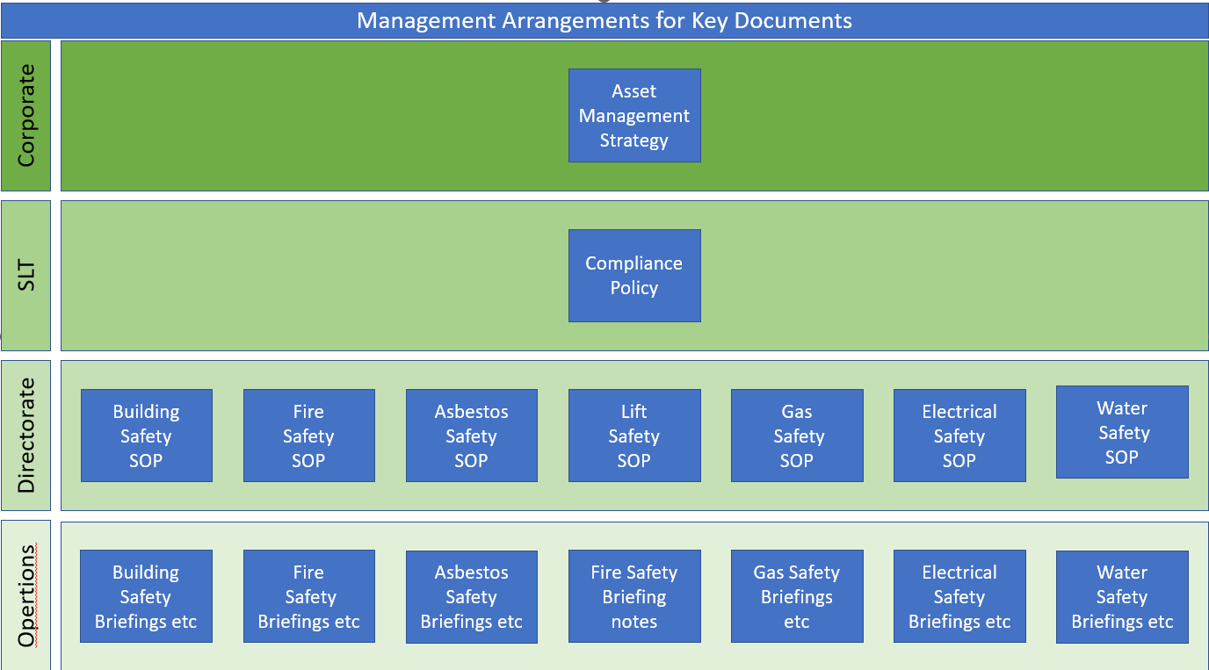

Operations

## Delivery Procedures

The Asset Management Service will maintain quality of management systems to support internal delivery and document control. External delivery providers will be expected to maintain similar standards.

## Competency

We will ensure that our teams have the appropriate levels of experience and competency, combining both technical specialisation and management capability. We invest to train our teams and augment capability through external technical advisors where required. Specific competencies will be defined in the Local Directorate/Service Area Procedure Documents. Currently stored at - S:\RepMan H&S\ASSET MANAGEMENT SAFETY PROCEDURES

## SMBC Agreed Review of key Compliance Certification and Assessments

As described in the various pieces of legislation listed above certain checks require regular review, some are set in the legislation others are a policy decision, the table below describes SMBC’s interpretation.

|  |  |  |
| --- | --- | --- |
| **Area** | **Details** | **Frequency** |
| FRA’s | High Risk (includes HRB’s, Sheltered etc and other considered High risk due to issues of a nature considered high) | 1 Year |
| FRA’s | Medium Risk (Includes 5/6 storey blocks, others considered medium risk) | 2 Years |
| FRA’s | Low Risk (Includes all low rise blocks 4 storey and below and everything else no deemed High or Medium) | 3 Years |
| FRA’s | Renewed when any significant changes or incidents are recorded | As required |
| WRA’s | Are a live document in a live system, deemed to review the risk frequently, however they should be reviewed regularly as per L8 | 1 years |
| WRA’s | Low/Medium risk | 3 years |
| WRA’s | Renewed when any significant changes or incidents are recorded | As required |
| LGSR’s | Legal requirement to annually complete a Gas Safety Check and Service use of MOT employed by SMBC. Relevant to domestic and commercial Appliances. | 1 year |
| EICR’s | 5 Years, (Best Practice for now for social housing providers), or sooner if the renewal date is sooner. Relevant for domestic and communal areas of blocks. | 5 years |
| Asbestos | **Management Survey** is carried out and renewed sooner if significant changes are noted | 10 years |
| Asbestos | **Re-inspection** is carried out every year where ACMs are identified in the Management survey | 1 year |
| Asbestos | **Refurbishment & Demolition** – carried out as required before any planned works | As required |
| Lifts - LOLER | **Passenger Lifts –** legal requirement in offices but keeping in good order is covered under the Housing Act and HaSAW so good practice in residential.  **Domestic Lifts – as above this is good practice and there is case law that SMBC could fall foul of.** | 6 months  Annual  (if adopted) |
| Building Safety | Building Safety Case – legal requirement to submit to the BSR within 28 days once requested – once approved a Building Assessment Certificate, BAC is issued and must be displayed in each block | 5 years |

## Access Policy

SMBC will follow a planned access procedure to ensure it meets its legal responsibilities as required with all tenures as per the legal section above.

There are avenues for planned access including:

* Access for periodic inspections/check such as gas and electric.
* Access to remove or inspect for the presence of known hazards e.g. asbestos through survey or removal.
* Access to post inspect works.
* Health and safety breaches.
* Fire & Building Safety requirements such as Flat entrance and other Fire door Inspections.

## Reporting on agreed performance measures

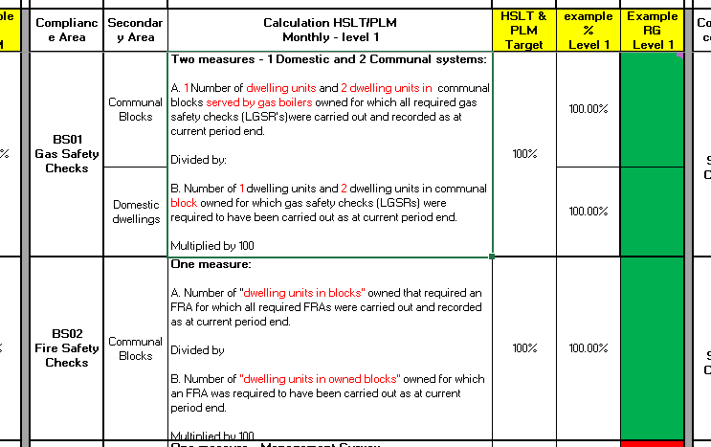Regular reporting of performance will be communicated to key strategic stakeholders to enable performance monitoring and to support effective governance. Reporting will be completed by the Asset Management’ Compliance Team as shown below.

## Assurance and Governance

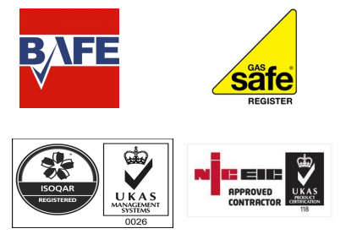Assurance of performance is provided through various mechanisms. Specific assurance activities are described in the relevant “Big 6 Procedure”. Assurance is co-ordinated by the Asset Management’ Building Safety & Compliance Team along with technical and engineering support and oversight.

Certification to accredited standards requires 3rd party external verification which provides us with additional assurance.

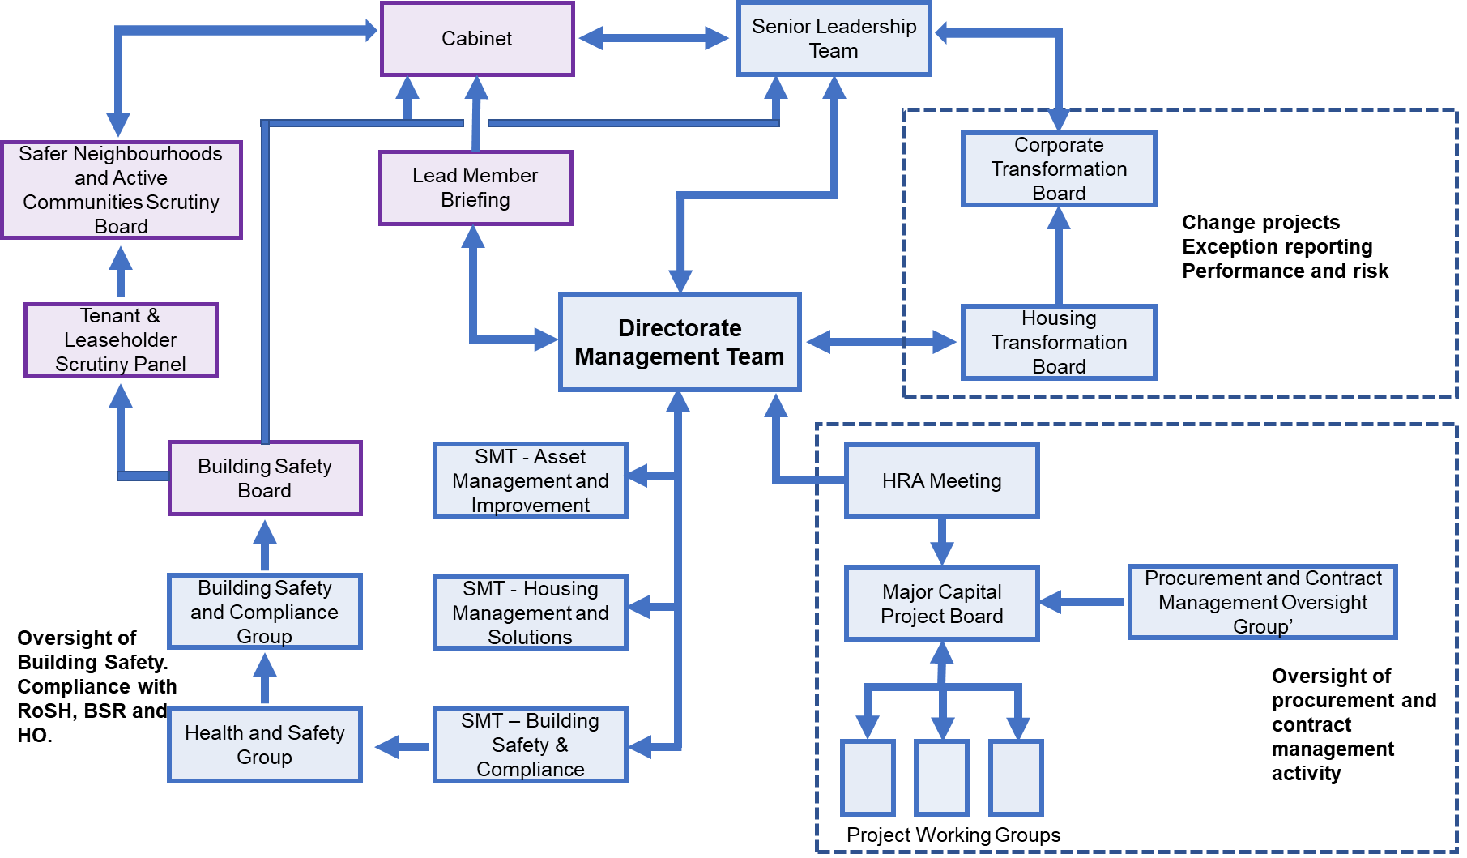**SMBC Governance Structure**

# **Escalation**

The process for escalation of incidents, risks and any issues found that cannot be dealt with as per this Policy, other SMBC relevant polices, such as H&S, RIDDOR etc and the relevant compliance procedures will be via the responsibility chain as listed in section 4.

Whistle blowing policy <https://old.sandwell.gov.uk/intranet/downloads/file/3157/confidential_reporting_code>

should be followed where employees feel escalation as above is not being effective and have concerns their issue are not being resolved and would meet the definition as listed below.

A whistle blower is usually a worker who reports certain types of wrongdoing. Often in the workplace but not always.

The wrongdoing reported must be in the public interest. This means it must affect others, for example, the general public.

Whistle blowers are protected by law – and should not be treated unfairly or lose a job because they ‘blow the whistle’.

You can raise a concern at any time about an incident that happened in the past, is happening now, or you believe will happen soon.

# **Monitoring and Review**

* 1. This Policy will be reviewed every 3 years or sooner if there are significant changes in legislation, management, a major incident or if it is no longer suitable.

# **Policy Document Version Control**

|  |  |  |  |  |
| --- | --- | --- | --- | --- |
| **Version** | **Date** | **Description** | **Updated By** | **Approved By** |
| 1.0 | Sept 24 | Approved Version | T Jones | TBC |
|  |  |  |  |  |