

**Sandwell MBC: Standard Operating Procedures**

**1. Process overview**

|  |  |
| --- | --- |
| **Process Name** | Lift Breakdowns |
| **Process Reference** | AM_Rep_07 |
| **Service Area** | Asset Management and Maintenance and Housing Services |
| **Process Summary** | The process for Lift Breakdowns |
| **Senior Responsible Officer** | Tony Thompson - Fire Safety, Facilities & Premise Manager |
| **Frequency** | Adhoc |
| **Inputs** | Notification of breakdown |
| **Outputs** | Completion of lift repair |
| **Links to other Processes** | N/A |
| **Systems Used** | MySandwell/Service, Job Manager, DRS, Open Housingousing |
| **Templates / Tools** |  |

**INdex**

1. **Operational PROCESS MAP**
2. **Operational PROCESS DETAILed description**
3. **Appendices**

2. OPERATIONAL PROCESS MAP

For a larger view of the process flow please click the link [Lift Breakdown process - Sandwell Intranet](https://housingservices.sandwell.gov.uk/downloads/download/70/lift-breakdown-information)

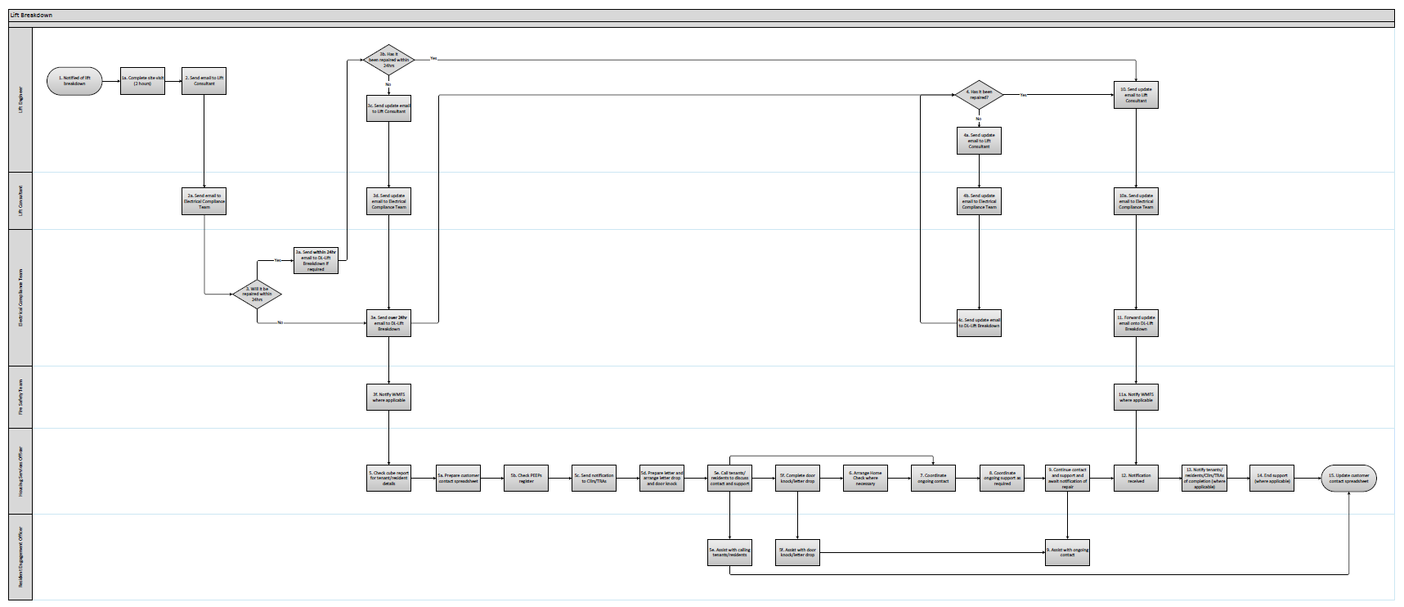

3. OPERATIONAL PROCESS DETAILED DESCRIPTION

| Step No. | **Process Step** | **Detailed Description** | **Timeline** | **Team and named contact** | **System Required** | Outputs and Templates |
| --- | --- | --- | --- | --- | --- | --- |
|  |  |  |  |  |  |  |
| 1 | Notification of Lift breakdown | Report of lift breakdown received from customer. | Adhoc | Lift Engineering Services (LES) | Telephone, email, MySandwell/Service |  |
| 1a. | Complete site visit | LES complete a site visit to determine the issue | Day of notification | Lift Engineering Services (LES) |  |  |
| 2 | Send email to Lift Consultant | LES email to advise they have received notification of a lift breakdown and when the inspection/repair has been scheduled for. | Day of notification | Lift Engineering Services (LES) |  |  |
| 2a. | Send email to Electrical Compliance Team | Cundall emails to advise they have received notification of a lift breakdown and when the inspection/repair has been scheduled for. | Day of notification | Lift Consultant (Cundall) |  |  |
| 3 | Will it be repaired within 24hrs? | Email received from LES will determine the length of time the lift will be out of service. | Day of notification | Electrical Compliance Team | Outlook |  |
| 3a | Send **within 24hr** email to DL-Lift Breakdown if required | The Electrical Compliance Team use their discretion to email the DL – Lift Breakdown if required due to lift being fixed within 24hrs. | Day of notification | Electrical Compliance Team | Outlook |  |
| 3b | Has it been repaired within 24hrs? | LES to liaise with engineers. | Within 24hrs | Lift Engineering Services (LES) |  |  |
| 3c | Send update email to Electrical Compliance Team | LES email the Lift Consultant with an update on the repair. | Within 24hrs | Lift Engineering Services (LES) |  |  |
| 3d | Send email to Electrical Compliance Team | Cundall emails to advise they have received notification of a lift breakdown and when the inspection/repair has been scheduled for. | Day of notification | Lift Consultant (Cundall) |  |  |
| 3e | Send over **24hr email** to DL-Lift Breakdown | The Electrical Compliance Team email the DL – Lift Breakdown to notify them of the breakdown and any details relating to the repair. | Day of notification | Electrical Compliance Team | Outlook |  |
| 3f | Notify WMFS where necessary | The Fire Safety Team notify WMFS via the portal that the lift is out of service. | Day of notification | Fire Safety Team | WMFS portal |  |
| 4 | Has it been repaired? | LES to liaise with engineers. | Within 24hrs | Lift Engineering Services (LES) |  |  |
| 4a | Send update email to Lift Consultant | LES email the List Consultant with an update on the repair. | As required | Lift Engineering Services (LES) |  |  |
| 4b | Send update email to Electrical Compliance Team | Cundall emails the Electrical Compliance Team with an update on the repair. | Day of notification | Lift Consultant (Cundall) |  |  |
| 4c | Send update email to DL-Lift Breakdown | The Electrical Compliance Team email the DL – Lift Breakdown to notify them of the update. | Day of notification | Electrical Compliance Team | Outlook |  |
| 5 | Check cube report for resident details | A cube report is available for the Housing Services Officers to be able to view the contact details and vulnerabilities of tenants and residents in the affected block. | Day of notification | Housing Services Officer | Excel | Cube report |
| 5a | Prepare customer contact spreadsheet | The Housing Services Officer accesses the customer contact spreadsheet and starts to populate the customer contact details from the cube report. | Day of notification | Housing Services Officer | Excel | Customer contact spreadsheet |
| 5b | Check PEEPs register | The Housing Services Officer contacts the Fire Safety Team to check if any tenants/residents have a personal evacuation plan. Details of which should be recorded on the customer contact spreadsheet. | Day of notification | Housing Services Officer | Excel | PEEP’s register, Customer contact spreadsheet |
| 5c | Send notification to Cllrs/TRAs | The Housing Services Officer sends notification of the breakdown email to Cllrs and TRAs. | Day of notification | Housing Services Officer | Outlook | Lift out of order emails |
| 5d | Prepare letter and arrange letter drop and door knock | The Housing Services Officer prepares the customer contact letter with the relevant information and arranges a letter drop/door knock. | Day of notification | Housing Services Officer | Word | Customer contact letter |
| 5e | Call tenants/residents to discuss contact and support  Assist with calling tenants/residents | The Housing Services Officer calls the tenants/residents with the assistance of the Resident Engagement Officer to advise them of the lift breakdown, discuss contact preferences and any support needs they may have that will be affected by the breakdown.  All questions from the customer contact checklist should be asked and details recorded on the customer contact spreadsheet. | Day of notification | Housing Services Officer, Resident Engagement Officer | Word, Excel | Customer contact checklist, Customer contact spreadsheet |
| 5f | Complete door knock/letter drop  Assist with door knock/letter drop | A letter drop and door knock will be complete by the Housing Services Officer and Resident Engagement Officer to ensure contact has been made with all tenants/residents.  All questions from the customer contact checklist should be asked and details recorded on the customer contact spreadsheet. | Within 24hrs of notification | Housing Services Officer, Resident Engagement Officer | Word, Excel | Customer contact checklist, Customer contact spreadsheet |
| 6 | Arrange Home Check where necessary | Where it has been identified that there are support needs the Housing Services Officer should arrange to complete a home check. | Suitable time for the tenant | Housing Services Officer | JM, DRS | Home check form |
| 7 | Coordinate ongoing contact | Any contact preferences and frequencies that have been identified and recorded on the customer contact spreadsheet should be diarised. | Time of identification | Housing Services Officer | Excel, Outlook | Customer contact spreadsheet |
| 8 | Coordinate ongoing support as required | Where support needs have been identified the Housing Services Officer makes relevant referrals/arrangements.  If a Floating Support referral is required clearly identify that it relates to a Lift Breakdown on the referral form and in the subject of the email.  The customer contact spreadsheet should be updated accordingly. | Time of identification | Housing Services Officer | Excel, Outlook | Customer contact spreadsheet, Floating Support referral form |
| 9 | Continue contact and support and await notification of repair  Assist with ongoing contact | The Housing Services Officer ensures that contact and support is ongoing throughout the duration of the lift breakdown. | As required | Housing Services Officers, Resident Engagement Officer | Excel | Customer contact spreadsheet |
| 10 | Send update email to Lift Consultant | LES email the Lift Consultant to advise the repair has been complete. | Time of completion | Lift Engineering Services (LES) |  |  |
| 10a | Send update email to Electrical Compliance Team | Cundall emails the Electrical Compliance Team to advise the repair has been complete. | Day of notification | Lift Consultant (Cundall) |  |  |
| 11 | Forward update email onto DL-Lift Breakdown | The Electrical Compliance Team email the DL – Lift Breakdown to notify them that the repair is complete. | Day of notification | Electrical Compliance Team | Outlook |  |
| 11a | Notify WMFS where necessary | The Fire Safety Team notify WMFS via the portal that the lift has been repaired. | Day of notification | Fire Safety Team | WMFS portal |  |
| 12 | Notification received | The Housing Services Officer receives notification of the repair. | Day of notification | Housing Services Officer |  |  |
| 13 | Notify tenants/residents/Cllrs/TRAs of completion (where applicable) | The Housing Services Officer notifies tenants/residents Cllrs and TRAs that the lift has been repaired. | Day of completion | Housing Services Officer |  |  |
| 14 | End support (where applicable) | The Housing Services Officer liaises with the tenant/resident and any relevant teams to end support. | Day of notification | Housing Services Officer |  |  |
| 15 | Update customer contact spreadsheet | The Housing Services Officer updates the customer contact spreadsheet confirming contact and support that has been ended. | Day of notification | Housing Services Officer | Excel | Customer contact spreadsheet |

1. APPENDICES

|  |  |
| --- | --- |
| Appendix 1 | Customer contact letter |
| Appendix 2 | Customer contact update letter |
| Appendix 3 | Lift out of order email |
| Appendix 4 | Customer contact checklist |
| Appendix 5 | Customer contact spreadsheet |
| Appendix 6 | Distribution List |

**Appendix 1**



Address

S

S

S

S

S

Our Ref:

Your Ref:

Date:

Dear Tenant/Resident,

**Re: Lift breakdown**

As you may be aware the lift in block name is currently out of order.

Our lift contractor, Lift Engineering Services (LES), have been instructed to complete the necessary repair.

In the meantime, officers from Sandwell Council will contact you to discuss any support you may need while the lift is not in operation.

Should you require any further information please scan the QR code below or contact your Housing Services Officer insert name on insert number.



Yours sincerely,

cid:image003.png@01CA03D5.B85D9AA0

**Mr Tony Thompson**

**Fire Safety, Facilities & Premise Manager**

**Appendix 2**



Address

S

S

S

S

S

Our Ref:

Your Ref:

Date:

Dear Tenant/Resident,

**Re: Lift breakdown**

Following notification that the lift in block name is currently out of order, we would like to advise you of the following update

Insert details

Should you require any further information please scan the QR code below or contact your Housing Services Officer insert name on insert number.



Yours sincerely,

cid:image003.png@01CA03D5.B85D9AA0

**Mr Tony Thompson**

**Fire Safety, Facilities & Premise Manager**

**Appendix 3**

Good morning/afternoon,

The lift in insert block is currently out of order.

Lift Engineering Services (LES), have been instructed to complete the necessary repair and it is expected that the repair will be completed by insert date.

The reason for the delayed repair is insert reason.

We will continue to notify you if there are any issues with the repair that will cause further delays.

Kind regards

**Appendix 4**

**Customer contact checklist**

|  |  |
| --- | --- |
| **Name** |  |
| **Address** |  |
| **Contact telephone** |  |
| **Email address** |  |
| **Date contacted** |  |
| **Officer name** |  |

|  |  |
| --- | --- |
| Do you have any medical needs that would make it difficult for you to leave or return to your flat whilst the lift is broken? |  |
| Are there any tasks that you feel you need support with? |  |
| How frequently do you feel you need this support? |  |
| Do you live with anyone that can assist you? |  |
| Do you have any carers or relatives that can assist you? |  |
| Do you receive support from any other agencies? |  |
| Would you consider support from another agency? |  |
| How would you like to receive lift updates? |  |
| How often would you like to receive the updates? |  |

**Appendix 5**

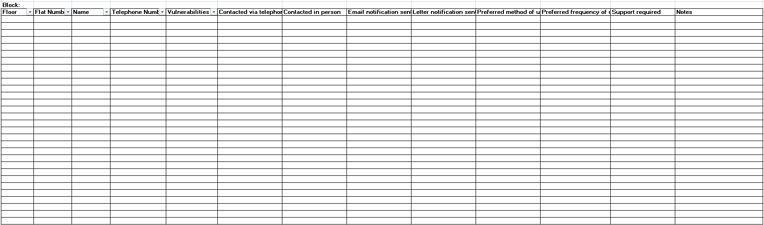

**Appendix 6**

Distribution list DL-Lift Breakdown

|  |  |
| --- | --- |
| **Recipient** | **Email address** |
| John Nash | John_Nash@sandwell.gov.uk |
| Phil Deery | Phil_Deery@sandwell.gov.uk |
| Tony Thompson | Tony_Thompson@sandwell.gov.uk |
| Lee Mlilo | Lee_Mlilo@sandwell.gov.uk |
| Abdulmonim Khan | Abdulmonim_Khan@sandwell.gov.uk |
| Bryan Low | Bryan_Low@sandwell.gov.uk |
| Estate Services | Estate_Services@sandwell.gov.uk |
| CCTV | CCTV_Team@sandwell.gov.uk |
| Voids | voids_maintenance@sandwell.gov.uk |
| Repairs | Ryan_Davies@sandwell.gov.uk  John_Hall@sandwell.gov.uk  Ian_Sorrell@sandwell.gov.uk  Isabel_Cole@sandwell.gov.uk  Alex_Isherwood@sandwell.gov.uk  Ruth_Dolan@sandwell.gov.uk  Michelle_Dawes@sandwell.gov.uk |
| Repairs – out of hours | Simon_Moseley@sandwell.gov.uk  Deborah_Blackham@sandwell.gov.uk  Laraine_Rowley@sandwell.gov.uk  Richard_Thomas@sandwell.gov.uk  Claire_Harrison@sandwell.gov.uk  Angela _Pinney@sandwell.gov.uk |
| Housing Hub | Housing Hub@sandwell.gov.uk |
| Contact Centre | Customer_Services@sandwell.gov.uk |
| Local teams | Wednesbury_Support@sandwell.gov.uk  WestBromwich_Support@sandwell.gov.uk  Rowley_Support@sandwell.gov.uk  Oldbury_Support@sandwell.gov.uk  Tipton_Support@sandwell.gov.uk  Smethwick_Support@sandwell.gov.uk |
| Community Alarms | community_alarms@sandwell.gov.uk |
|  |  |

**9. PROCESS DEVELOPMENT HISTORY**

| **Version** | **Modified By** | **Date** | **Reason** | **Approved By** | **Amendment Details** |
| --- | --- | --- | --- | --- | --- |
|  |  |  |  |  |  |
| V1 | Tony Tompson | 25.03.2024 | Creation | Sarah Ager | N/A |

**Key Stakeholders**

|  |  |  |  |
| --- | --- | --- | --- |
| **Name** | **Position / Role** | **Details of consultation / review** | **Date** |
| Sarah Ager | Assistant Director – Asset Management and Improvement | Agreed and SOP sign off complete | 25.03.2024 |
| Jim Brennan | Head of Tenancy and Estate Management | Input and review of process | 25.03.2024 |
| Tom Jones | Head of building safety compliance | Input and review of process | 25.03.2024 |
| Dean Wright & Jan Macmillan | SCIPS | Review of process | 29.02.2024 |
| Sue Smith | Hamstead Village TRA | Review of process | 29.02.2024 |
| John Nash | Electrical Compliance Manager | Input and review of process | 25.03.2024 |

**Documentation Consulted**

|  |  |  |
| --- | --- | --- |
| **Title** | **Author** | **Date Reviewed** |
|  |  |  |
|  |  |  |

**Process Sponsor Sign Off**

|  |  |  |  |
| --- | --- | --- | --- |
| **Name** | **Position** | **Version Reviewed** | **Date** |
| Sarah Ager | Assistant Director – Asset Management and Improvement | Lift Breakdown SOPv1 | 25.03.2024 |

**Key Issues and Business Decisions Pending**

|  |  |  |  |
| --- | --- | --- | --- |
| **Issue or Business Decision** | **Owner** | **Contact for Resolution** | **Date of Resolution** |
|  |  |  |  |