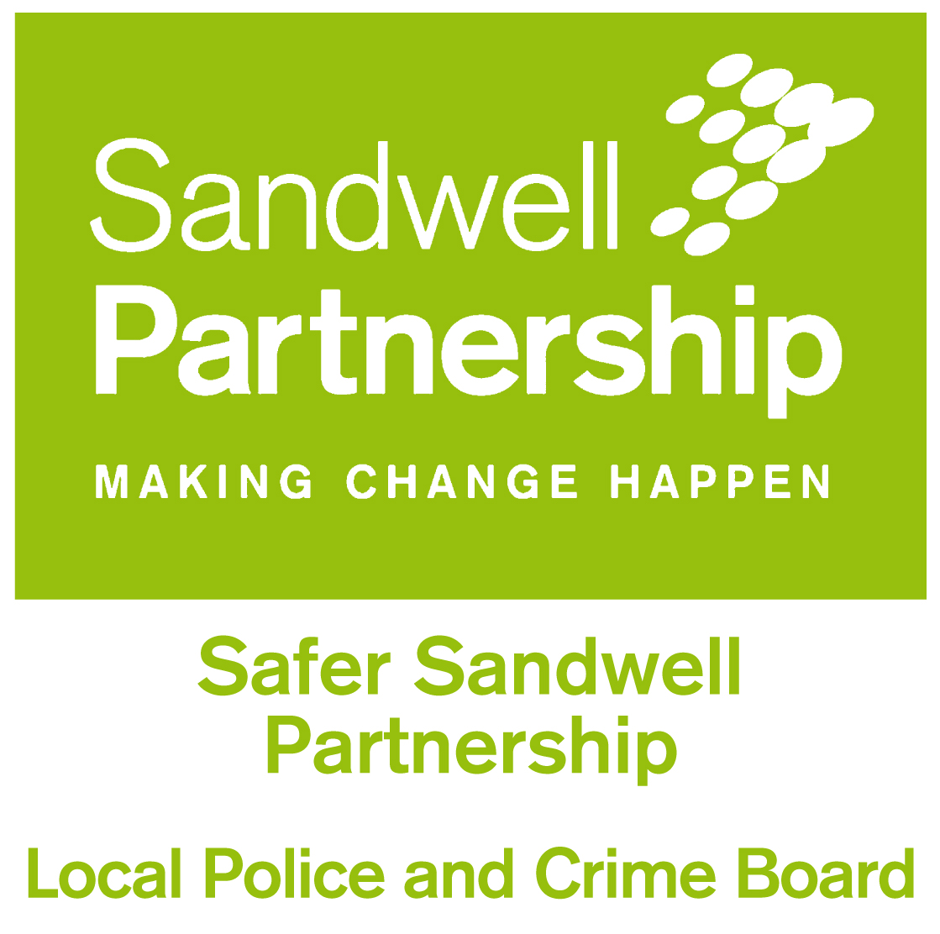
DOMESTIC HOMICIDE REVIEWS

Domestic Homicide Reviews were established on a statutory basis under Section 9 of the Domestic Violence, Crime and Victims Act (2004). This provision came into force on 13 April 2011.
A domestic homicide review (DHR) is a review of the circumstances in which the death of a person aged 16 or over has, or appears to have, resulted from violence, abuse or neglect by:
- a person to whom they were related or with whom they had been in an intimate personal relationship, or
- a member of the same household as themselves.
The purpose of a DHR is to:
- Establish what lessons are to be learned from the domestic homicide regarding the way in which local professionals and organisations work individually and together to safeguard victims;
- Identify clearly what those lessons are both within and between agencies, how and within what timescales they will be acted on, and what is expected to change as a result;
- Apply these lessons to service responses including changes to policies and procedures as appropriate; and
- Identify what needs to change in order to reduce the risk of such tragedies happening in the future to prevent domestic violence homicide and improve service responses for all domestic violence victims and their children through improved intra and inter-agency working.
The lead responsibility for co-ordinating Domestic Homicide Reviews (DHRs) in Sandwell lies with the Safer Sandwell Partnership, the local Community Safety Partnership for the borough. The partnership will initiate Domestic Homicide Reviews and select who should sit on the review panel. The panel will then carry out the review as an independent body.
The ethos of the reviews should be around what we would have done differently to stop this Domestic Homicide happening if we had hindsight and not about apportioning blame. This process should open and transparent and viewed as a positive process.
DHRs are being undertaken in Sandwell and the implementation of the recommendations from these reviews is under way. More information will be made available for practitioners and managers in partners organisations on lessons learnt from these reviews.
A copy of the multi-agency statutory guidance for the conduct of domestic homicide reviews is available in the useful documents section below, along with relevant Home Office information leaflets. Sandwell’s local protocol for undertaking a Domestic Homicide Review is also included.

Useful documents

The following documents are in Portable Document Format (PDF):
Safer Sandwell Partnership – process for undertaking Domestic Homicide Reviews (April 2017)
Safer Sandwell Partnership DHR Procedure April 2017
https://www.sandwell.gov.uk/downloads/download/253/domestic-homicide-review-protocol

Domestic Homicide Reviews – revised national Home Office guidance December 2016:
https://www.gov.uk/government/uploads/system/uploads/attachment_data/file/575273/DHR-Statutory-Guidance-161206.pdf

Domestic Homicide Review information – leaflet for family members:
https://www.gov.uk/government/uploads/system/uploads/attachment_data/file/601398/Leaflet_for_Family_English.pdf

Domestic Homicide Review information for family members (other languages)
https://www.gov.uk/government/publications/domestic-homicide-review-leaflet-for-family-other-languages

Domestic Homicide Review information – leaflet for employers and colleagues:
https://www.gov.uk/government/uploads/system/uploads/attachment_data/file/601456/Leaflet_for_Employers_Colleagues.pdf

Domestic Homicide Review information- leaflet for friends:
https://www.gov.uk/government/uploads/system/uploads/attachment_data/file/601433/Leaflet_for_Friends_English.pdf

Domestic Homicide Review information – leaflet for friends (other languages)
https://www.gov.uk/government/publications/domestic-homicide-review-leaflet-for-friends-other-languages

